**Activity:01**

**Document the major business divisions and their activities**

**Cyberverse** will help design, develop and deploy effective platforms that will bring together the government, academia, industry and the community to build cyber security awareness at all levels.



**Entity**:

Cyberverse Foundation is an organization dedicated to building a robust cybersecurity ecosystem in India.

**Main aim:**

An initiative towards protecting the digital economy of India

**Founder** :Mrs Trishika Kumari Wadiyar



**Document the major business divisions and their activities.**

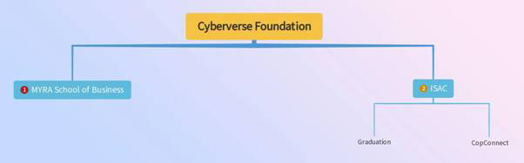

**MYRA School of Business**

MYRA School of Business is an innovatively designed business school established in 2012 at Mysore under the aegis of the Mysore Royal Academy (MYRA). The school’s avant-garde and architecturally acclaimed campus were inaugurated on November 4th, 2012 by Padma Bhushan Deepak Parekh, Chairman of HDFC.



The school’s business education model has been developed in the context of the emerging need for a relook at current business education needs, given the rapidly growing focus on emerging market economies. The school’s learning model offers an equitable mix of individual attention, academic rigor, and experiential learning with a view to develop future leaders with the requisite energy and passion to help transform the business landscape. MSB strives to prepare its students for a world yet to be imagined, to manage markets that are yet to emerge, and to lead decisively in situations that cannot be predicted

**ISAC**



Information Sharing and Analysis Center is India's leading cyber security non-profit foundation and a Partner with CERT-IN, AICTE, Ministry of Education, Government of India.

ISAC brings the prestigious National Cyber Security Scholar, a senior leadership program for professionals.

Facilities

●       Physical labs

●       Virtual Labs

●       Hardware security standards

●       They provide certificate for every course

**CopConnect**



CopConnect is an exclusive mobile app for Police and Law Enforcement Agencies, Lawyers & CISOs to find technical & legal help in cyber crime investigations and cases.

The objective of this program is for Security professionals to assist the Law Enforcement agencies to solve such cases which mostly do not even reach the FIR / inquiry stage and are closed due to lack of expertise and operation.

The App can be accessed by Police, Law Enforcement Agencies, Cyber Crime Lawyers and CISOs

**Draw the workflow for each identified division.**

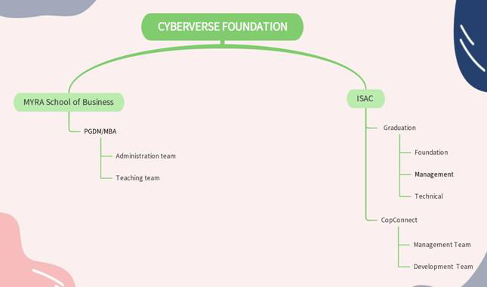

**Activity:-02**

**Create product backlog, sprint and UI/UX design for your project using**

**Suitable tools.**

Create product backlog, sprint:

**Tolls used**:JIRA

To create a product backlog in Jira, follow these steps:

1. Navigate to your Jira project and click on the "Backlog" button.
2. Click on the "Create" button in the top-right corner of the page.
3. In the "Create issue" dialogue, select the "**Epic**" issue type.
4. Enter a summary and a description for your epic.
5. In the "Create issue" dialogue, select the "**Story**" issue type.
6. Enter a summary and a description for your story.
7. Use the "Estimation" field to set an estimate of the effort required to complete the story.
8. Click the "Create" button to add the story to the product backlog.
9. In the "Create issue" dialogue, select the "**Task**" issue type.
10. Enter a summary and a description for your story.
11. Use the "Estimation" field to set an estimate of the effort required to complete the story.
12. Click the "Create" button to add the story to the product backlog.

You can repeat these steps to add additional stories to the product backlog. You can also use the "Epic" issue type to group related stories together.



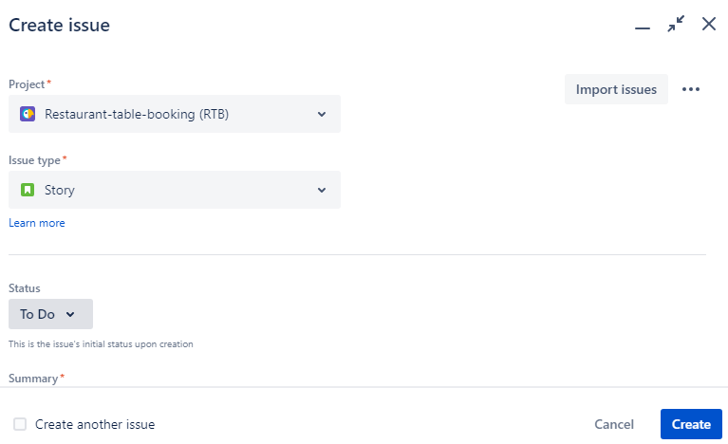 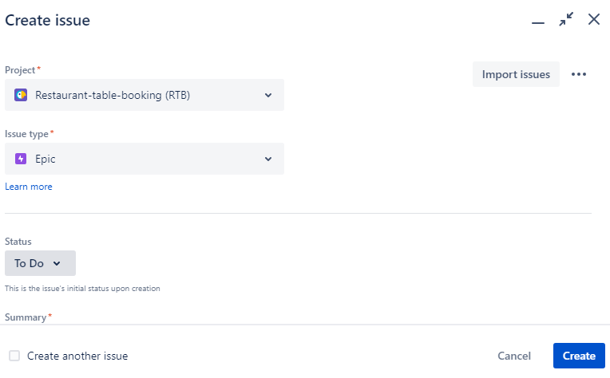

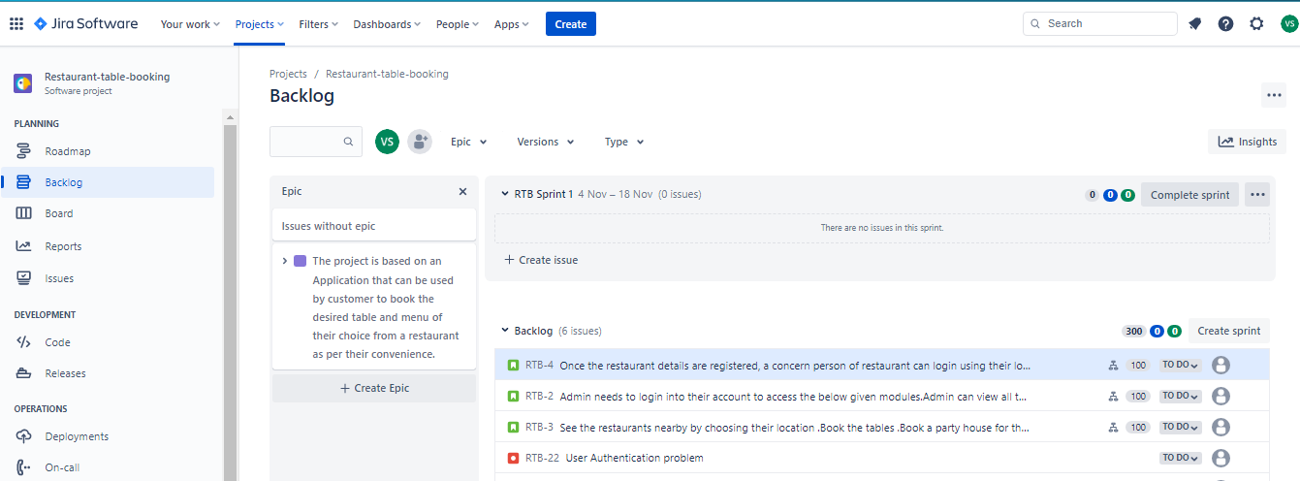

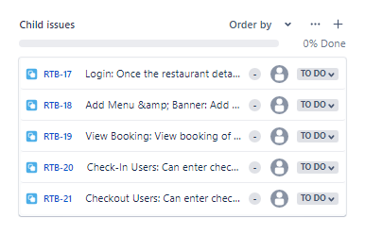

Subtasks

**To start a sprint in Jira, follow these steps:**

1. Navigate to your Jira project and click on the "Backlog" button.
2. From the backlog view, select the stories and/or epics that you want to include in the sprint by clicking the checkbox next to each item.
3. Click on the "Create sprint" button in the top-right corner of the page.
4. In the "Create a new sprint" dialogue, enter a name for your sprint and specify the start and end dates for the sprint duration.
5. Click the "Create" button to create the sprint.

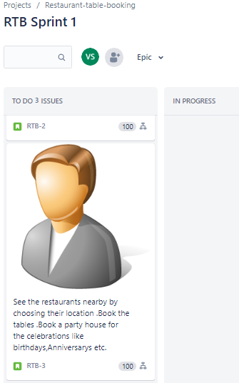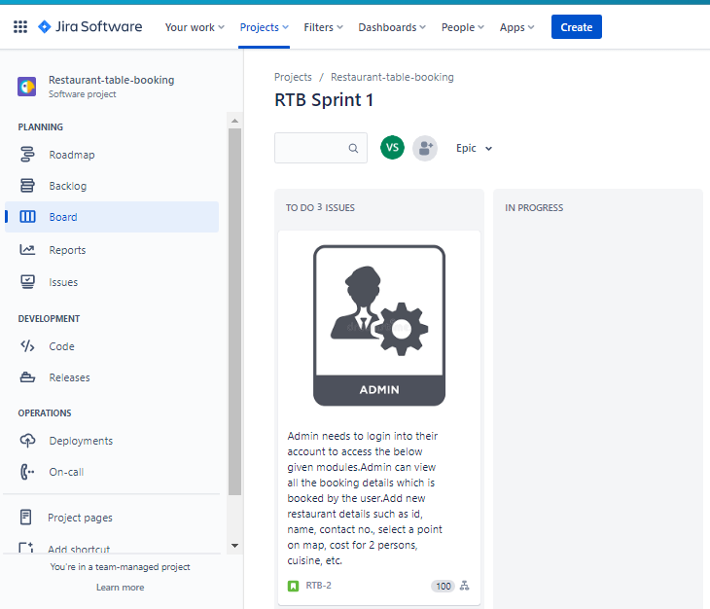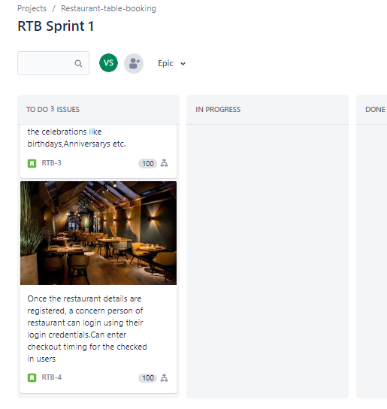

**UI/UX design for your project using Suitable tools.**

**Tolls used**:VISILY

GUI of Visily:

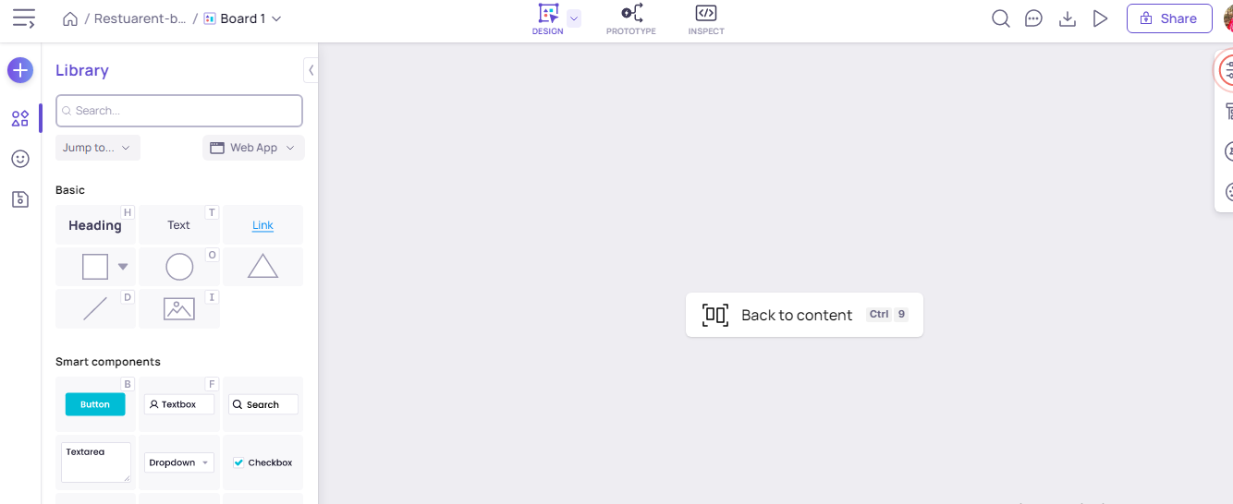

The Library contains UI elements that you can use to design your apps. The main categories of elements are:

* Basic elements: Primitive elements like text, rectangle, line, arrow etc. that you can use to build any high-level components.
* Smart components: High-level components such as Button, Textbox, Chart, Rating etc. that you can use to quickly design the app. These components can be easily customized through their context toolbar.
* Component templates: Such as Forms, Cards, Headers etc. These are prebuilt templates created from smart components and basic elements. Use these templates to quickly assemble design screens.
* Click “Jump to…” to quickly access any category.
* Click “View all” next to a category name to view all elements in the category.
* Click the “Library option” to switch between web and mobile app elements.



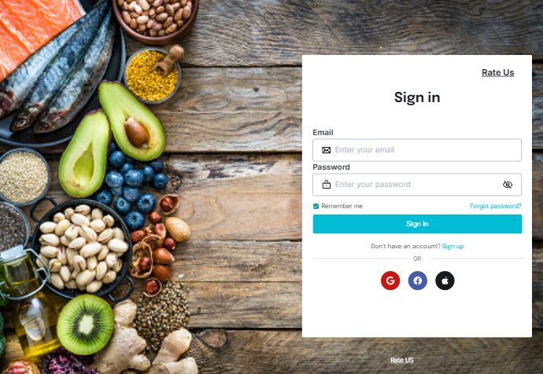 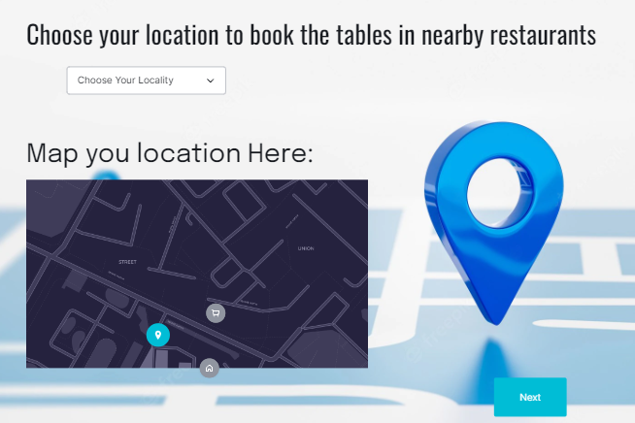

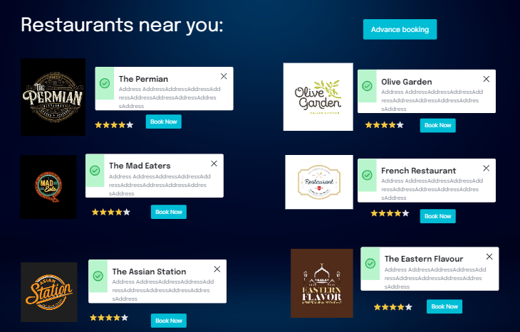

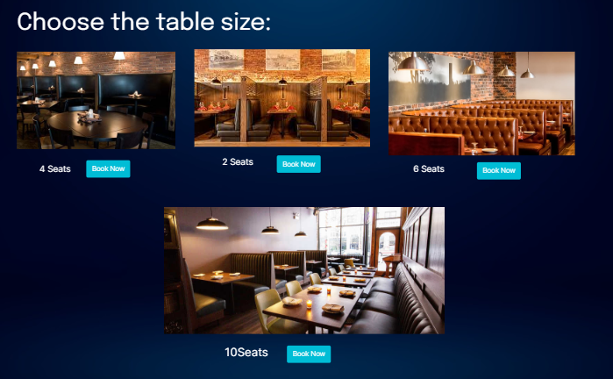

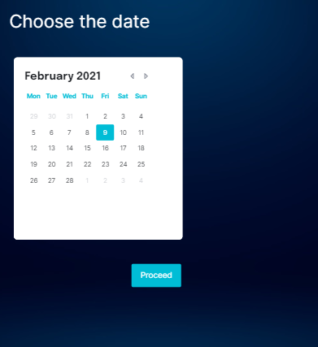

Advance Booking

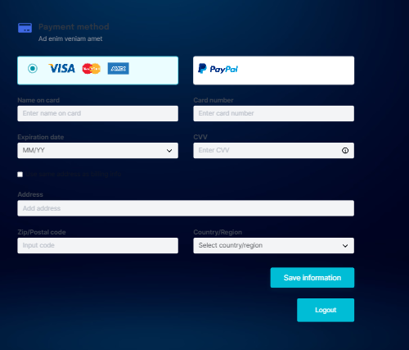

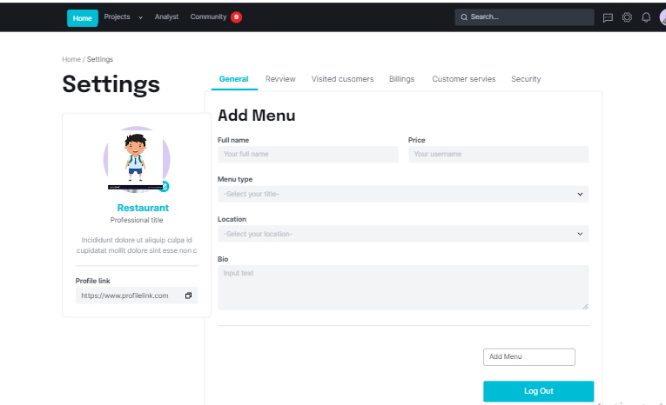 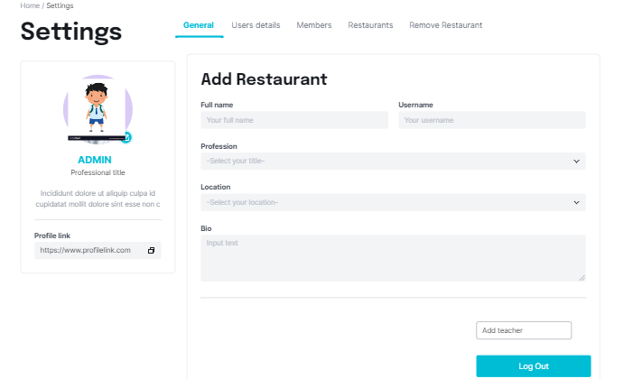

Linking the pages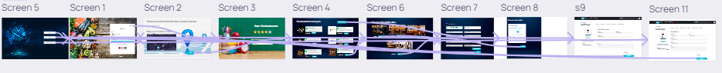

**Activity:-03**

**Create a repository named as “GitDemo”.Clone the repository to your local repository and push a new file to GitDemo.**

**To create a new repository in GitHub:**

1. Go to the GitHub website (https://github.com/) and sign in to your account.
2. Click on the "+" icon in the top right corner of the page, and select "New repository" from the dropdown menu.
3. On the "Create a new repository" page, enter a name “**GitDemo**”, a short description (optional), and select whether the repository should be public or private.
4. If you want to create a repository from an existing local repository, you can select the "Import code" option and follow the prompts to import the code from your local repository.
5. If you want to create an empty repository, you can leave the "Initialize this repository with a README" option unchecked.
6. Click the "Create repository" button to create the repository.

After the repository is created, you will be taken to the repository page, where you can view the repository's code, make changes, and collaborate with others.

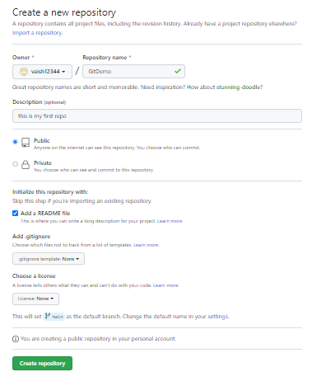

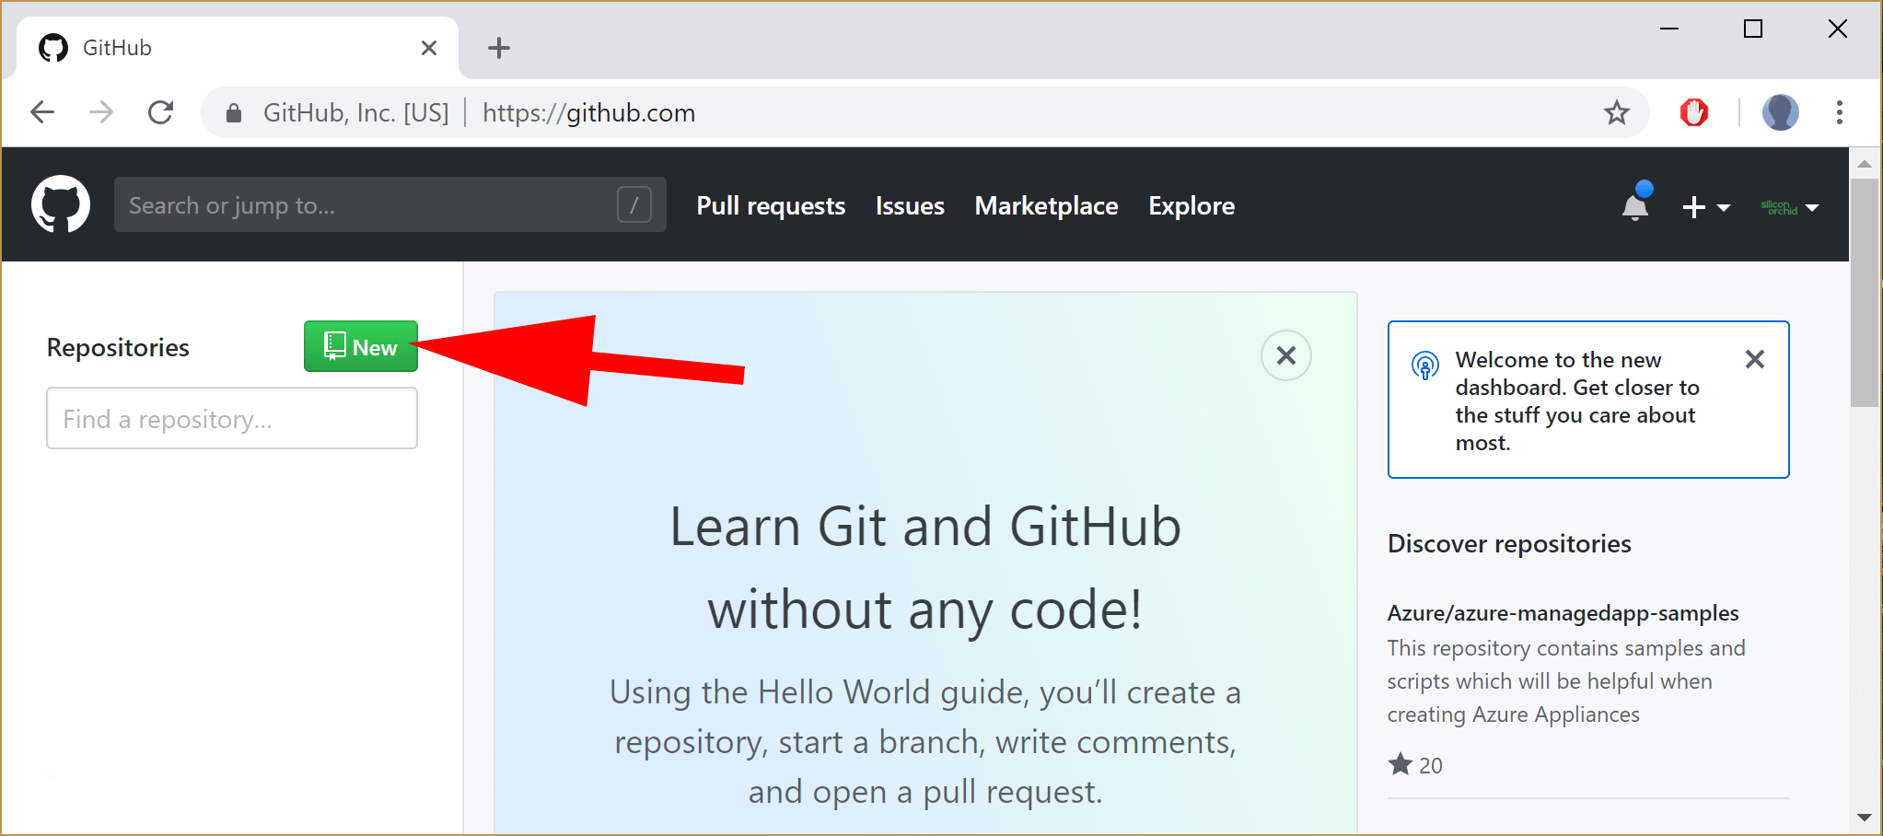

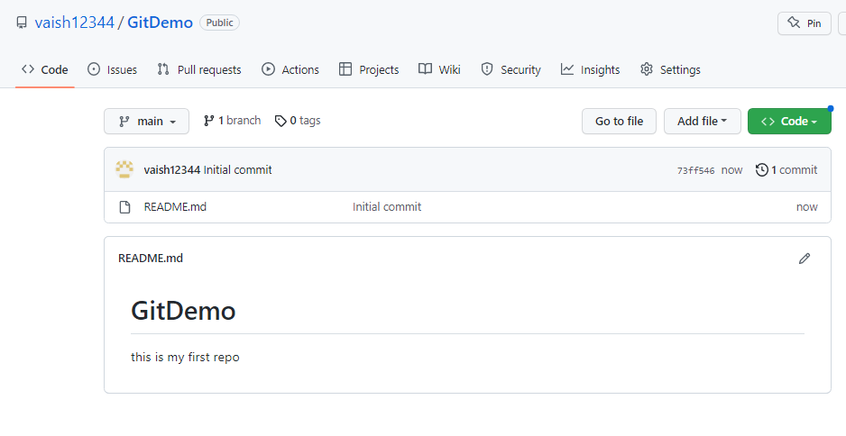

**Cloning the Repository:**

To clone a repository from GitHub:

1. Go to the repository page on the GitHub website and copy the repository's URL.
2. Open a terminal or command prompt on your local machine.
3. Change to the directory where you want to clone the repository.
4. Use the git clone command to clone the repository. For example:

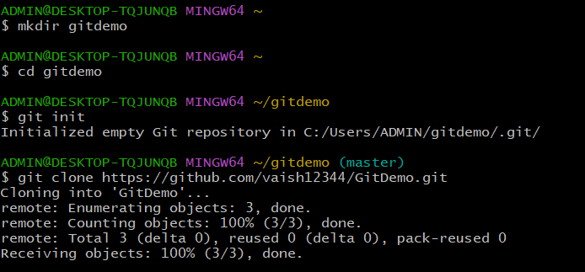

1. Replace " https://github.com/vaish12344/GitDemo.git " with the URL of the repository that you copied in step 1.
2. Press Enter to start the cloning process.
3. When the cloning is complete, you will have a copy of the repository on your local machine, and you will be able to view the repository's code and make changes.

By following these steps, you should be able to clone a repository from GitHub to your local machine.

**Pushing code to remote repository:**

1. Enter into your local repository

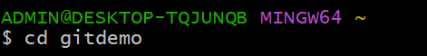

1. In your local repository, use the git remote add command to add the GitHub repository as a remote.



1. Create a new file that you want to push it into your remote repository and git status is used to check the status of the files:

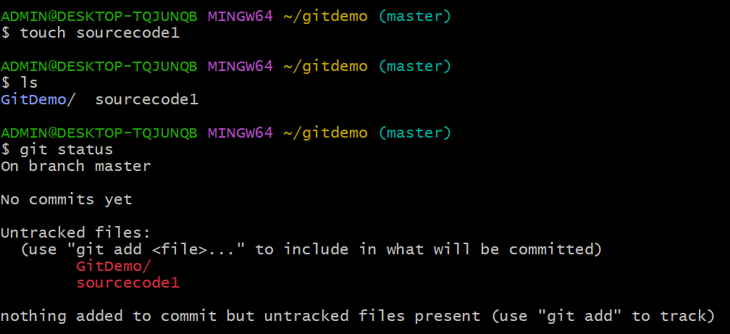

1. Add the file (file1.txt) to the repository
2. Commit the File and check the git status

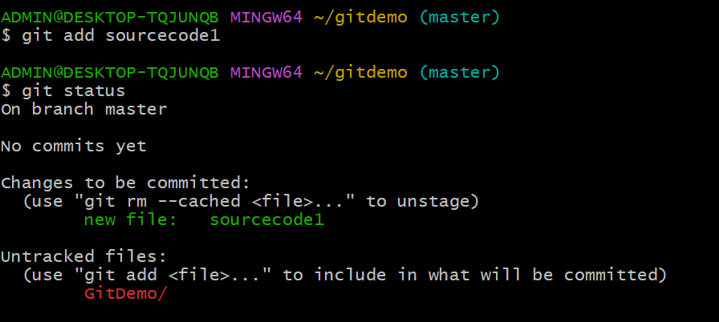

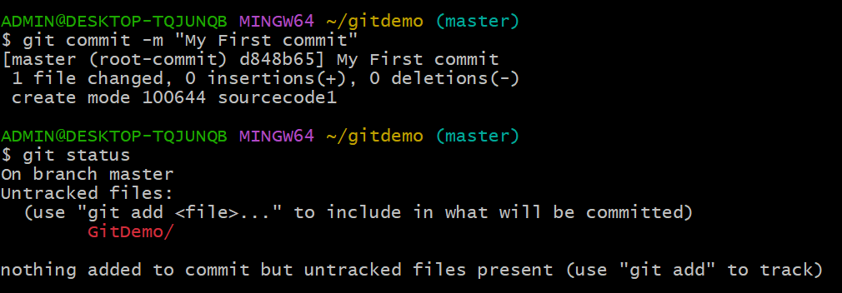

1. Now push your code using git push origin command followed by your branch name (this case : Master)

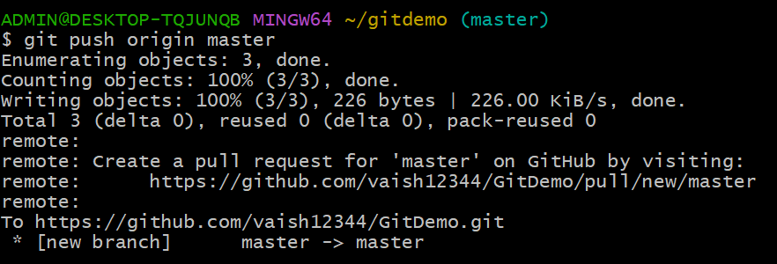

1. Establish connection between Remote and Local repository

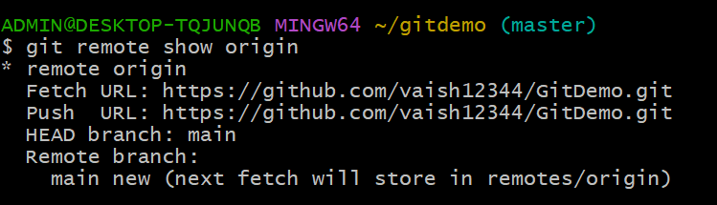

1. Reload your github page (Remote Repository):

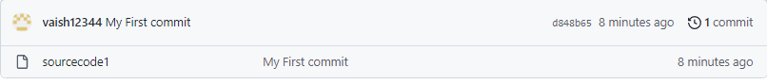

**Activity:-04**

**Create a repository named as "GitPro". Push a.txt file to a branch named “sub-branch" of the GitPro and merge it to main branch.**

# Prerequisites :

* Download and install the git bash
* Create an account in github

# Steps to push file from local repository to remote repository

Step 1: Create a new folder(named as GitDemo)

Step 2: Open your github account and create a new repository

* Click on new repository and repository window will appear as shown below

Enter the name and description of the repository

* Select public and Readme file
* Click on create button 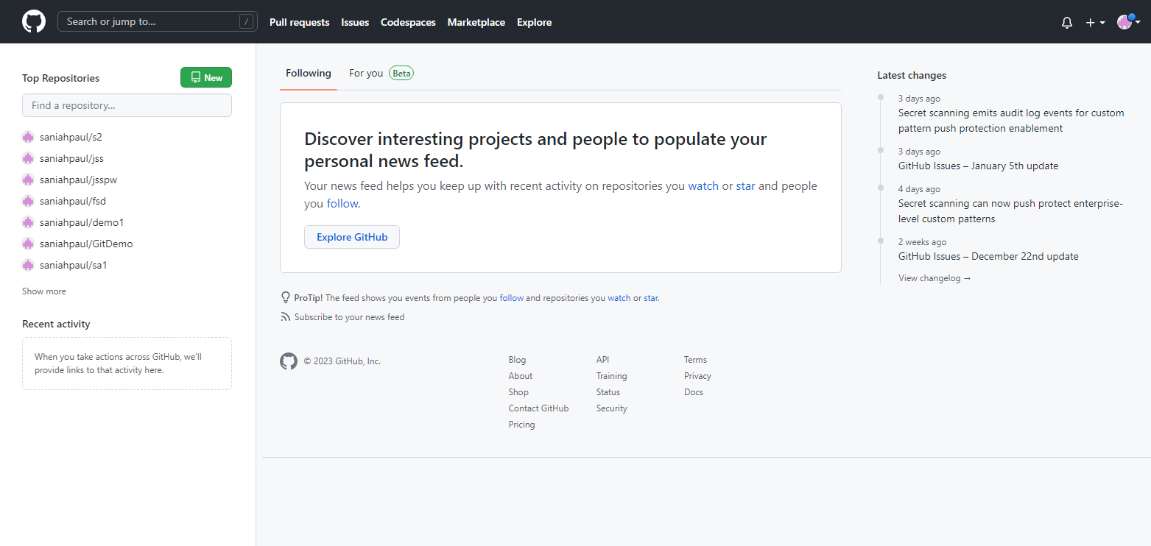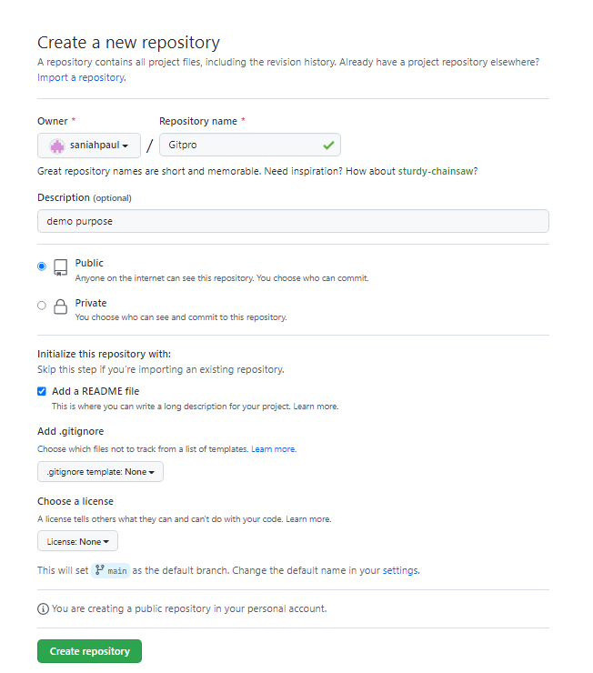

Step 3: Open GitBash and execute the following commands

* Get into the new folder i.e GitDemo
* Initialise the Git

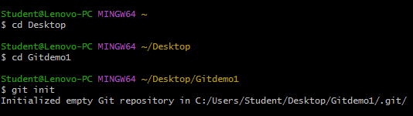

* Clone or download the central/remote repository
* Get into the cloned repository
* Create a file inside the repository

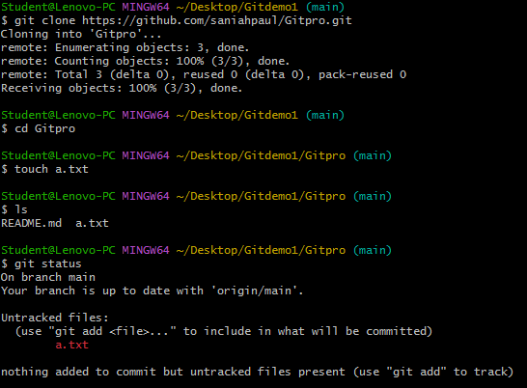

* Add the file (a.txt) to the repository
* Commit the File and check the git status
* Establish connection between Remote and Local repository

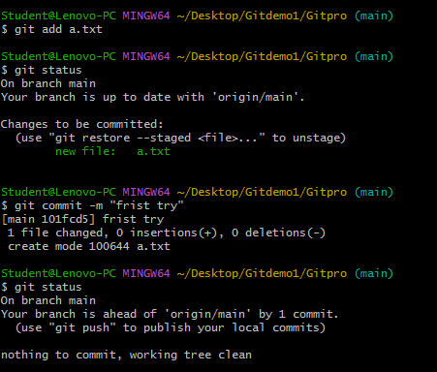

* Push the file to the remote/central repository

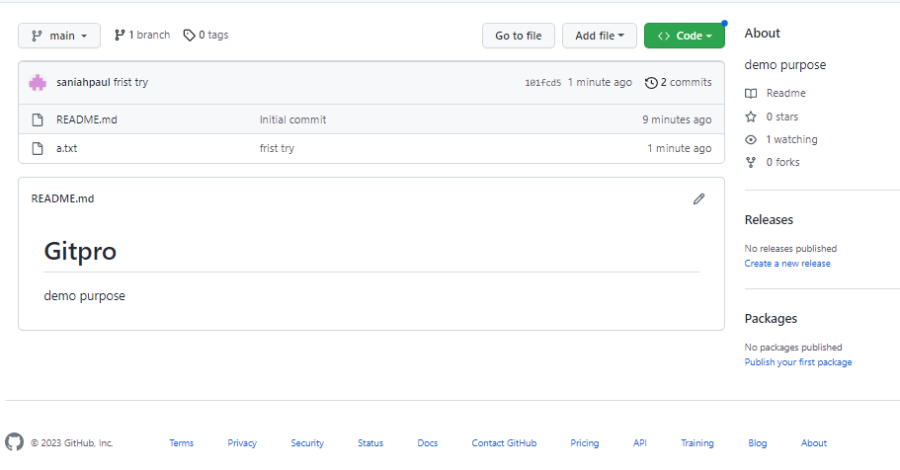

Note: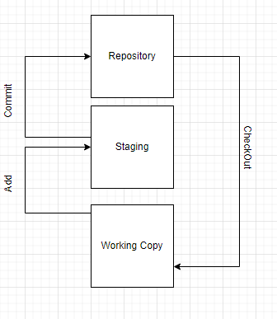

* Cd command :to change from current directory to specific directory
* Git init:initialise the git and creates .git file
* Git clone:creates a copy of the main repository to the working/local repository
* Touch:to create new new empty file
* Ls:lists files and directories within in the file system
* Git status:displays the state of the working directory and staging area
  + If the file name displays in red colour,then the file is still in the working copy
  + If the file name displays in green colour,then the file is in staging area

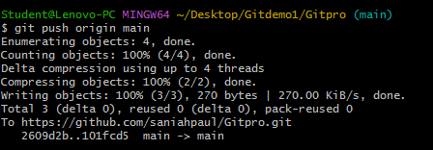

Creating a branch name sub- branch of Gitpro repo and merging it to main branch

**Creating a branch**

## 

**Step1**-At the top of the app, click  **Current Branch** and then in the list of branches, click the branch that you want to base your new branch on.

* Click **New Branch**
* Under **Name**, type the name of the new branch.

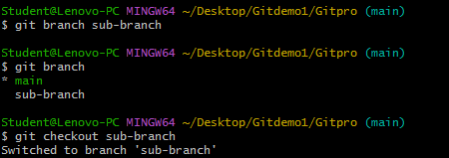

* Click **Create Branch**.

It as all copy of main branch, branch created

**Step2**:Creating a sub-branch in Git bash

* And checkout – Creating a local branch and switching to it
* Git branch – display the number of branchs

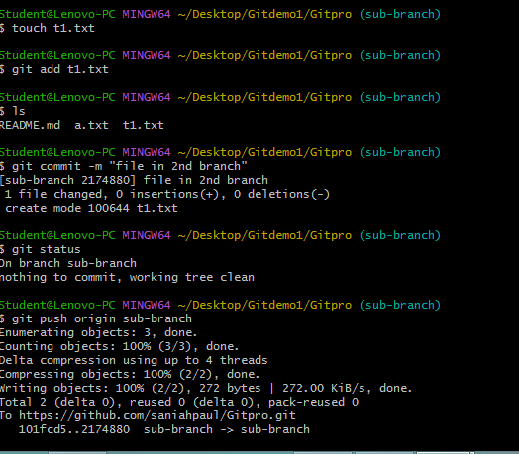

**Step3**- Creating a file and push it to sub-branch

* It will be add to sub-branch in git hub

**Step4**- there will be a message display in top like compare and pull request

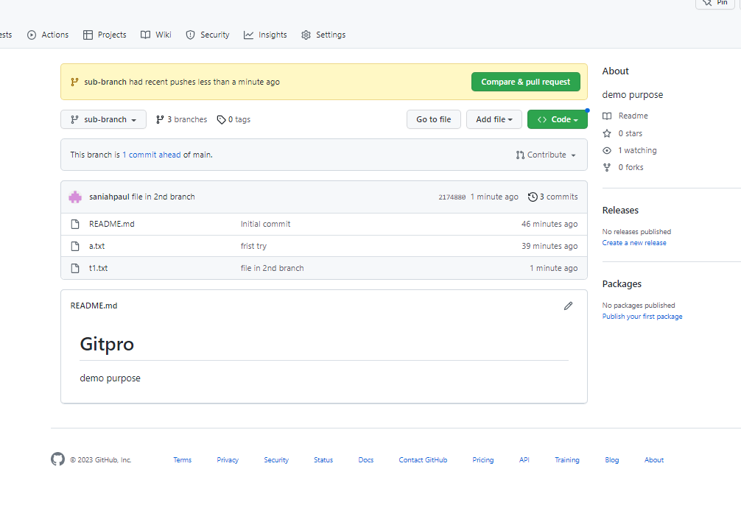

**Step5**- Click on compare and pull request

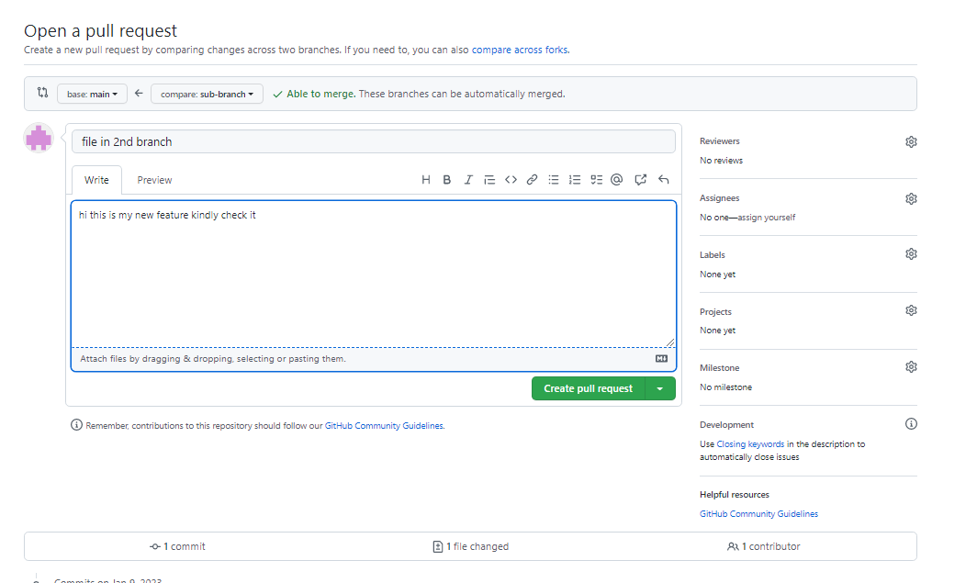

**Step6-** Add any description you want and create pull request to main branch

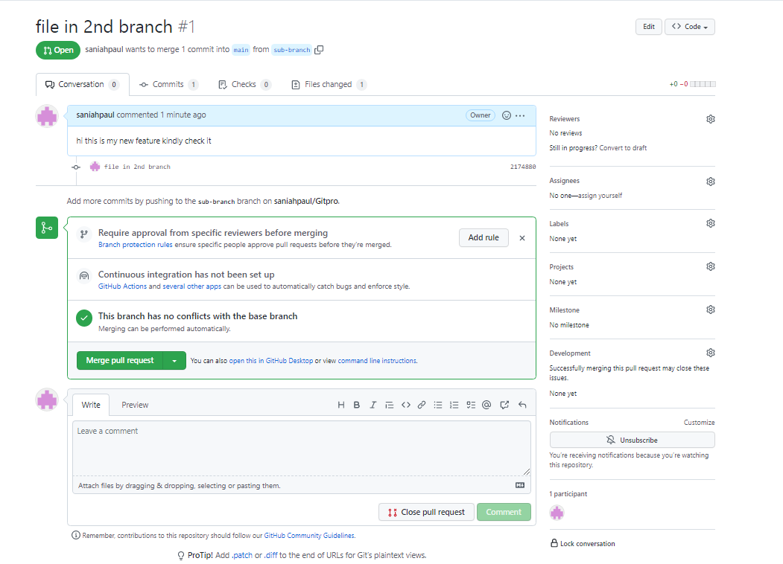

**Step7:** after this it display a request successfully merged

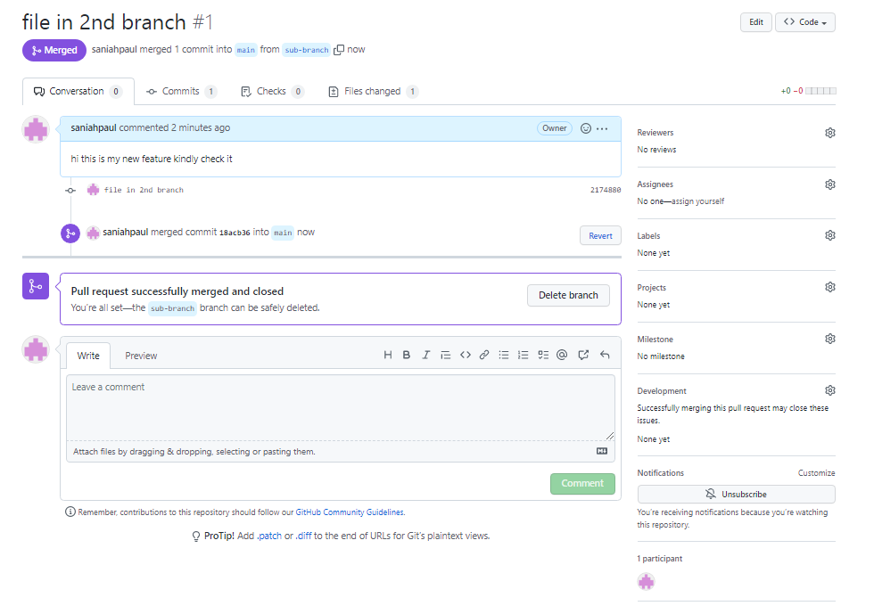

**Step8**- Sub-branch file merged to main branch and you any view files of sub-branch in main

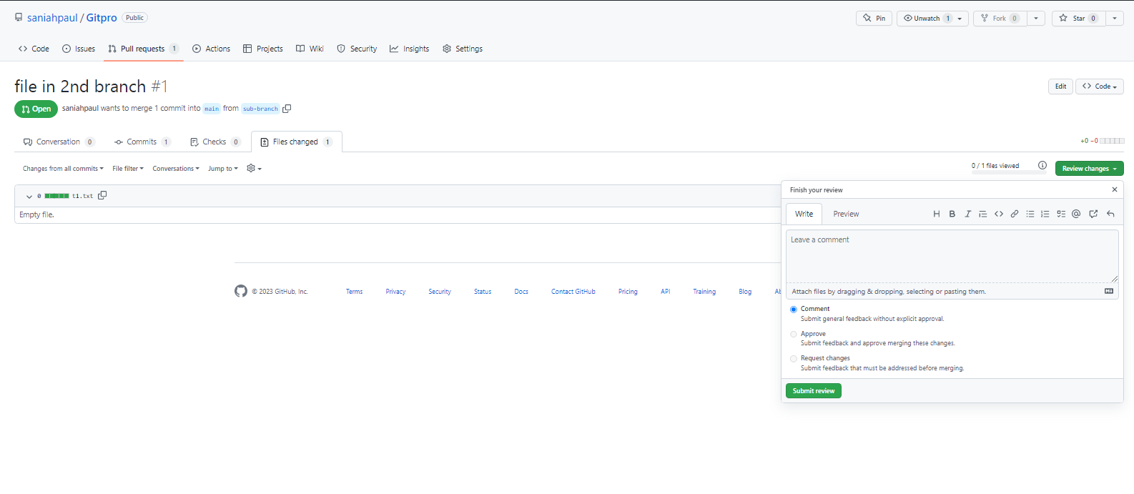

**Merge**

**Activity:-05**

**Create and launch Linux instances on AWS.Alter the default Apache file and display it**

# Steps to create an instance

* Login to your AWS account
* Click on services which is in present in top-left
* Select Compute and Click on EC2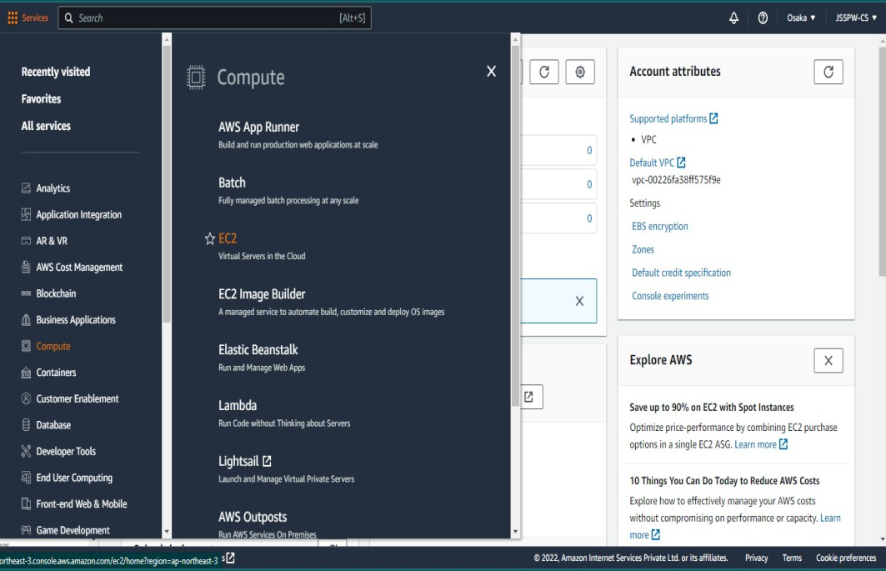
* Click on Launch Instance
* Specify Server Name, OS Type, Instance type and create new key-pair and select it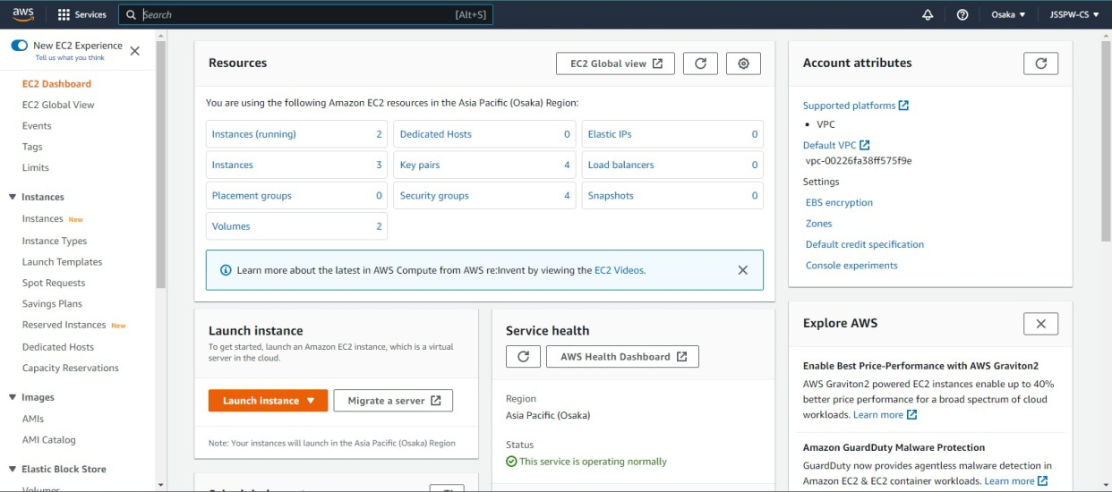

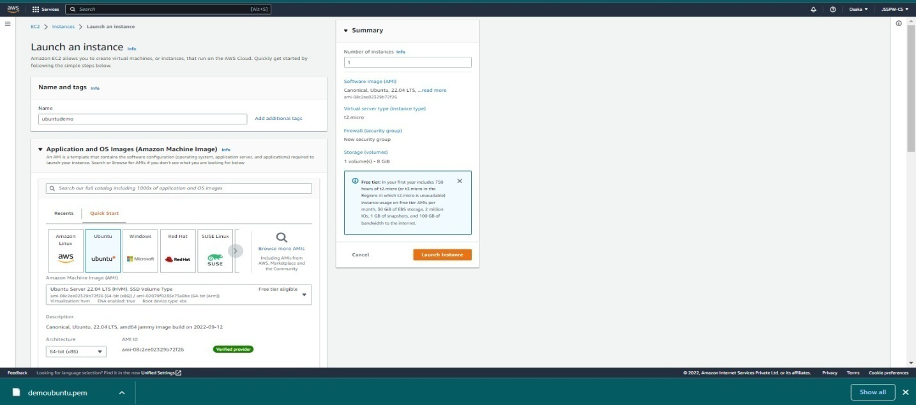

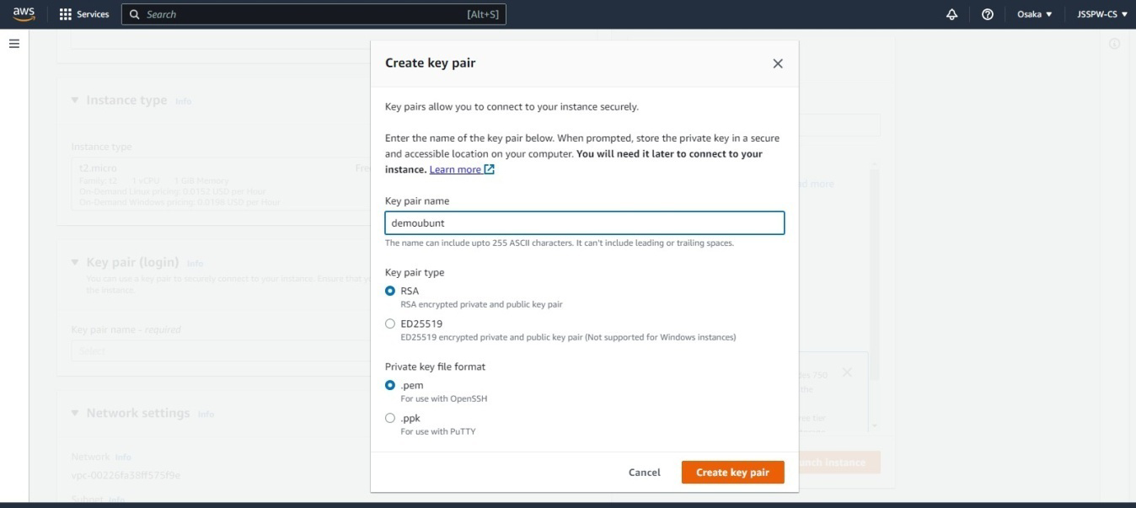

* Leave network settings as default
* Click on launch instance

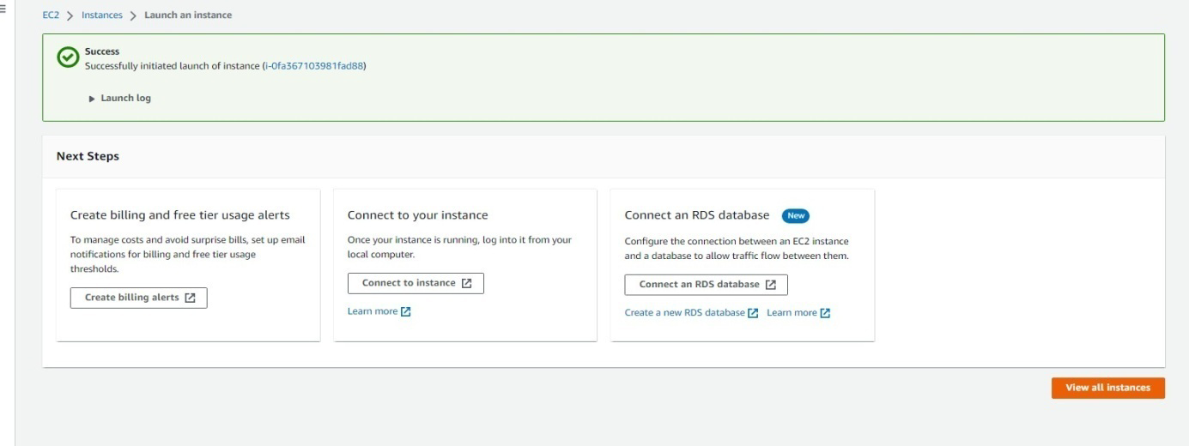

# Steps to add new security group

* Click on your instance
* Go to security tab
* Click on security group

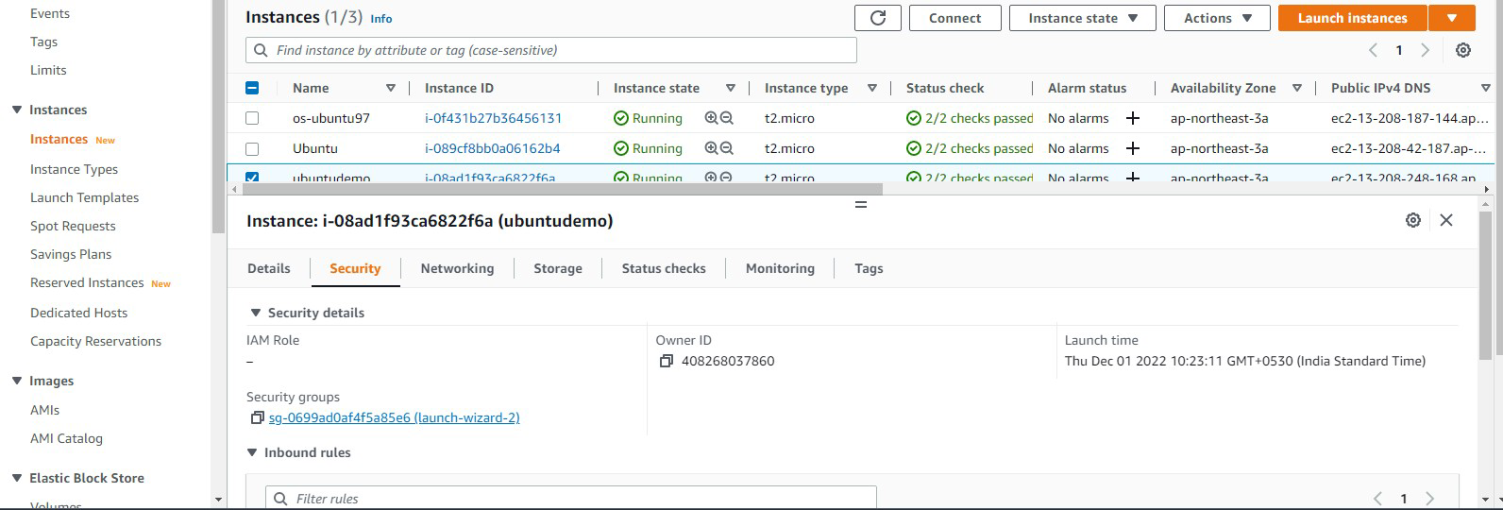

* Click on edit inbound rules
* Click on Add rules
* Specify security type (like HTTP ,HTTPs ,SSH),Port number And Click on save rules.

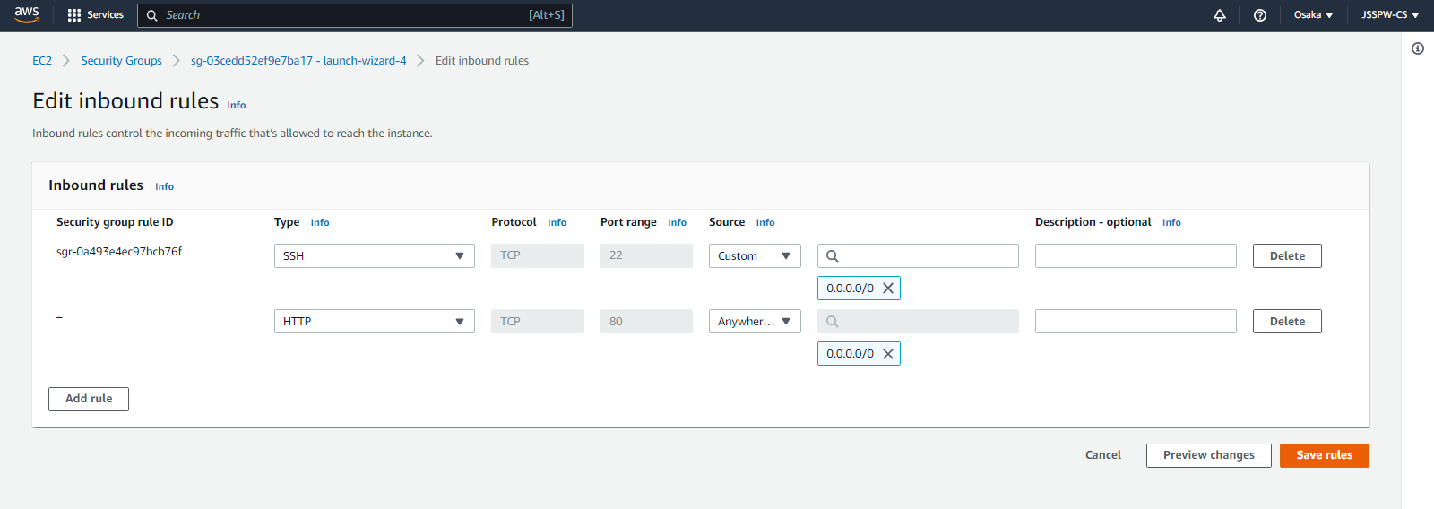

# Steps to Access Ubuntu Server

* Select your instance and click on connect
* Go to SSH Client
* Open GitBash(If your using Windows) OR
* Open Terminal( If your using Linux)
* Enter to the path where key-pair file is available using cd command
* Change the permission of private key file
* Enter the command to connect to the ubuntu server (command will be available in SSH client AWS)
* After Connecting to Ubuntu server you need to install Apache2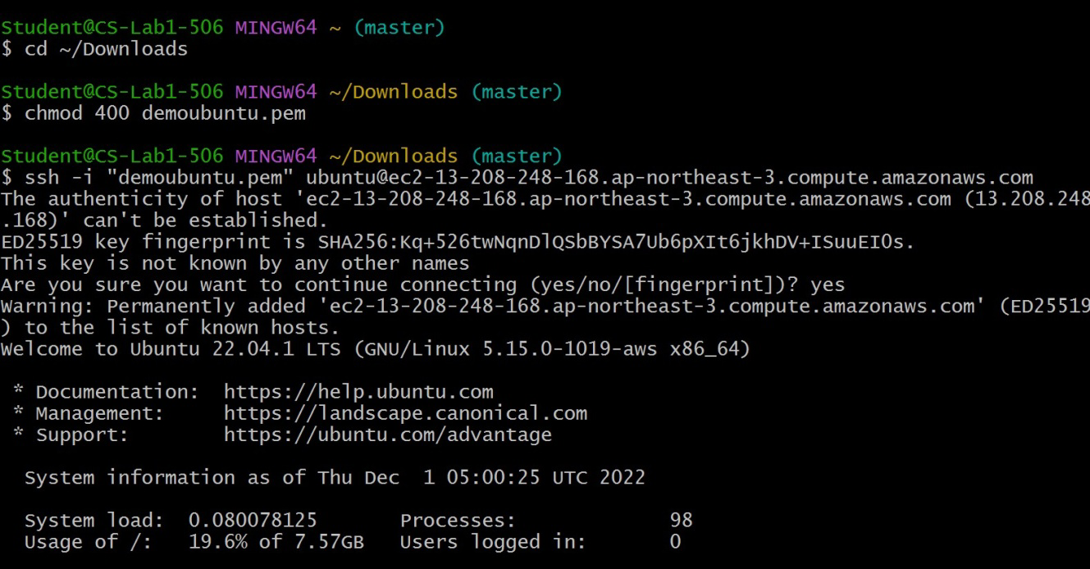
* Command: sudo apt-get install apache2

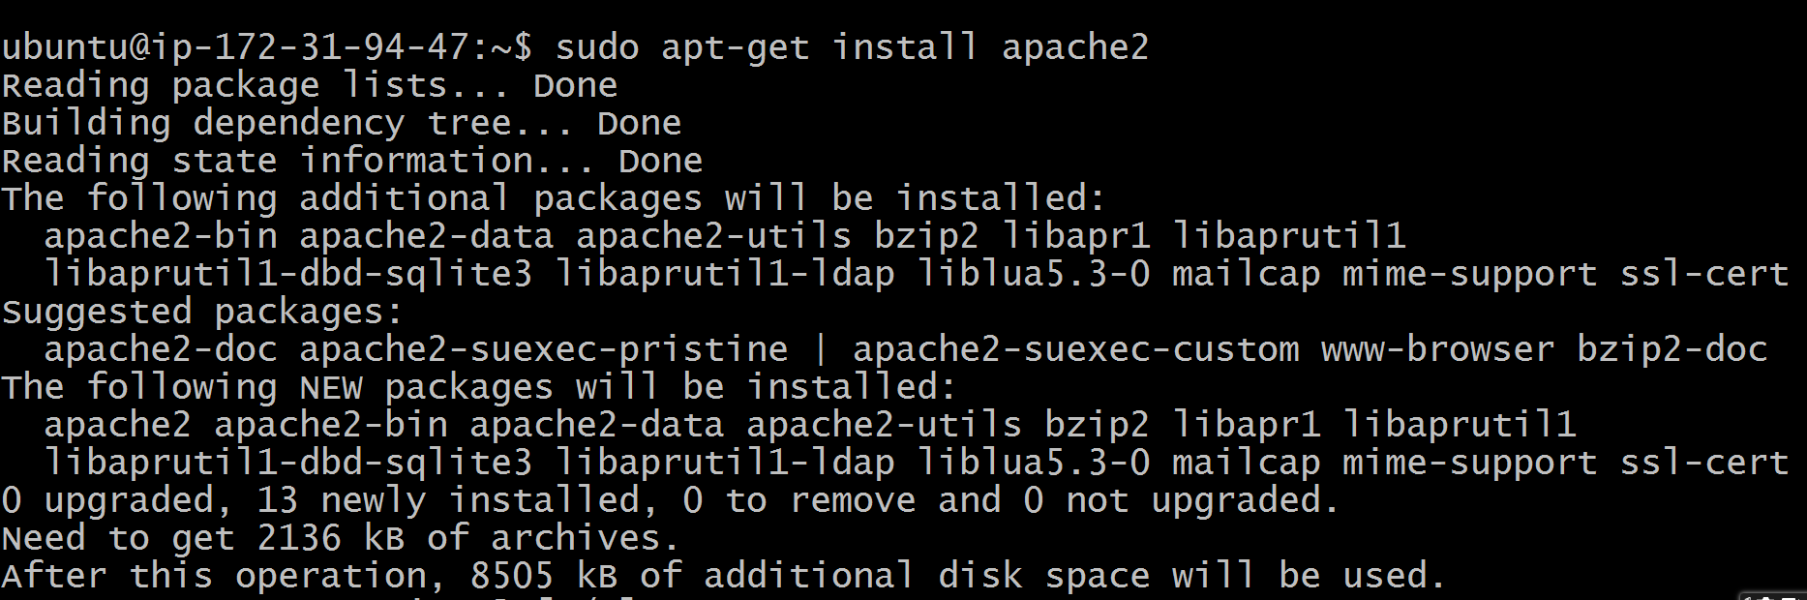

* Go to default path.

Command :cd /var/www/html/

* Enter ls command to list the files.
* Edit the index.html and save the changes.

Command :sudo vi index.html

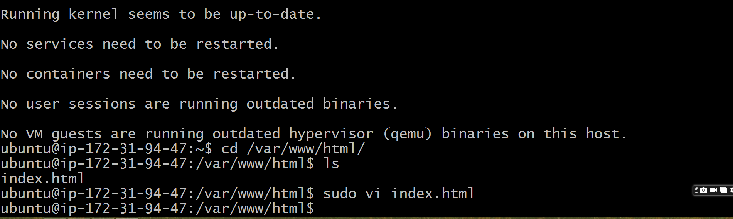

**To Run file:**

* Open the Google Chrome.
* Enter the public Ip address.

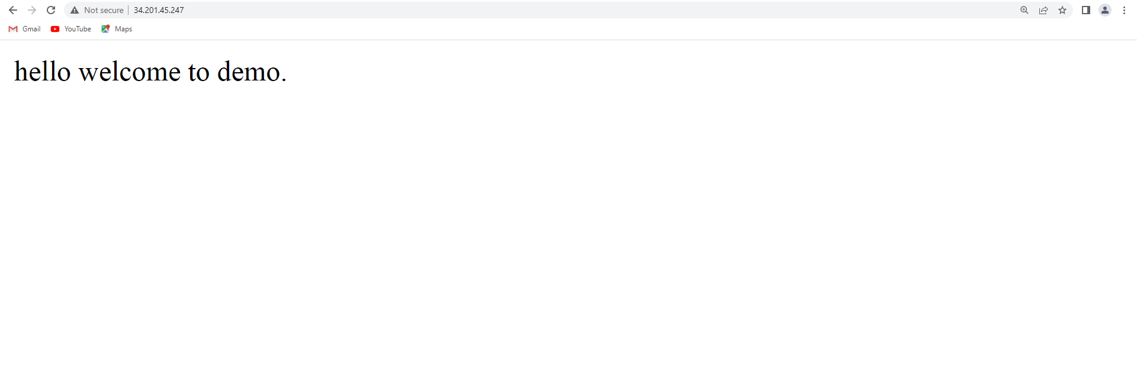

**Activity:-06**

**Create job and built it using Jenkins**

### Step 1:

1. Install Jenkins on your machine. This can be done by downloading the Jenkins war file from the Jenkins website (https://jenkins.io/) and running it using the Java command.
2. Start the Jenkins server and access the Jenkins dashboard using a web browser. The default URL is <http://localhost:8080>.
3. Login to your jenkins account
4. Click the New Item link on the left-hand side of the Jenkins dashboard.

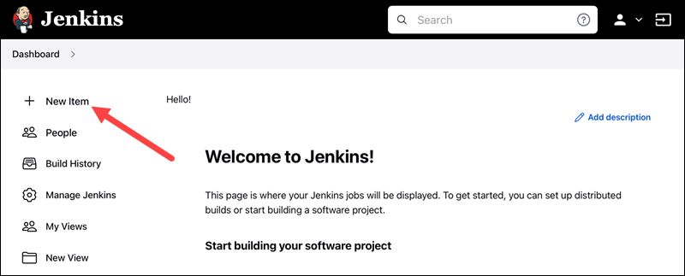

2. Enter the new project's name in the Enter an item name field and select the Freestyle project type. Click OK to continue.

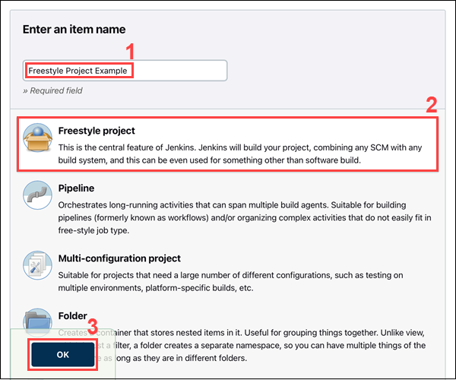

3. Under the General tab, add a project description in the Description field.

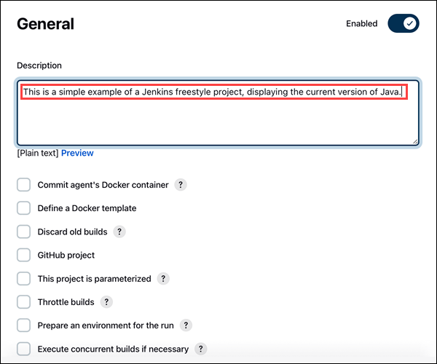

### Step 2: Add a Build Step

1. Scroll down to the Build section.

2. Open the Add build step drop-down menu and select Execute Windows batch command.

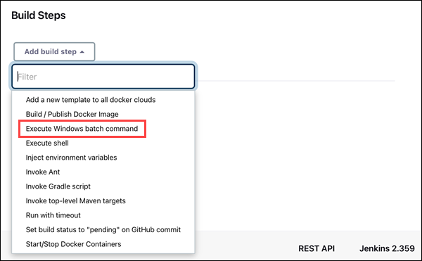

3. Enter the commands you want to execute in the Command field. For this tutorial, we are using a simple set of commands that display the current version of Java and Jenkins working directory:

* java -version
* dir

4. Click the Save button to save changes to the project.

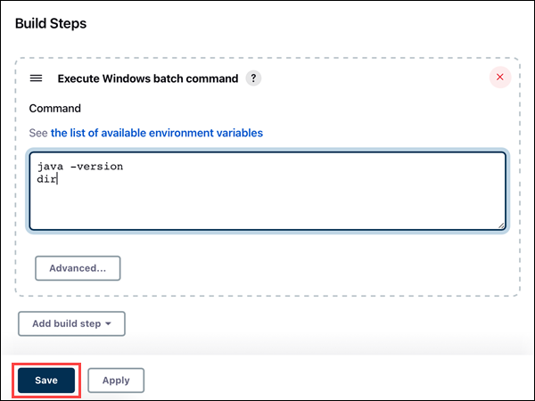

### Step 3: Build the Project

1. Click the Build Now link on the left-hand side of the new project page.

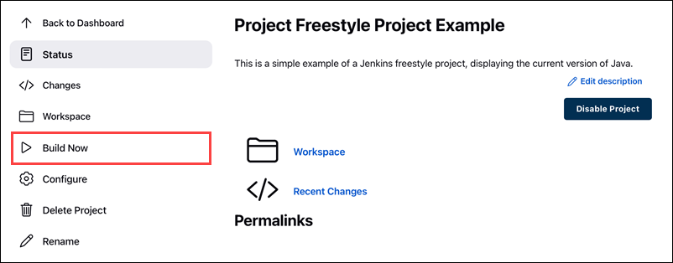

2. Click the link to the latest project build in the Build History section.

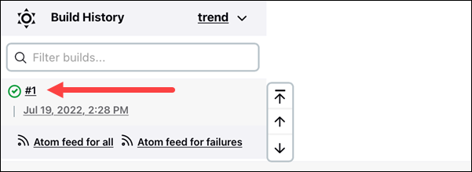

3. Click the Console Output link on the left-hand side to display the output for the commands you entered.

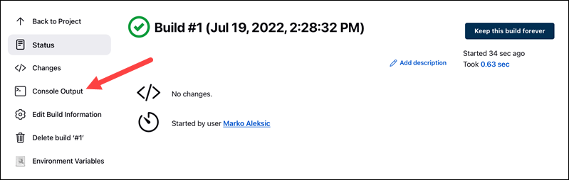

4. The console output indicates that Jenkins is successfully executing the commands, displaying the current version of Java and Jenkins working directory.

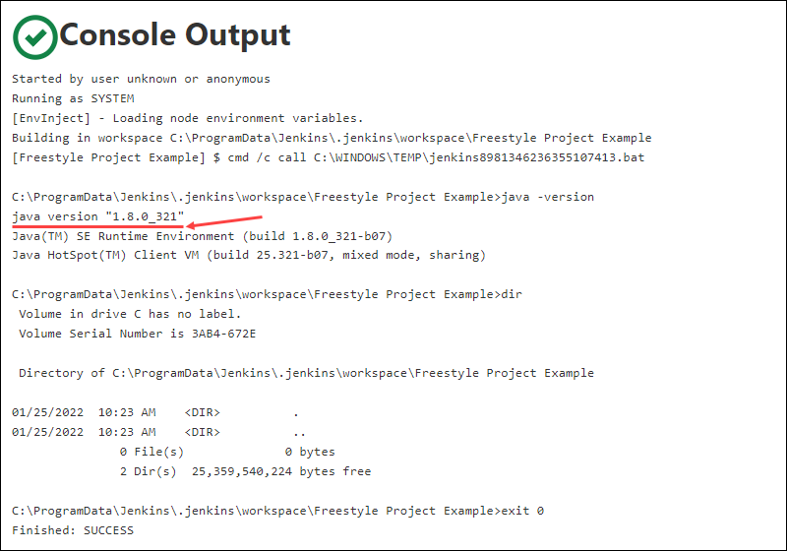

**Activity:-07**

**Create and build pipeline job using Jenkins**

Step1: click on new to create pipeline job

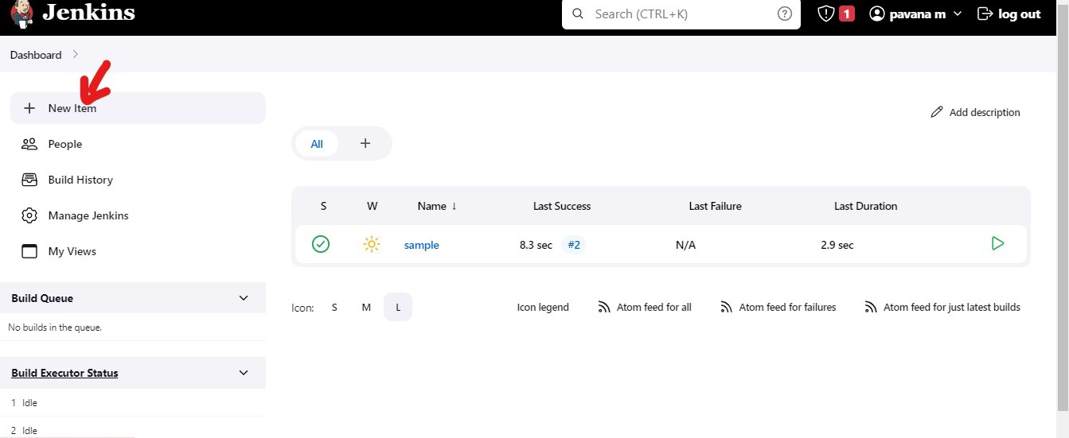

Step2: Give the name of the job

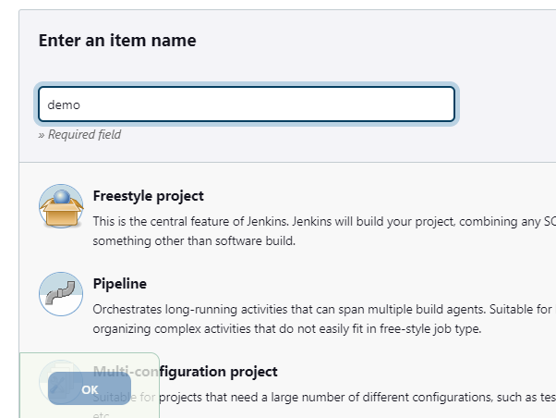

Step3: Select pipeline option to build pipeline job and click ok

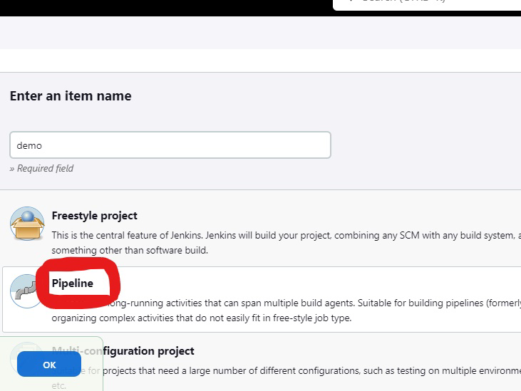

Then the below screen appears

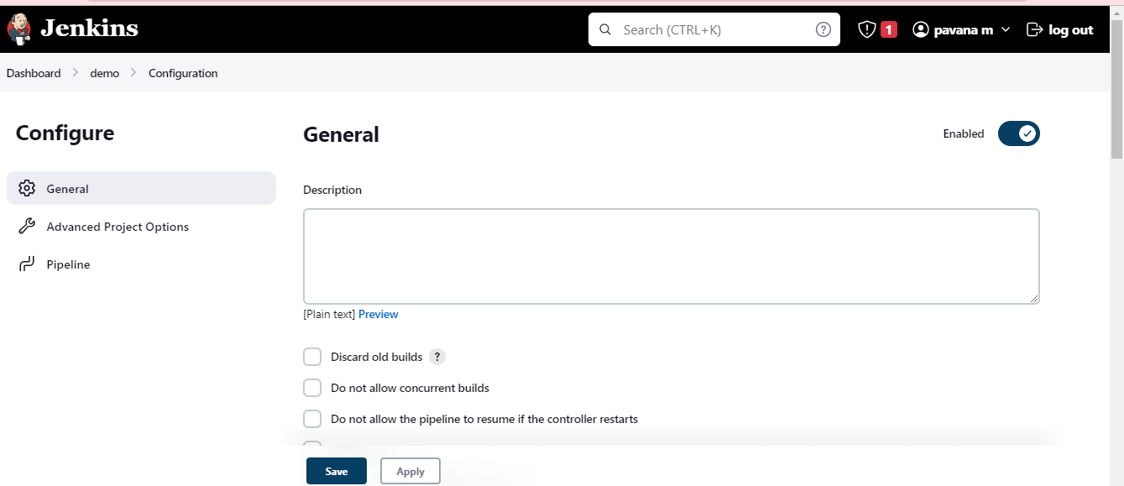

Step4:give the description for the job

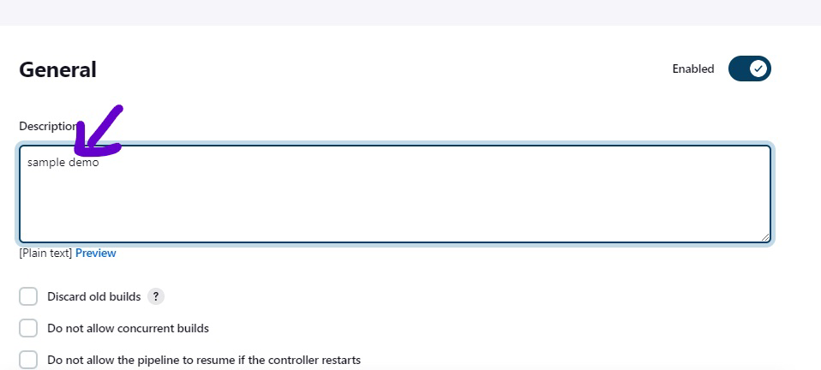

Step5:Give information about when to build job

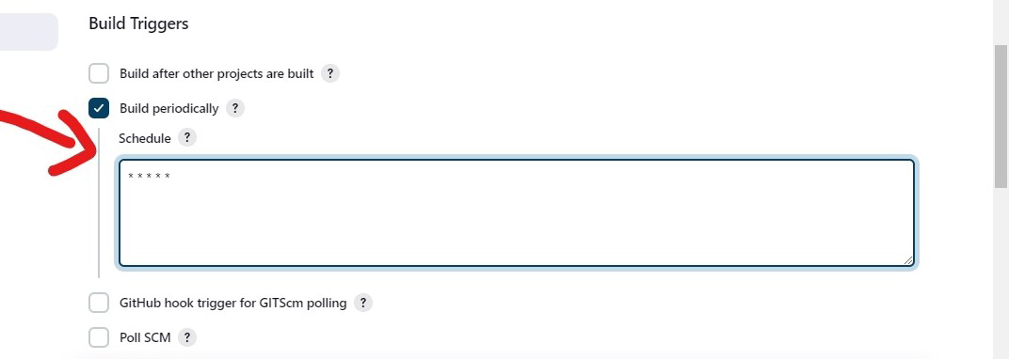

Write the script

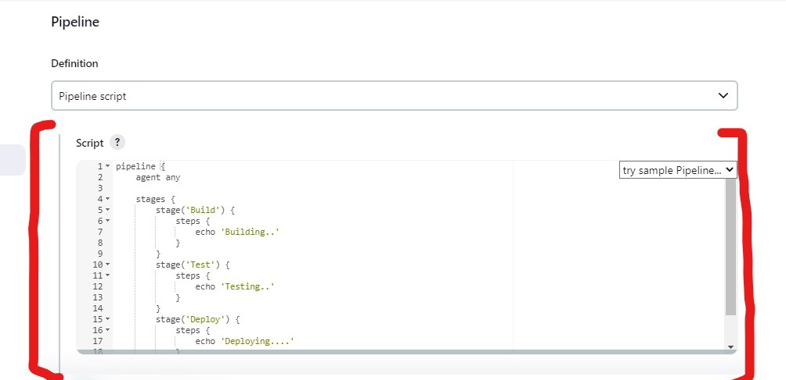

And click on save

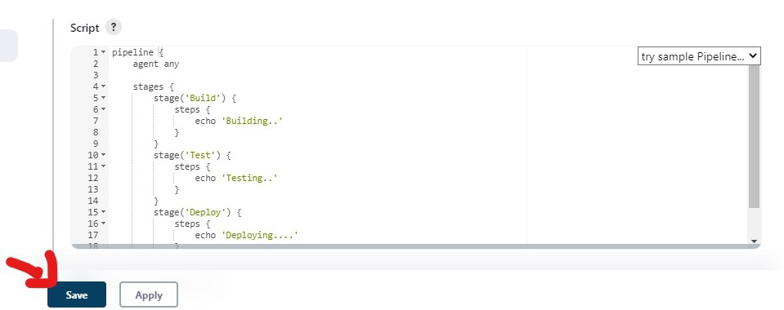

Step 6:Job is running 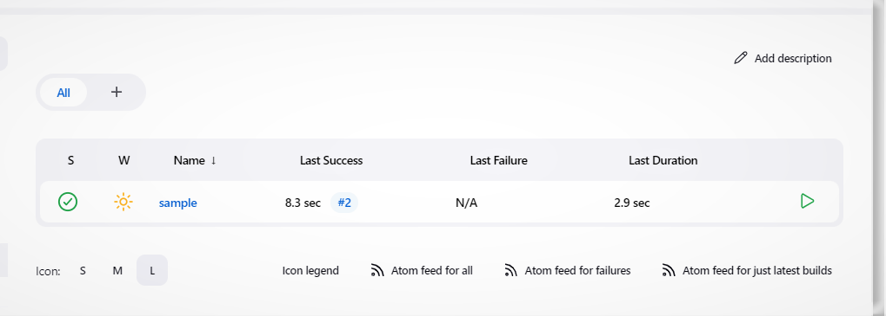

Step 7:click on console to see the output

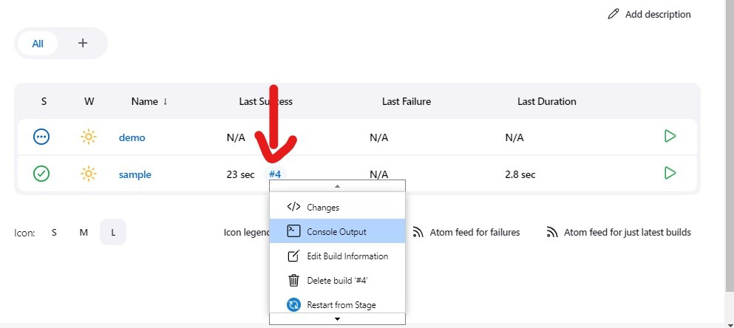

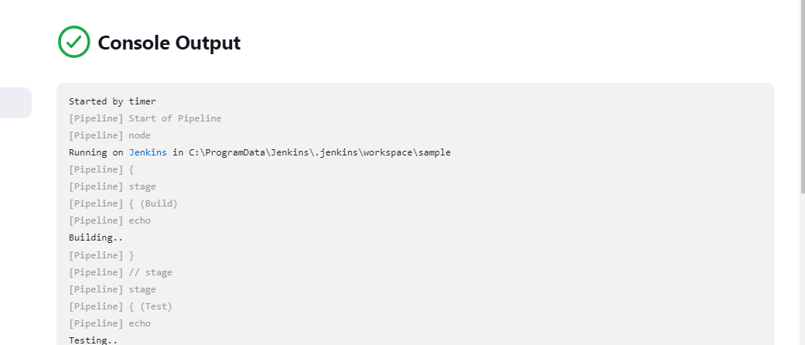

**Activity:-08**

**Create a form like registration form and feedback form after submit hide created form and enable the display section.**

**Form.html**

Code:

<!DOCTYPE html>

<html lang="en">

<head>

    <title>Registration Form</title>

    <style>

        h1 {

            text-align: center;

            font-family: 'Times New Roman', Times, serif;

            background-color: rgb(216, 186, 220);

        }

        body {

            /* background-color:rgba(162, 237, 240, 0.905); */

            background-color: rgb(0, 0, 0);

            /* background-image:url(giphy\ \(1\).gif ); */

            background-position: right;

            background-attachment: fixed;

            background-repeat: no-repeat;

            font-size: 26px;

            /* text-align: center; */

            font-family: 'Times New Roman', Times, serif;

        }

        .form1 {

            border-style: solid;

            background-color: rgb(161, 239, 245);

            padding: 90px;

            margin: auto;

            text-align: center;

            max-width: 500px;

        }

        #sub {

            font-size: 24px;

            font-family: 'Times New Roman', Times, serif;

        }

        div.chk {

            text-align: left;

        }

        div.dep{

            text-align: left;

        }

        #p1 {

            font-size: 28px;

            background-color: rgb(216, 186, 220);

        }

        sub{font-size: 26px;

        font-family: 'Times New Roman', Times, serif;}

    </style>

</head>

<body>

    <div class="form1">

            <h1>Registration Form</h1>

            <h2>Contact Information</h2>

            <label>Enter the first Name: </label>

            <input type="text"id="name"required></p>

            <label>Enter the last Name: </label>

            <input type="text"id="lname"required></p>

            <label>Enter the Register Number: </label>

            <input type="number"id="rname"required></p>

            <label>Enter the Email: </label>

            <input type="email"id="ename"required></p>

            <p>Gender :

                Male <input type="radio"name="gender"id=""required>

                Female <input type="radio"name="gender"id=""required></p>

            <label>Address</label>

            <textarea name="Address"id="Address"required></textarea>

            <br>

            <pid="p1"><b>Select Your Department :</b></p>

            <div class="dep">

            <br><input type="radio"name="dep"required> CSE <br>

            <br><input  name="dep"type="radio"required> IS <br>

            <br><input type="radio"  name="dep"required> Architecture <br>

            <br><input type="radio"name="dep"required> CP <br>

            <br><input type="radio"name="dep"required> ADFT <br>

            <br><input type="radio"name="dep"required> EC <br>

            </div>

            <hr>

            <pid="p1"><b>Select your Hobbies</b></p>

            <div class="chk">

                <input type="checkbox"id="chkc1"/> Playing Outdoor <br><br>

                <input type="checkbox"id="chkc2"/> Playing indoor games <br><br>

                <input type="checkbox"id="chkc3"/> Reading Fiction Books <br><br>

                <input type="checkbox"id="chkc4"/> Gardening <br><br>

                <input type="checkbox"id="chkc4"/> Self Care <br><br>

                <input type="checkbox"id="chkc4"/> Listening to Music <br><br>

            </div>

            <pid="p1"><b>Select Your Semester :</b></p>

            <select name="select sem"id="sem"required>

                <option value="">---Select The Semester---</option>

                <option value="1st">1st Sem</option>

                <option value="2nd">2nd Sem</option>

                <option value="3rd">3rd Sem</option>

                <option value="4th">4th Sem</option>

                <option value="5th">5th Sem</option>

                <option value="6th">6th Sem</option>

            </select>

            <hr>

            <pid="p1"><b>Activities that you are Participating in collage</b></p>

            <div class="chk">

                <input type="checkbox" id="chk1"/>NCC <br><br>

                <input type="checkbox" id="chk2"/>NSS <br><br>

                <input type="checkbox" id="chk3"/>Cultural <br><br>

                <input type="checkbox" id="chk4"/>Indoor Sports <br><br>

                <input type="checkbox" id="chk4"/>Outdoor Sports<br><br>

                <input type="checkbox" id="chk4"/>Debetting and seminars <br><br>

            </div>

        <form action="thank.html">

            <center><input type="submit" value="Submit" id="sub"></center>

        </form>

</body>

</html>

**Thank.html**

<!DOCTYPE html>

<html lang="en">

<head>

    <title>Document</title>

    <style>

        body{background-color: rgb(255, 201, 165);}

    </style>

</head>

<body>

    <center><h1>You Are Registered</h1></center>

    <center><img src="done.gif" alt=""></center>

</body>

</html>

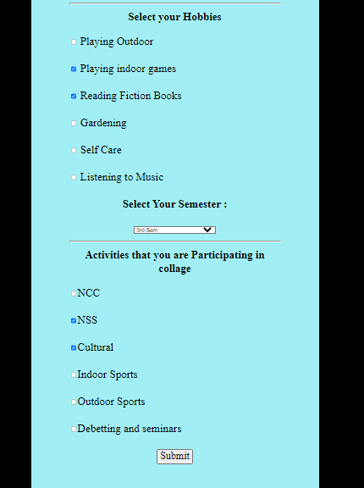**Output:**

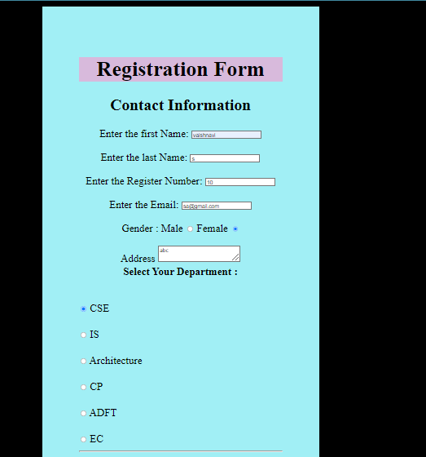

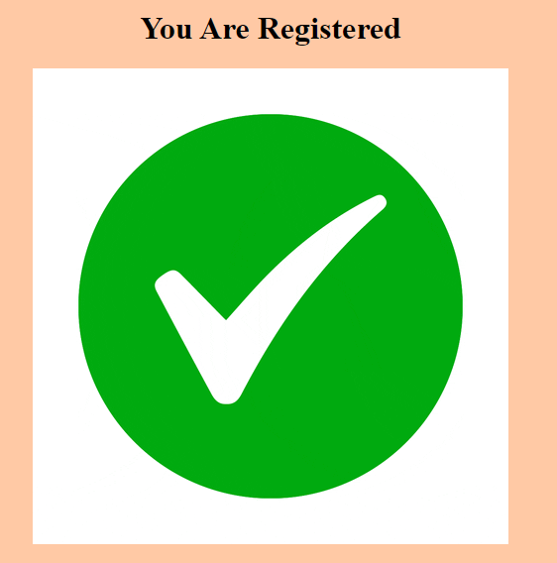

**Activity:-09**

**Create form validation using JavaScript**

**Example.html**

<html>

<body>

<script>

function validateform(){

var name=document.myform.name.value;

var password=document.myform.password.value;

if (name==null || name==""){

  alert("Name can't be blank");

  return false;

}else if(password.length<6){

  alert("Password must be at least 6 characters long.");

  return false;

  }

 }

</script>

<body>

<form name="myform" method="post" action="Index.html" onsubmit="return validateform()" >

Name: <input type="text" name="name"><br/><br>

Password: <input type="password" name="password"><br/>  <br>

<input type="submit" value="register">

</form>

</body>

</html>

**Index.html**

<!DOCTYPE html>

<html lang="en">

<head>

    <meta charset="UTF-8">

    <meta http-equiv="X-UA-Compatible" content="IE=edge">

    <meta name="viewport" content="width=device-width, initial-scale=1.0">

    <title>Document</title>

</head>

<body>

    <h1>Thank you!!.. </h1>

</body>

</html>

**OUTPUT : Example.html**

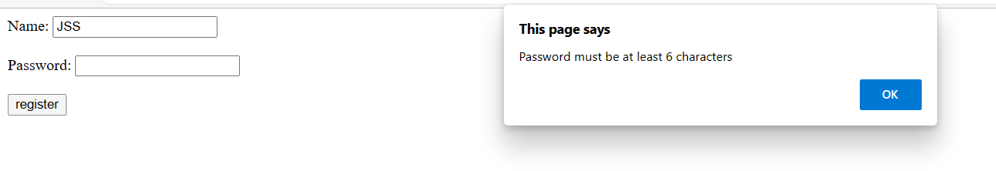

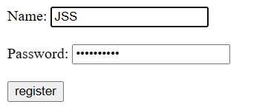

**OUTPUT:Index.html**

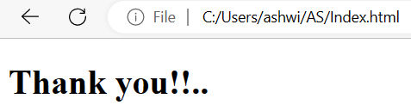

**Activity:-10**

**Create a simple hello world application using Typescript.**

**Tools used:**

* Node.js
* Visual Studio Code

**Prerequisites**

* Install Node.js
* Install VS Code

**Steps to create a simple hello world application :**

* Open Node.js command prompt
* In Node.js command prompt, check the node version as shown in the image
* Install the typescript the command to install this **npm install –g typescript**
* Check the tsc version

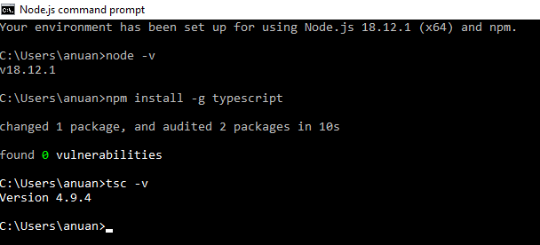

* Create a folder → open the folder in vs code.
* In vs code →click on file→ click on open folder→ select the folder.

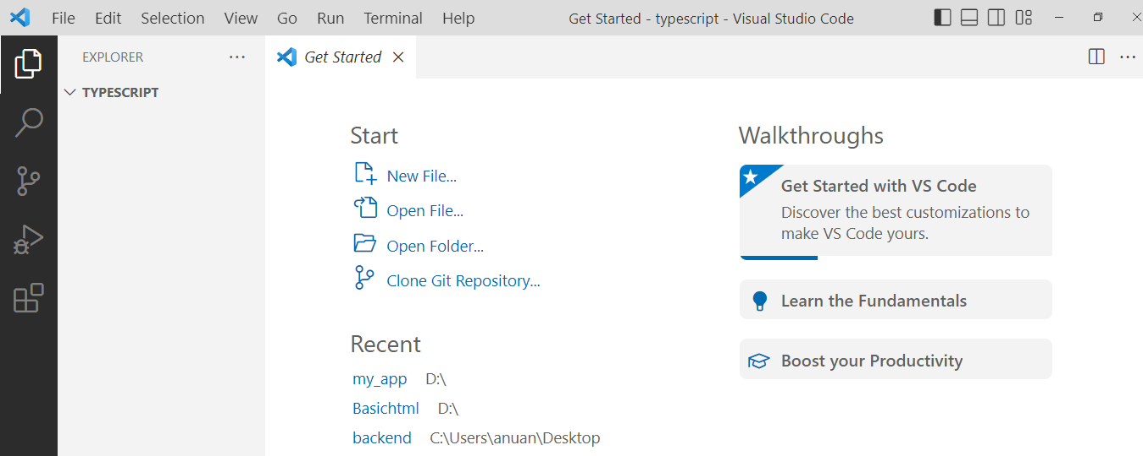

* Create a file in vs code→ right click on selected folder→ click on new file→ give the file name with extension **.ts** .

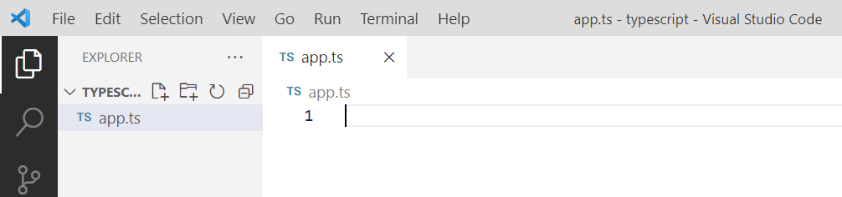

* Write the hello world program.

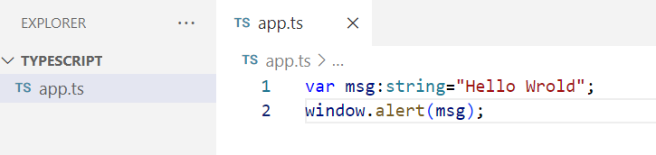

* Open terminal→ tsc file name.ts → Set –ExecutionPolicy –Scope Process –ExecutionPolicy Bypass (to give the permission to convert the typescript file to java script) →tsc filename.ts.

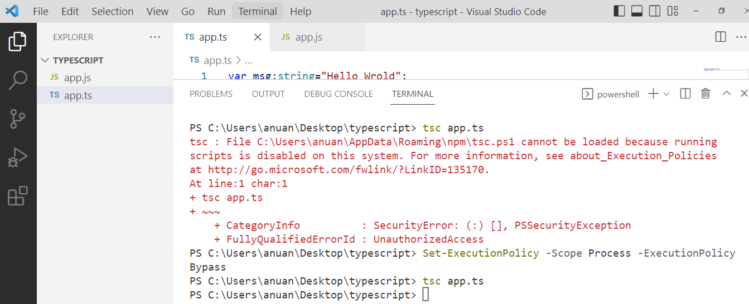

By default the app.js file will be created after executing this above command.

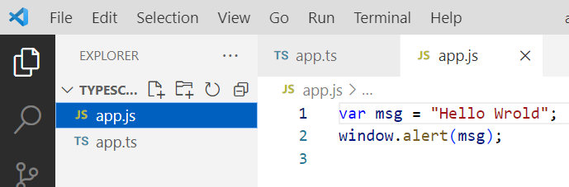

* Create a html file on the same folder→ right click on selected folder→ click on new file→ give the file name with extension **.html**
* Then**,** import the app.js in html file.

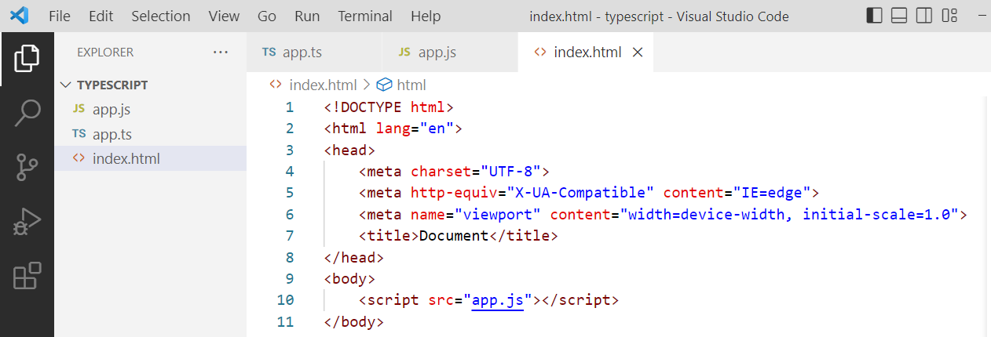

Run the html file.

**Output**

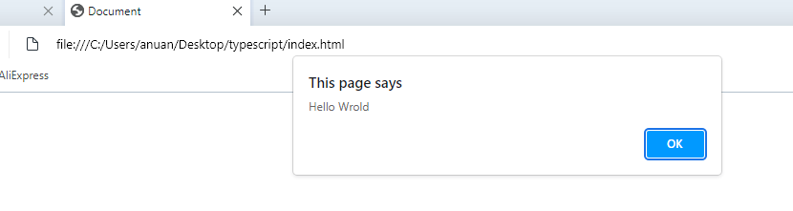

**Activity:-11**

**Create a simple login page using React**

**Folder structure:**

**Src:**

App.css

Home.js

index.js

**Note: Add Home.js file in index.js files**

**Index.js**

<Home />

**Home.js**

import { useState } from 'react';

import './App.css';

export default function Form()

{

// States for registration

const [name, setName] = useState('');

const [email, setEmail] = useState('');

const [password, setPassword] = useState('');

const [submitted, setSubmitted] = useState(false);

const handleName = (e) => {

setName(e.target.value);

};

const handleEmail = (e) => {

setEmail(e.target.value);

};

const handlePassword = (e) => {

setPassword(e.target.value);

};

const handleSubmit = (e) => {

e.preventDefault();

if (name === '' || email === '' || password === '') {

alert("Please enter all the fields");

} else {

setSubmitted(true);

}

};

// Showing success messages

const successMessage = () => {

if(submitted)

return (

<div className="success" >

<h1>User {name} successfully singed in!!</h1>

</div>

);

};

return (

<div className="form">

<div>

<h1>User Login</h1>

</div>

{/* Calling to the methods */}

<div className="messages">

{successMessage()}

</div>

<form>

<fieldset>

{/* Labels and inputs for form data */}

<label className="label">Name</label>

<input onChange={handleName} className="input" value={name} type="text"

/><br></br>

<label className="label">Email</label>

<input onChange={handleEmail} className="input" value={email} type="email"

/><br></br>

<label className="label">Password</label>

<input onChange={handlePassword} className="input" value={password}

type="password" /><br></br>

<button onClick={handleSubmit} className="btn" type="submit">

Login

</button>

</fieldset>

</form>

</div>

);

}

**App.css**

.input {

width: 30%;

padding: 12px 20px;

margin: 8px 0;

display: inline-block;

border: 1px solid #ccc;

border-radius: 4px;

box-sizing: border-box;

}

**Output :**

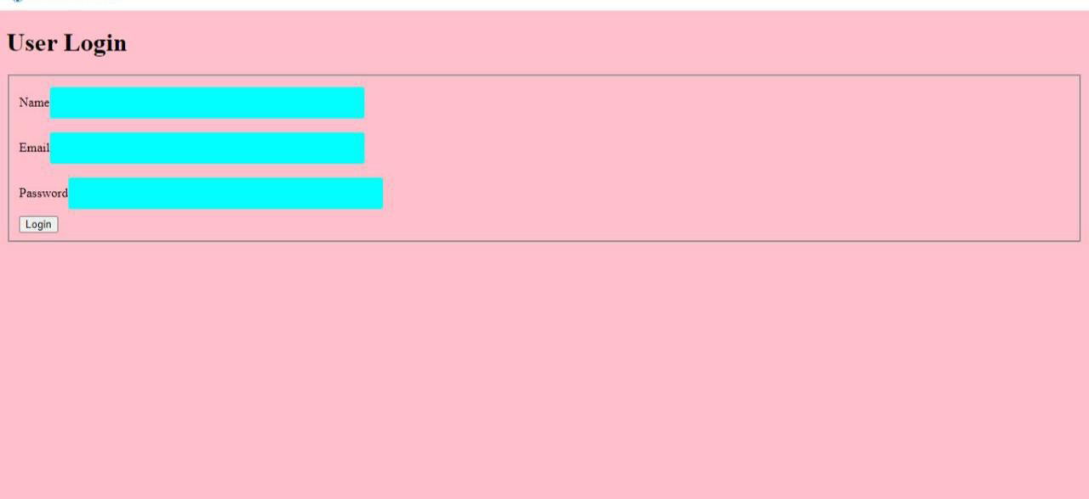

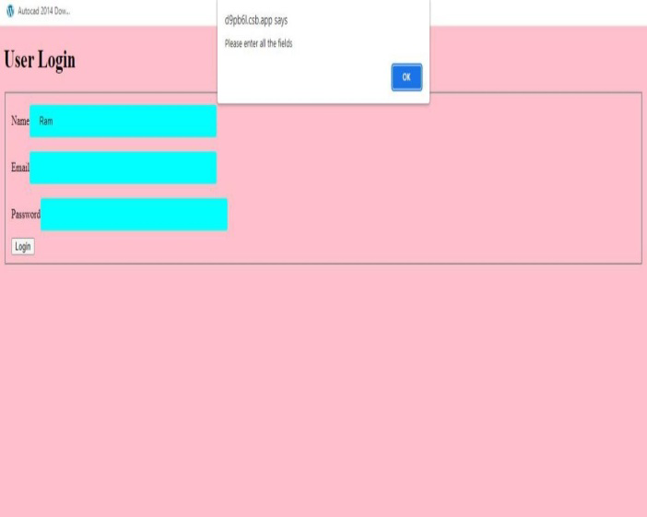

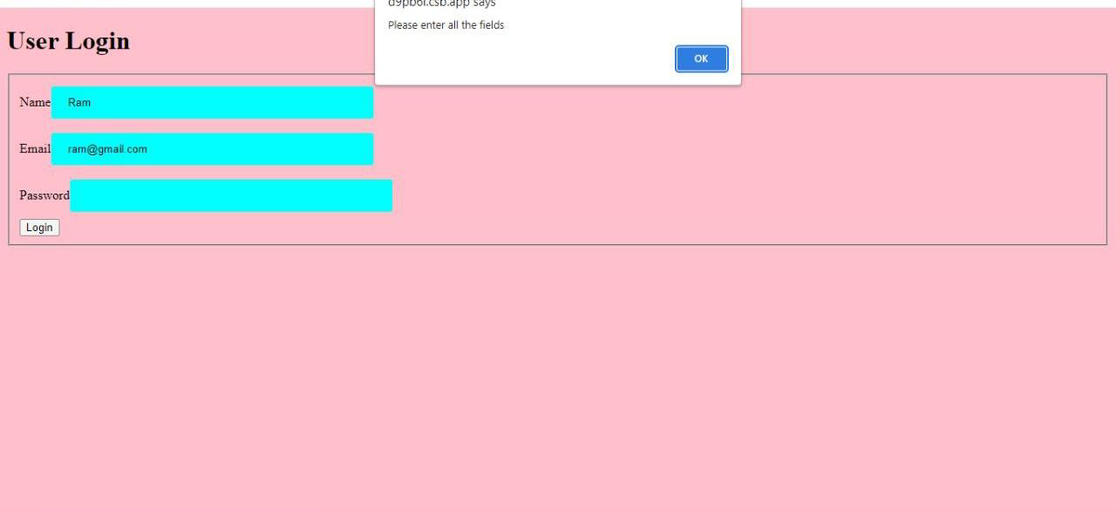

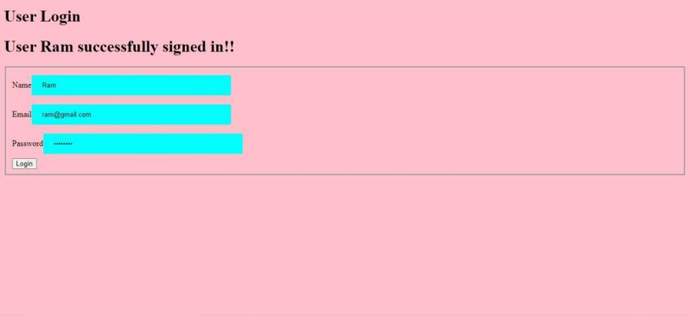

**Activity:-12**

**Create a maven project and Create JPA class using maven**

**We need to follow the below steps to create a Maven project in Eclipse:**

* 1. Open the Eclipse and **Go to File -> New -> Others**.

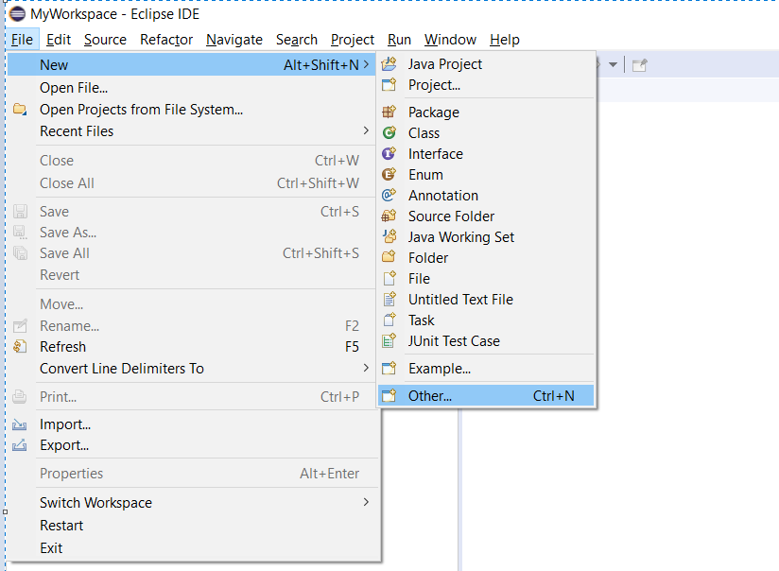

2) Select **Maven Project** and click on **Next**.

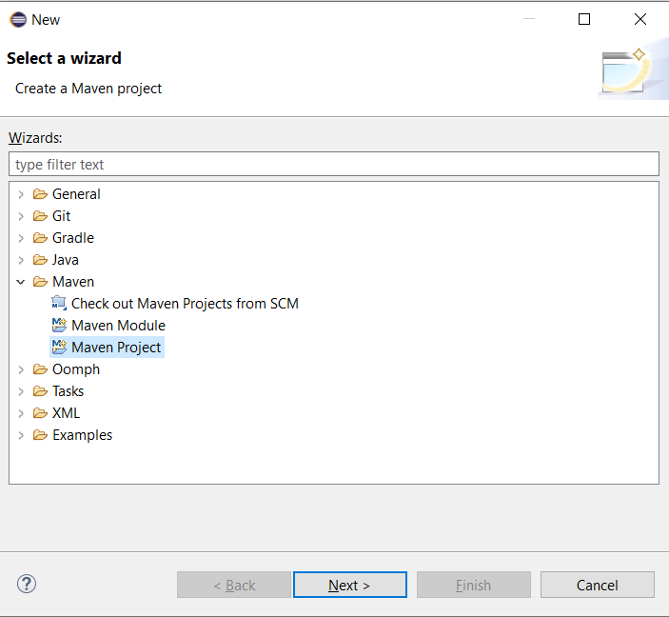

3) If you do not want to create your maven project on default Workspace then Uncheck the “**Use default Workspace location”**checkbox option and with the help of the **Browse** button choose your workspace where you would want to create your Maven project.

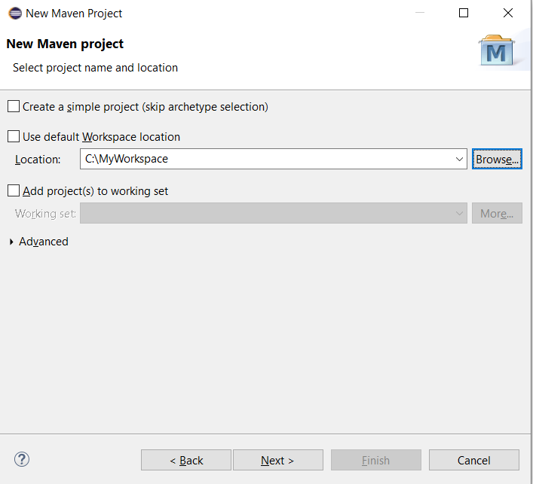

4) Select the **archetype** for this demo just select the ‘**maven-aechetype-quickstart**‘ and click on **Next**.

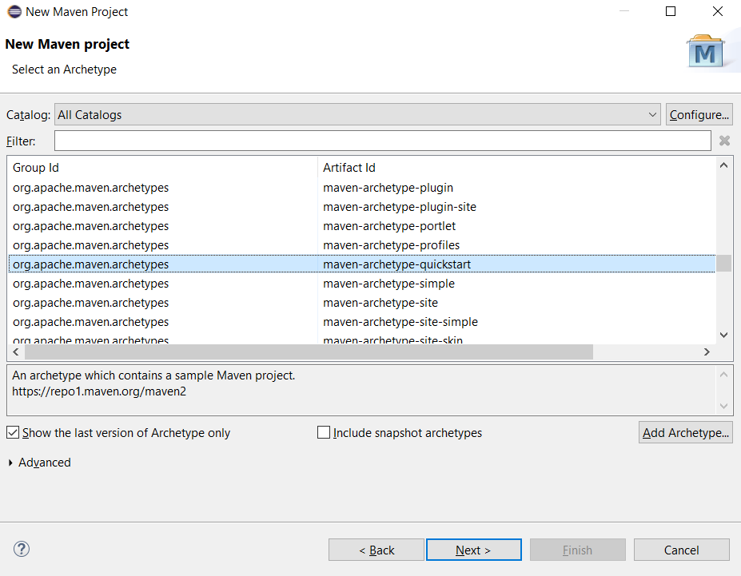

5) Specify the **Group Id** and **Artifact Id** and click on **Finish**.

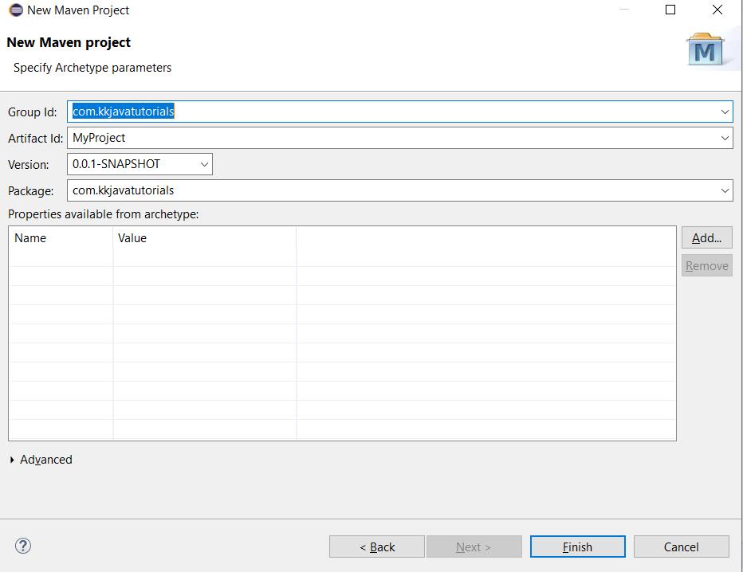

**Note:** Here the ‘**artifactId**‘ is nothing but your project name.

6) Now You can see the maven project is created in Eclipse. Now open the **pom.xml**file, which resides in the project root directory. By default the POM is generated like this:

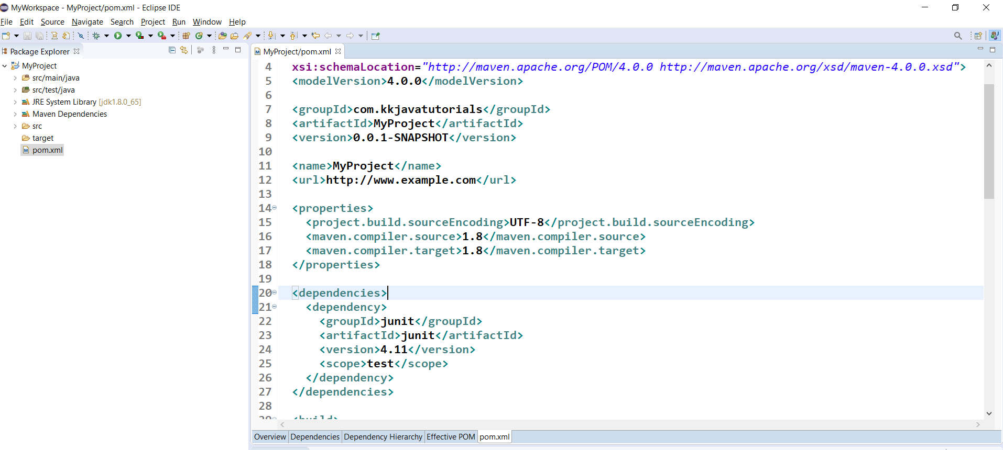

7) Look at the default maven project structure

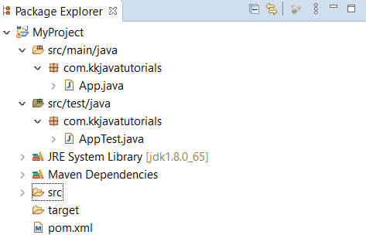

**Note:**Junit Test cases usually reside under the src -> test -> java > PackageName(**com.kkjavatutorials**) will only be considered as a test by Maven. The rest of the test cases will be ignored in case if you keep your test cases in some other directory.

8) Modify pom.xml with the latest Junit maven dependencies and save the file.

We have to add these two JUnit Jupiter dependencies in **test**scope:

* The junit-jupiter-api (version 5.7.0). This dependency usually provides the public API for writing Junit tests and extensions.

The junit-jupiter-engine (version 5.7.0). This dependency basically contains the implementation of the JUnit Jupiter test engine that runs our unit tests.

**Create JPA class using maven**

**Tools used:**

* Eclipse
* Mysql
* Sqlyog

**Prerequisites**

* Install Eclipse
* Install Mysql
* Install Sqlyog
* Install Jboss on Eclipse

**Steps to create a maven project:**

* Open Eclipse
* Click on File → New → Project → Select Maven Project.
* Select an archetype for your maven project (Set internal as catalog and maven-quickstart as filter)
* Add MySQL and Hibernates in pom.xml

<dependency>

<groupId>org.hibernate</groupId>

<artifactId>hibernate-core</artifactId>

<version>5.6.14.Final</version>

<dependency>

<dependency>

<groupId>mysql</groupId>

<artifactId>mysql-connector-java</artifactId>

<version>5.1.49</version>

</dependency>

* Open SqlYog
* Enter the required Details i.e username ,password,address of mysql
* Right click on new connection tab → click on create database → Enter database name (For eg:Student_db)
* Double tap on database created → right click on tables
* Enter table fields(attributes) → click on create table – Enter table name (For eg:Student_details)

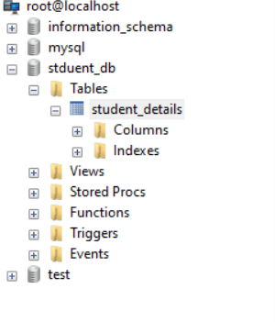

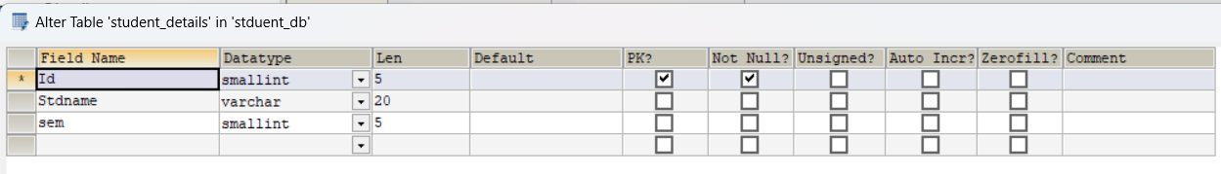

* Create a JPA class in Eclipse(Student.java)

| package com.demo.demo;  import javax.persistence.Id;  import javax.persistence.Column;  import javax.persistence.Entity;  import javax.persistence.Table;  @Entity  @Table(name="student_details")  public class Student1 {  @Id  @Column(name="Id")  private int id;    @Column(name="Stdname")  private String sname;    @Column(name="sem")  private int sem;  public int getId() {  return id;  }  public void setId(int id) {  this.id = id;  }  public String getSname() {  return sname;  }  public void setSname(String sname) {  this.sname = sname;  }  public int getSem() {  return sem;  }  public void setSem(int sem) {  this.sem = sem;  }  } |
| --- |

* Edit the existing App.java

| package com.demo.demo;  import org.hibernate.SessionFactory;  import org.hibernate.Transaction;  import org.hibernate.cfg.Configuration;  import org.hibernate.Query;  import org.hibernate.Session;  import java.util.List;  import java.util.Scanner;  public class App  {  public static void main( String[] args )  {  Configuration con=new Configuration().configure().addAnnotatedClass(Student1.class);  SessionFactory sf=con.buildSessionFactory();  Scanner scan=new Scanner(System.in);  Student1 obj=new Student1();  while(true) {  System.out.println("Enter 1 for Insertion ,2 for Deletion and 3 to Exit");  int i=Integer.parseInt(scan.next());  if(i==1)  {  Session s=sf.openSession();  Transaction tx=s.beginTransaction();  System.out.println("Enter the StudentID,StudentName and Sem");  obj.setId(Integer.parseInt(scan.next()));  obj.setSname(scan.next());  obj.setSem(Integer.parseInt(scan.next()));  s.save(obj);  tx.commit();  }  else if(i==2)  {  Session s=sf.openSession();  Transaction tx=s.beginTransaction();  System.out.println("Enter StudentId for deleting");  int pri=Integer.parseInt(scan.next());  obj =(Student1) s.get(Student1.class, pri);  s.delete(obj);  tx.commit();  }  else  {  break;  }  }  scan.close();  }  } |
| --- |

| Inputs | Outputs |
| --- | --- |
|  |  |
|  |  |

**Activity:-13**

**Create Spring application with Spring Initialize using dependencies like Spring Web**

Spring Boot helps developers create applications that just run. Specifically, it lets you create standalone applications that run on their own, without relying on an external web server, by embedding a web server such as Tomcat or Netty into your app during the initialization process.

To start spring application with spring initialize: go to the spring initialize or [start.spring.io](https://start.spring.io/) through Google.

# Spring Initialize:Spring Initialize is a Web-based tool that generates the [Spring Boot](https://www.geeksforgeeks.org/introduction-to-spring-boot/) project structure. Modern IDE have integrated Spring Initialize that provides the initial project structure. It is very easy for the developers to select the necessary configuration for their projects.

**Spring application with Spring Initialize:**

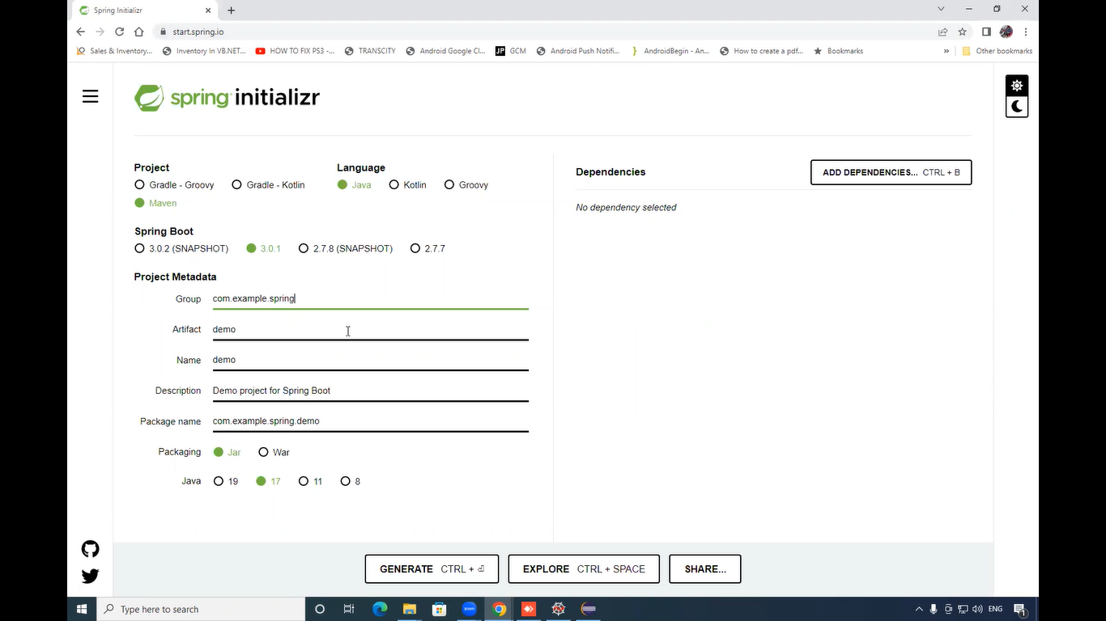

The Spring Initialize UI has the following options,

* **Project:**Using this one can create [Maven or Gradle](https://www.geeksforgeeks.org/difference-between-gradle-and-maven/) project Maven or Gradle can be used as a build tool. The default option is Maven Project.
* **Language:**Spring Initialize provide [Java](https://www.geeksforgeeks.org/java/), [Kotlin](https://www.geeksforgeeks.org/kotlin-programming-language/) and Groovy as a programming language for the project. You need to select java.
* **Spring Boot Version:**Using this can select the Spring Boot version for their project. Spring Boot latest Version is 2.5.0. The SNAPSHOT versions are under development and are not stable.
* **Project Dependencies:**Dependencies are artifacts that we can add to the project. I am selecting Web spring.
* **Project Metadata:**It is the information about the project.

Information in the metadata does include below key points:

* **Group ID:**It is the ID of the project group.
* **Artifact:** It is the name of the Application.
* **Name:** Application name.
* **Description:** About the project.
* **Package name:** It is the combination of Group and Artifact Id.
* **Packaging:** Using this Jar or War packaging can be selected.

1. Adding dependencies:

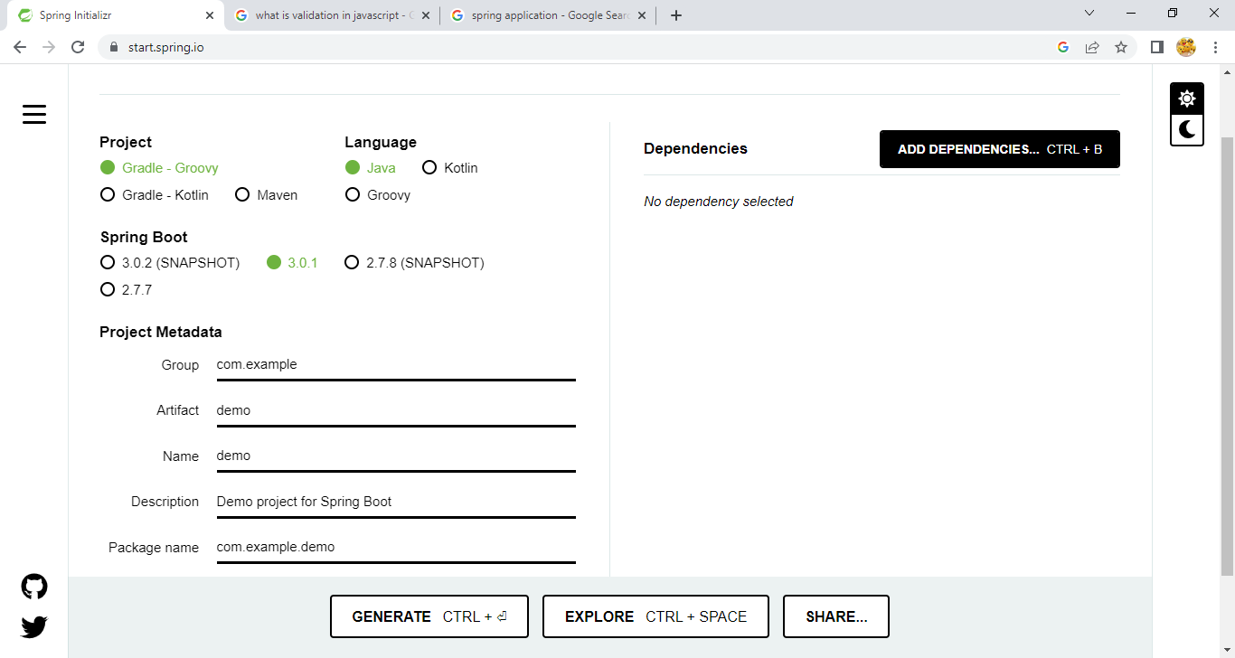

1. Click on add dependencies . Then select which one you need to add.here we add spring web.

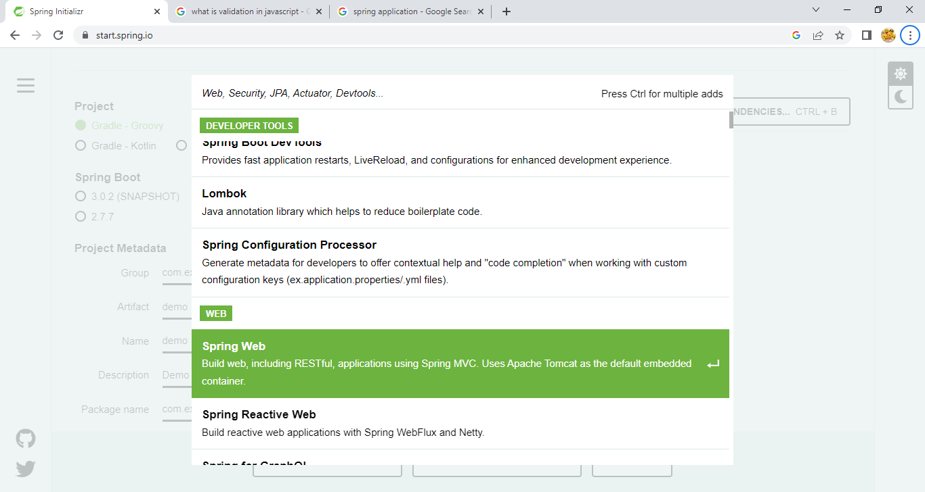

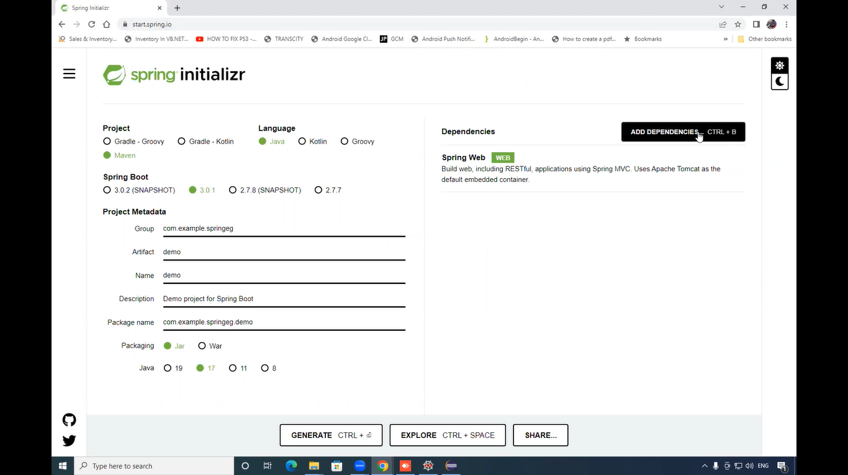

1. Than the dependencies add to your project. After that click on generate.
2. The file is generated in zip form we need unzip that file.for that right click on the file than select extract all.
3. 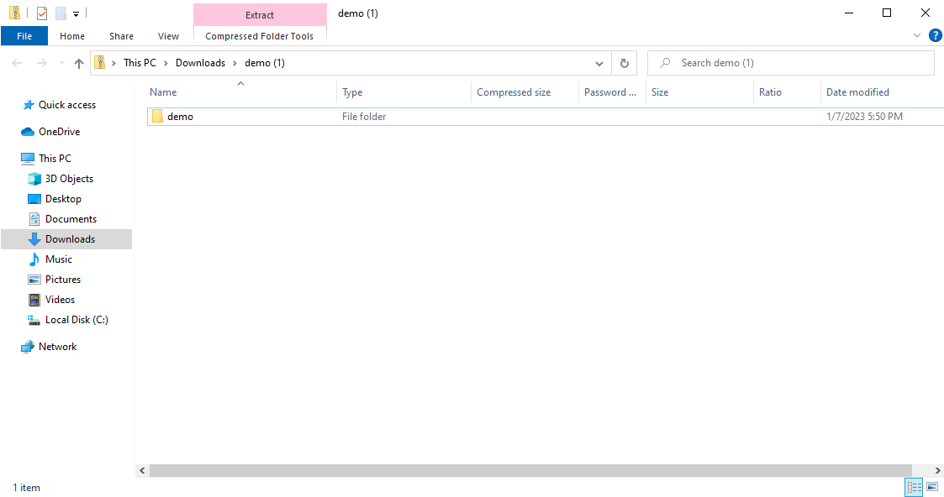

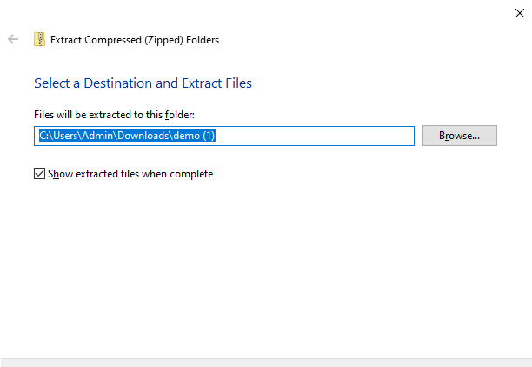

1. Import your spring initialize file in eclipse.
2. To open your file in eclipse click on files then select open project from file system.after that click on directory. select your file path then click on finish.

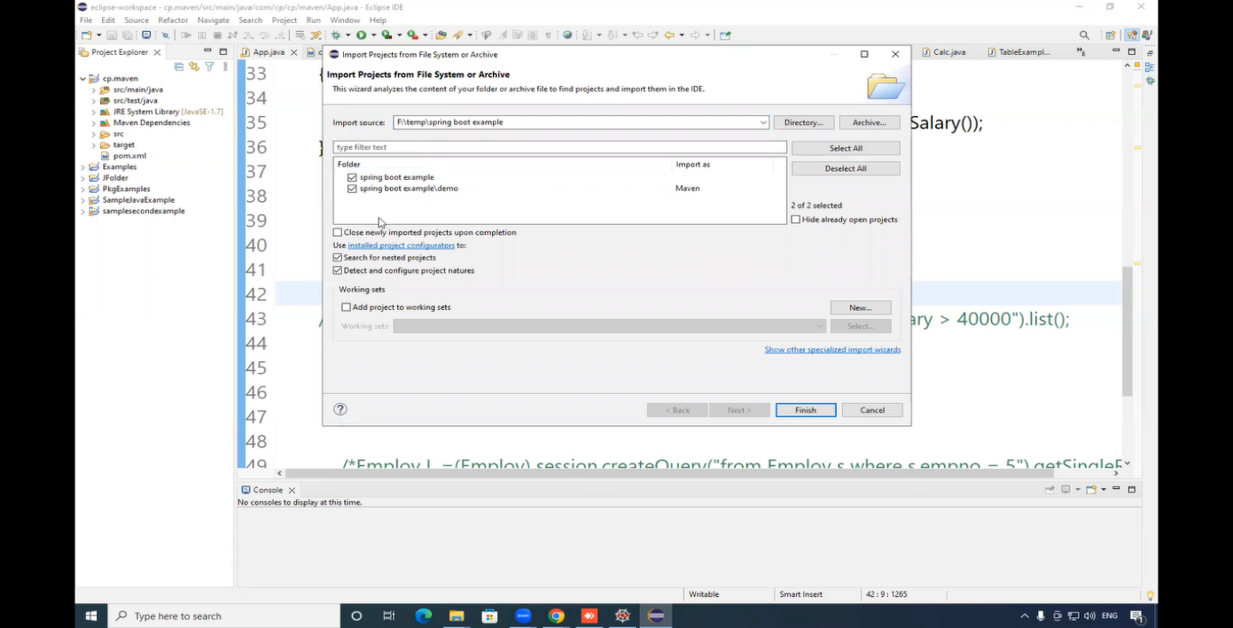

1. After that click pom.file for update the dependencies and add the necessary jar files.

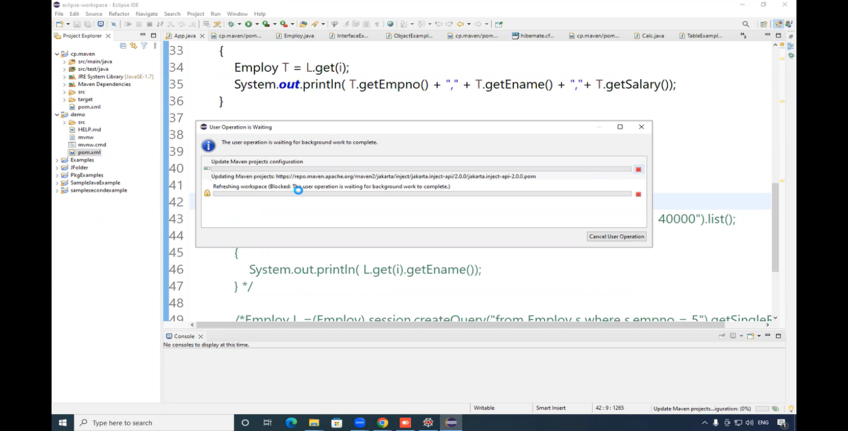

1. Now your project is created .if you go to the source you can see the created application.here Demo application is created.

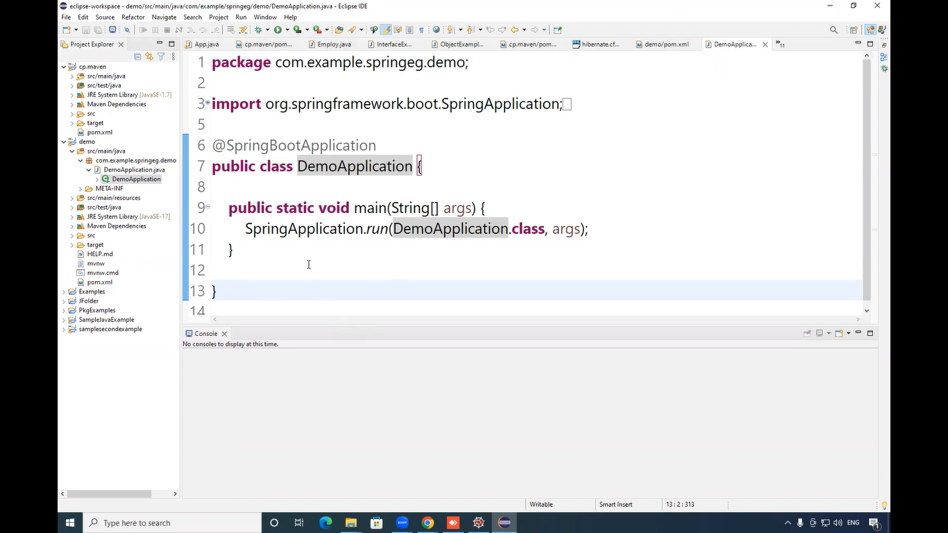

1. To make this application create class in your project here we create class called controller.

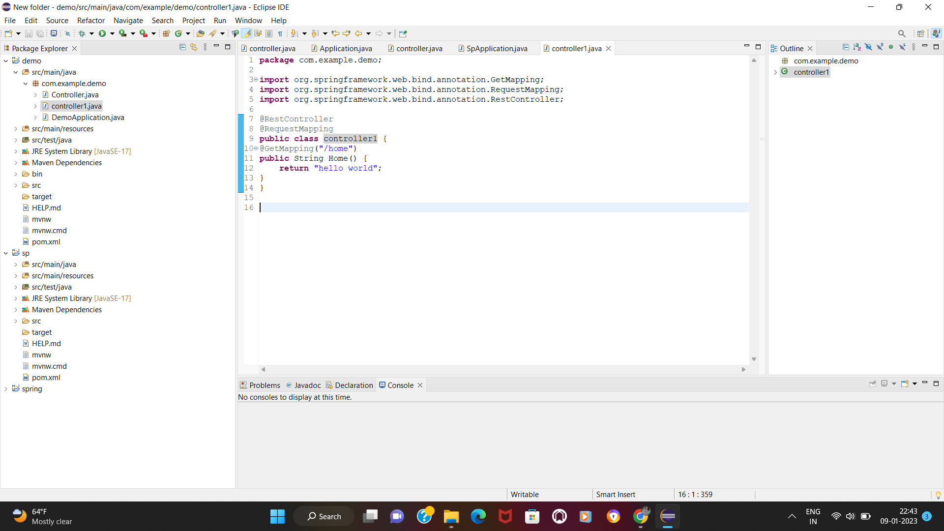

1. After creating class go to application in this project demo application.

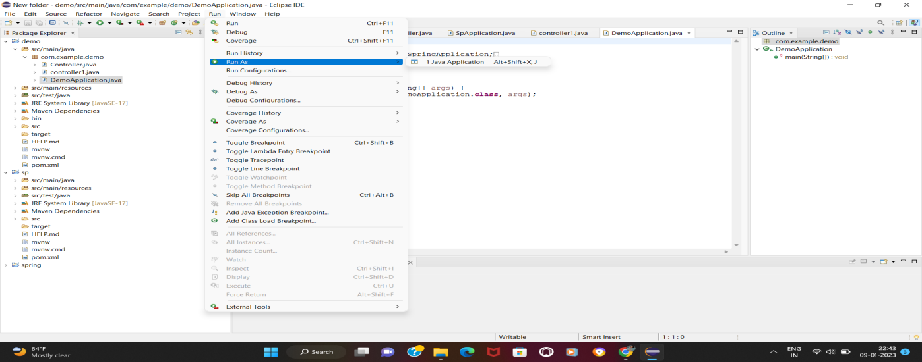

1. After run the application you can make request to browser like Local-host:8080/home there you can see what you return in function.

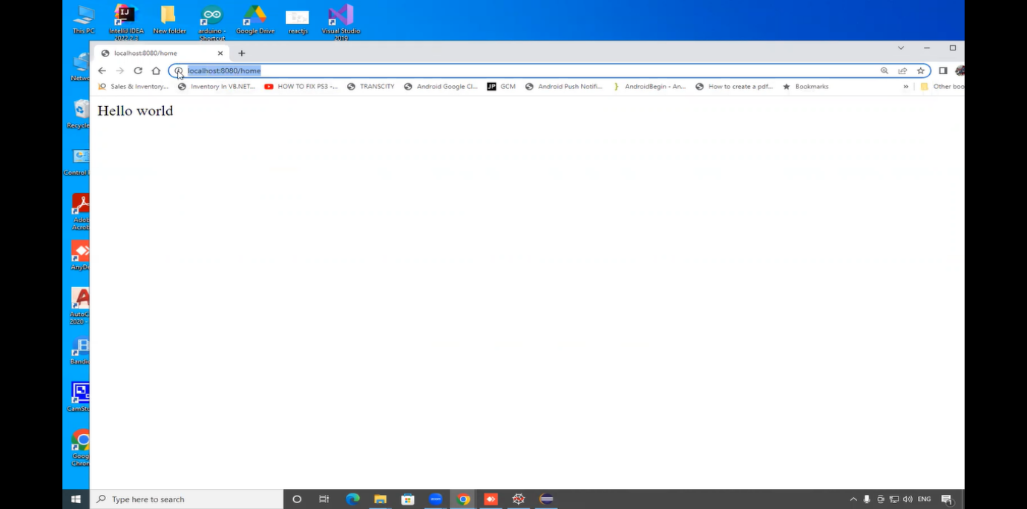

**Activity:-14**

**Test created APIs with the help of Postman.**

Follow the below steps to install Postman on Windows:

Step 1: Visit the <https://www.postman.com/> website using any web browser.

Step 2: Click on Windows Button to download.

Step 3: Now check for the executable file in downloads in your system and run it.

Step 4: Now the installation process will start. It takes a minute to install in the system.

* Postman is successfully installed on the system and an icon is created on the desktop.

Step-5: Create your account with all the required details, or you can also signup with Google, as shown in the image.

Step-6: After signing in, select the workspace tools as per your requirement, and then click on, continue to get the startup screen.

Step-7: You will see the following page, and then you are ready to use Postman.

Step1:Let us take the created API and test it using postman

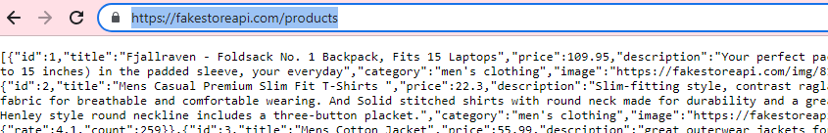

Step2: Paste the url to be tested and select Get http method and click on send

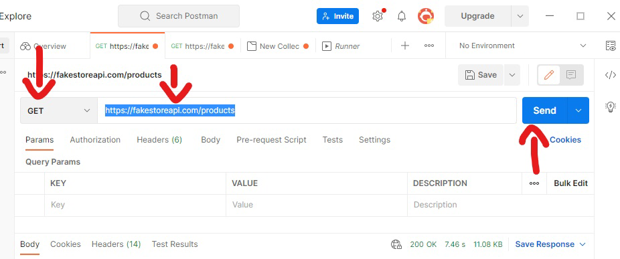

The result will be like this that means the url is working as required

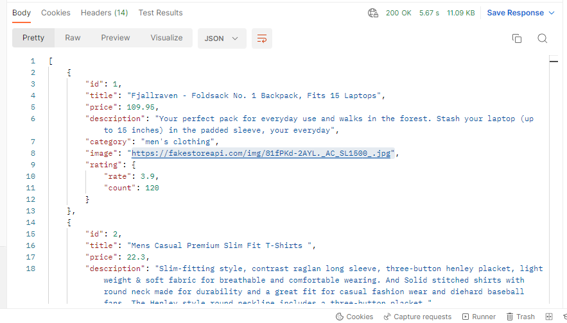

Step3: The output can be view in different formats as shown below

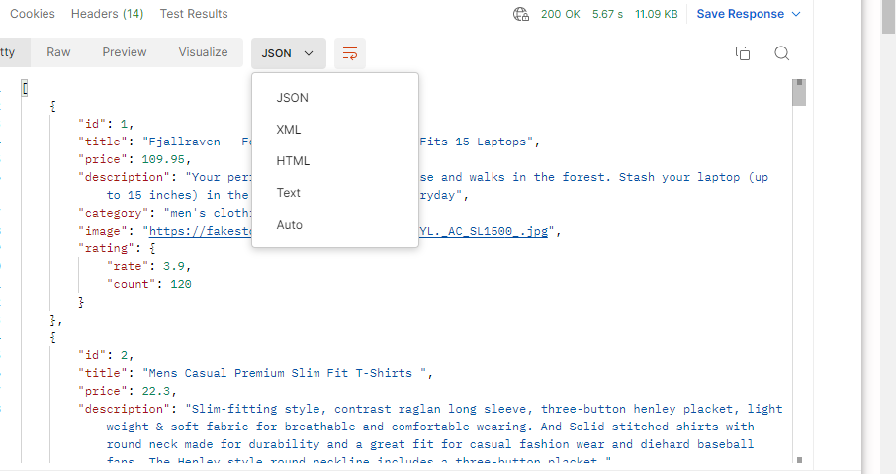

Step4: The image is displaying or not can also be tested .To test click on the url

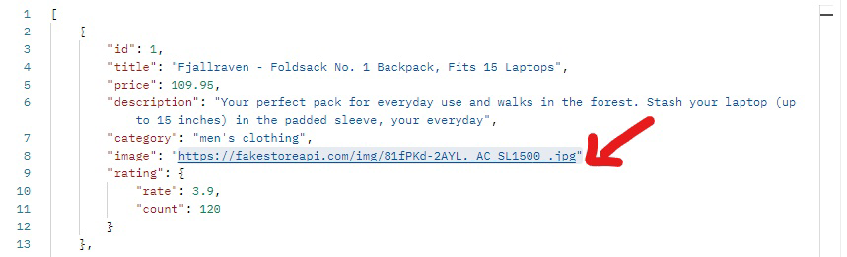

Step 5: Output of this is as shown below

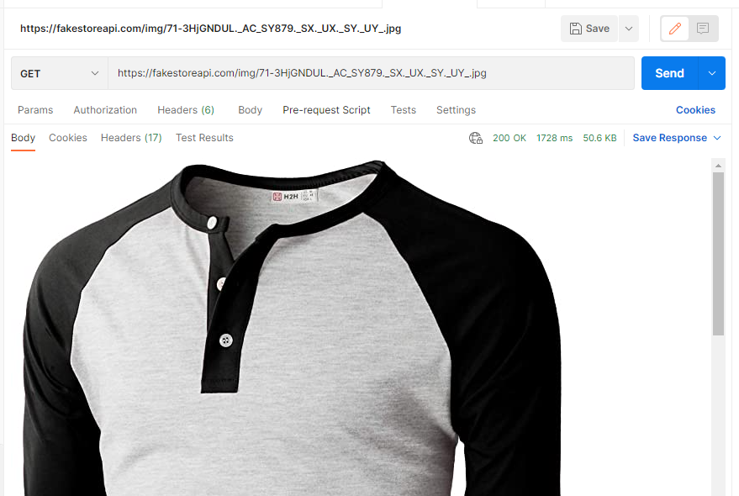

**Activity:-15**

**Securing REST APIs with Spring Security**

**Step1**:Go to chrome and give spring.initializer.io

Add Dependencies: Spring Web, Spring Security, Spring Boot Dev Tools

And select the options as shown in the image below

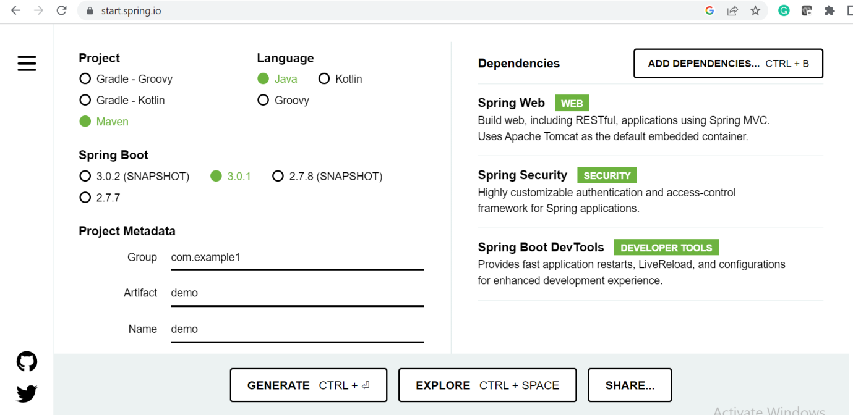

Click on **generate**. Now the zip file comes up.Unzip this file

**Step2:** Go to eclipse and click on File. Click on open project from file.Select Directory and choose the path of the file(unzipped file path)

**Step3:** Demo project appears with the standard spring boot application file format

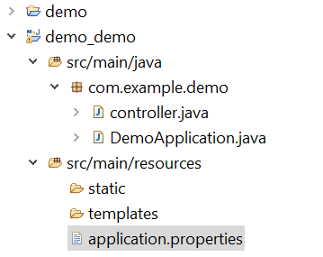

**Step4:** By default the class DemoApplication.java will be there

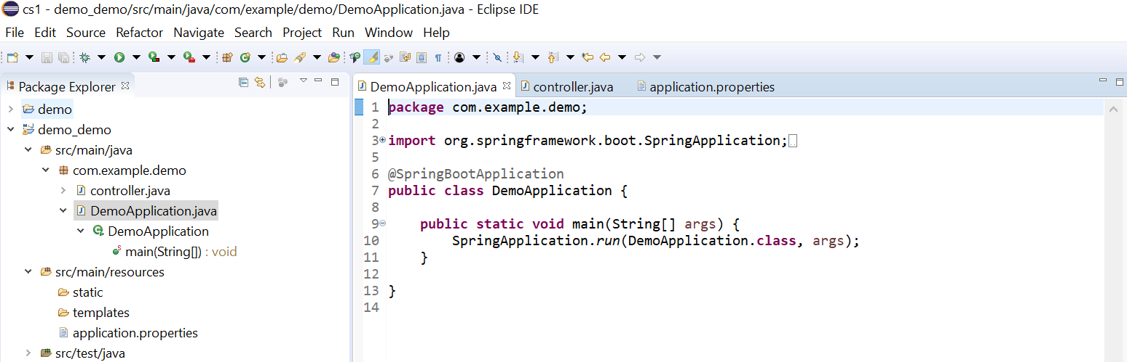

**Step5** :Now right click on the project select new then select class and give the name of the class as controller.Create the simple REST API inside this class

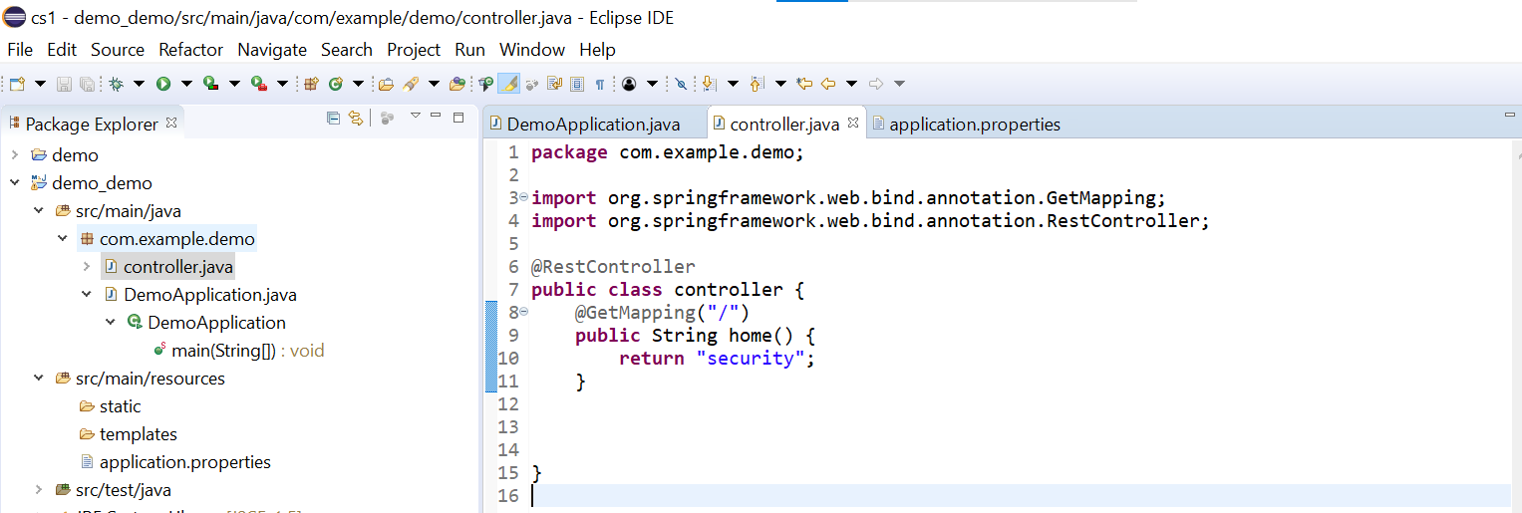

**Step6:** To give security ,open application.properties file and give the name and password

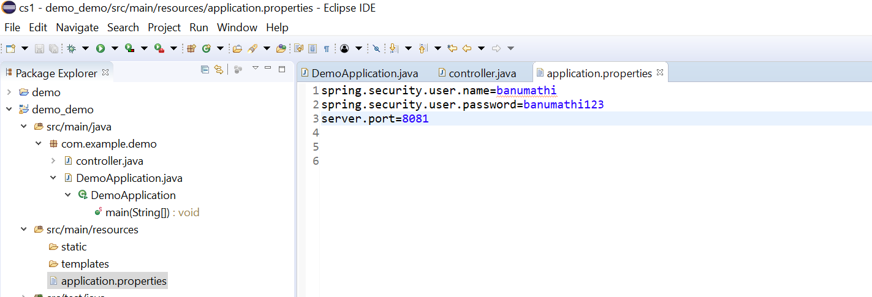

**Step7:** Now run the class DemoApplication.java and the output will be like this as shown below

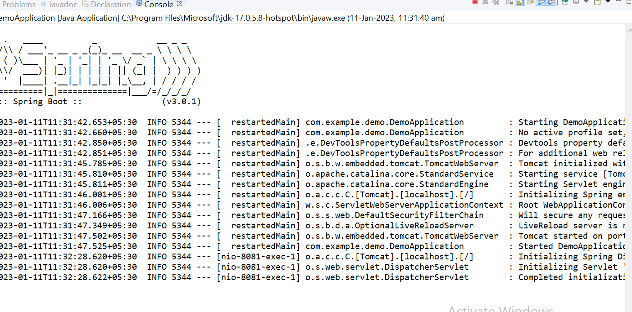

**Step8:** Now go to browser and give localhost:8081

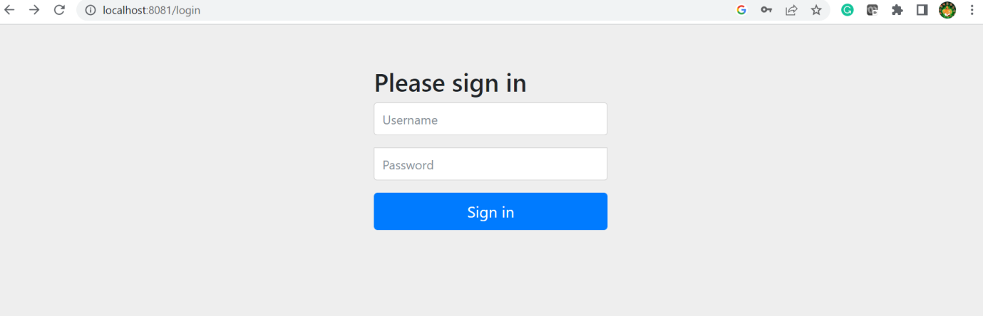

**Step9:** Give the username and password

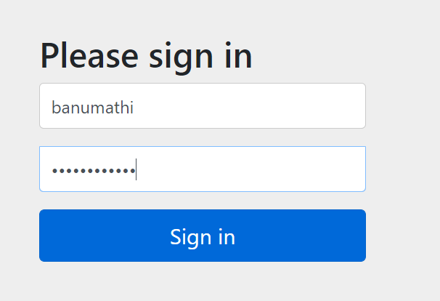

Step10: Now our application appears

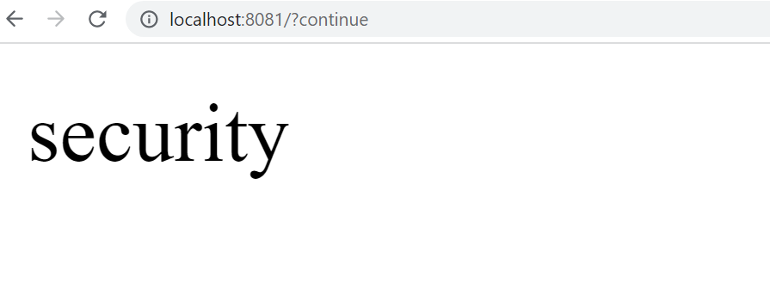

**Activity:-16**

**Download and Install MongoDB community**

**a) Create and drop database**

**b) Create and drop collections**

**Steps to Install mongodb shell**

<https://www.mongodb.com/try/download/shell>

Use above link to download Install mongo db shell.

Just follow the simple onscreen instruction to use mongo db shell.

**Steps to connect mongo shell and mongo db compass and perform DDL and DML Operation.**

**DDL and DML commands in Mongodb**

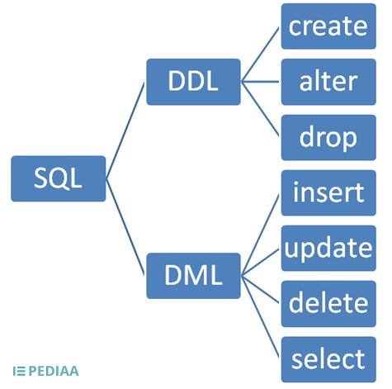

* **Enter the connection string which will be provided in mongodb compass. And to the shell**.

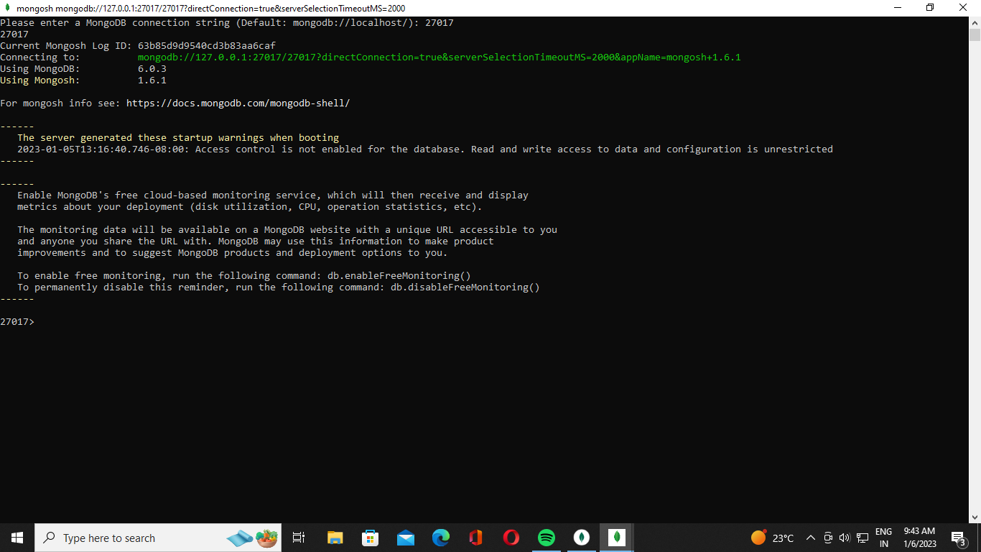

* **Commands to view the Databases created.**

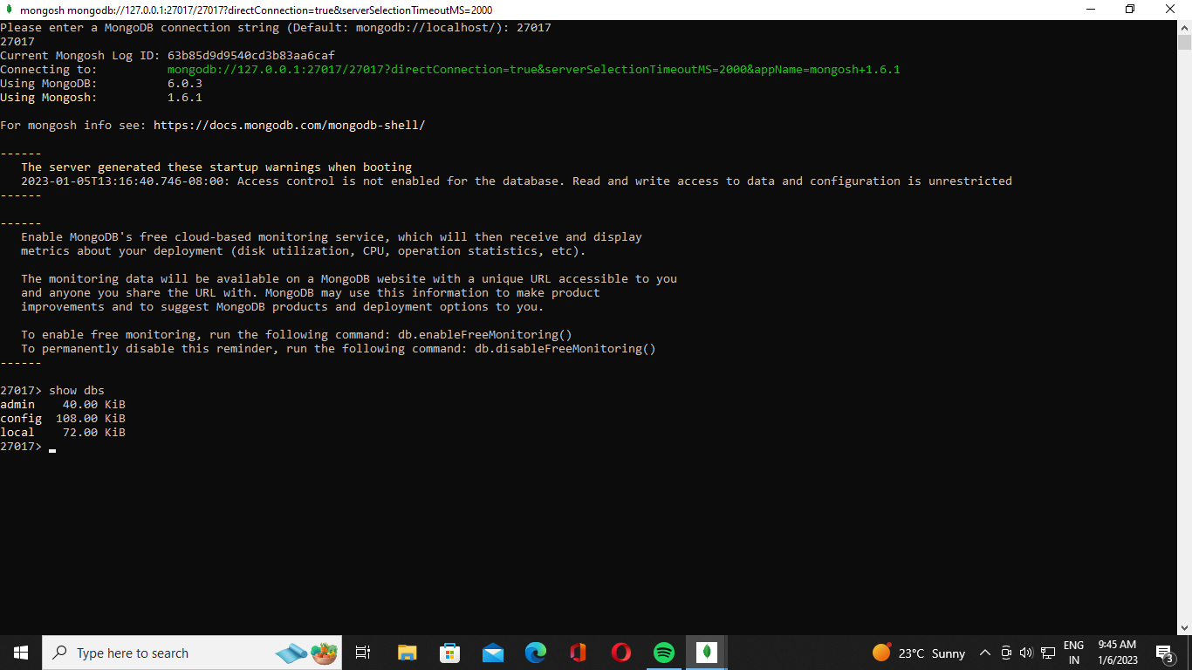

* **To create a new Database just use**

**>**use Database_name

* **Syntax to create collections**

**>**db.createCollection(“collection_name”)

**After creating the collection command to view the collection**

**>**show collections

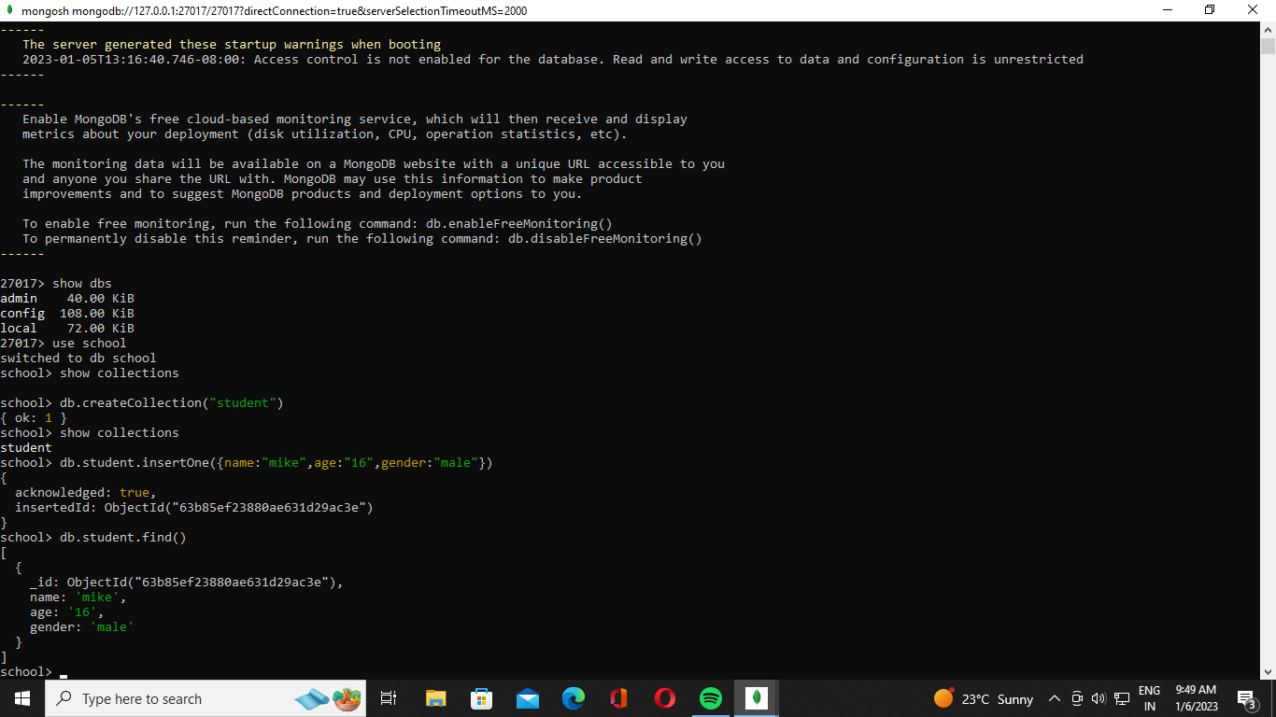

* **After creating the collection you can also view the collection created in the mongo db compass (GUI).**

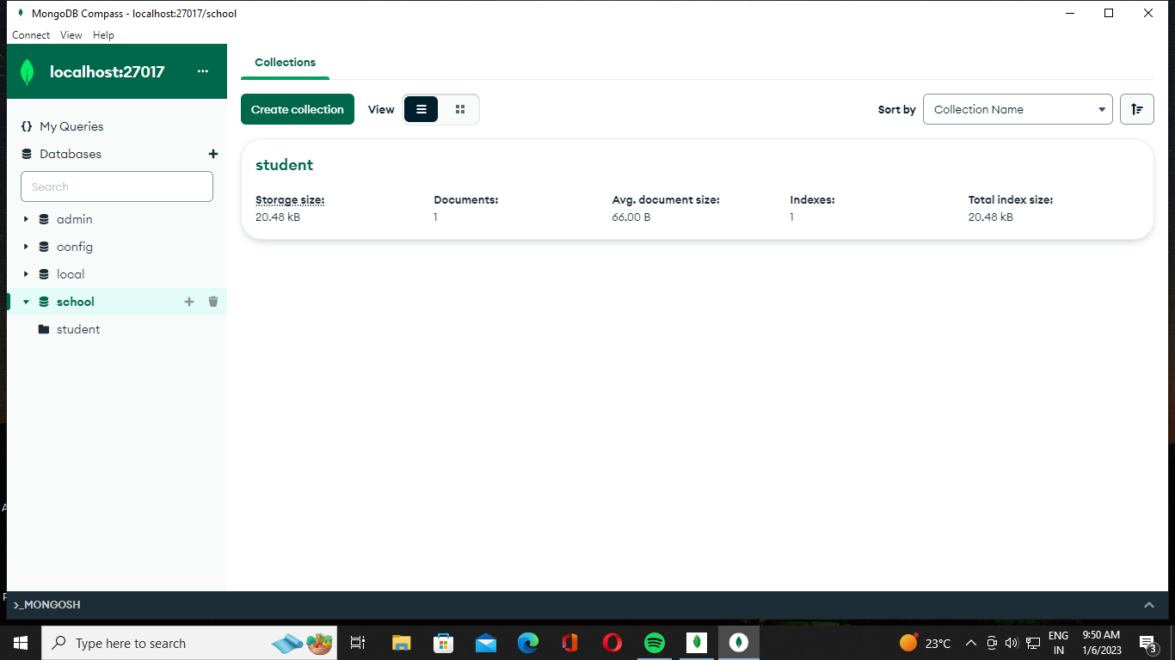

* **Command to drop a collection created.**

**>**db.collection_name.drop()

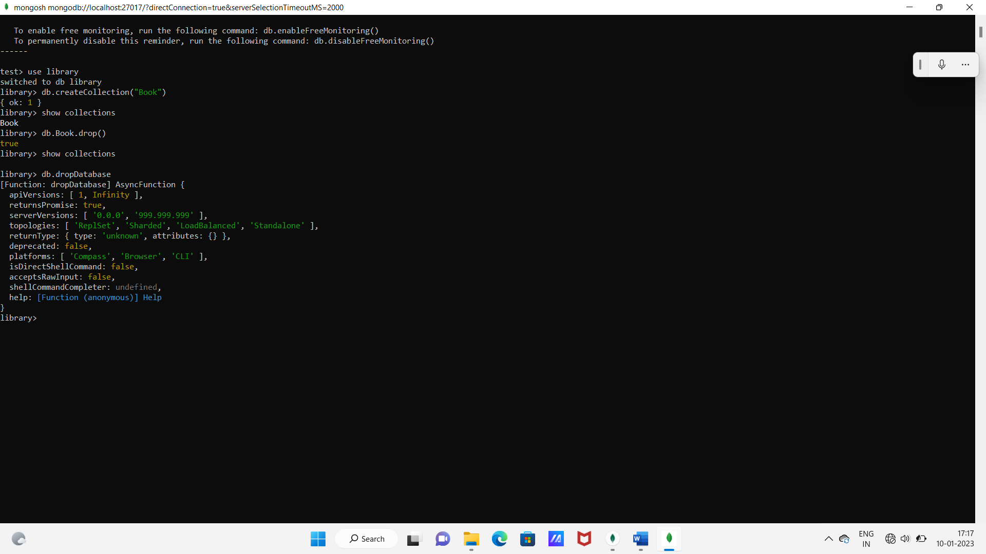

* **Command to drop the Entire Database created.**

**>**db.dropDatabase



**Activity:-17**

**Perform CURD operations on MongoDB**

**To insert single value into the collection.**

**>db.collection_name.insertOne({key:value”})**

To check whether the value is added or not!

**>db.collection_name.find()**

By using this command you get the value inserted in the collections.



* **To insert many values at a time to the collection.**

**>db.collection_name.insertMany([{key:”value”,key:”value”}])**

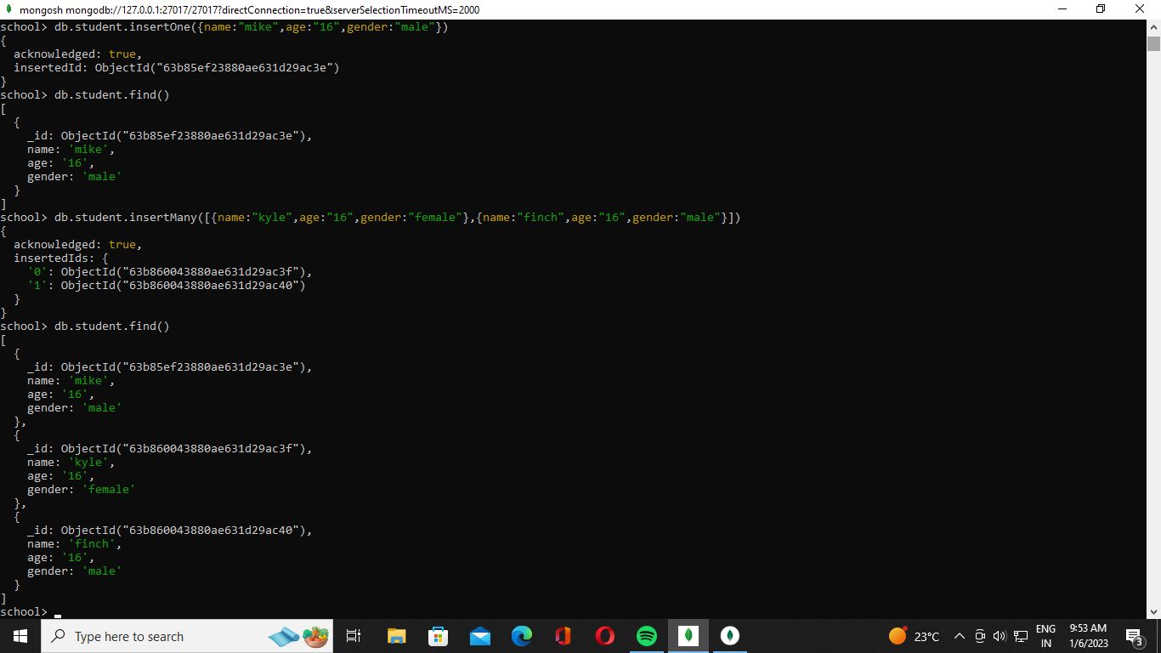

**GUI view of the inserted value in Shell.**

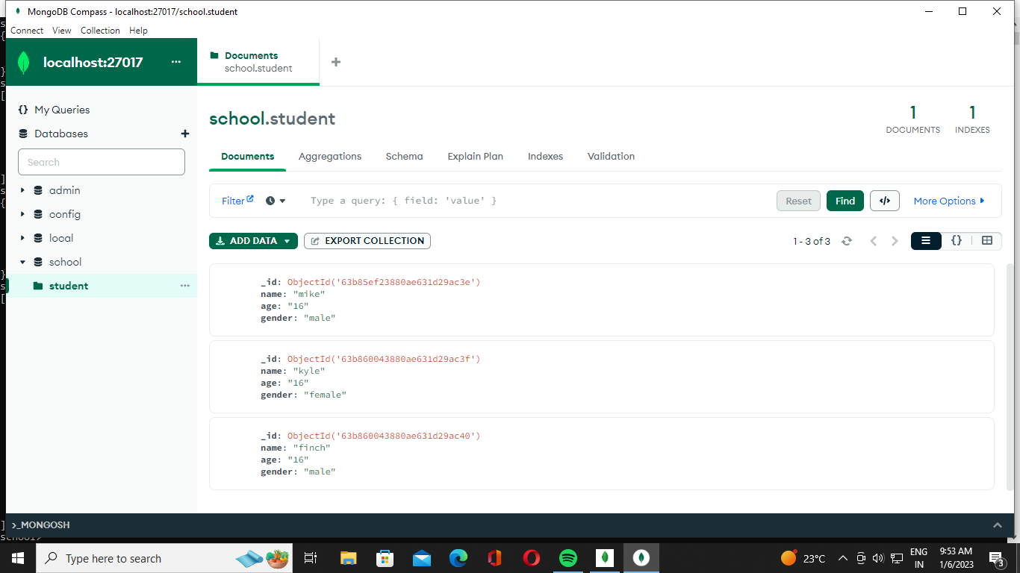

* **Updating the existing value in the collection.**

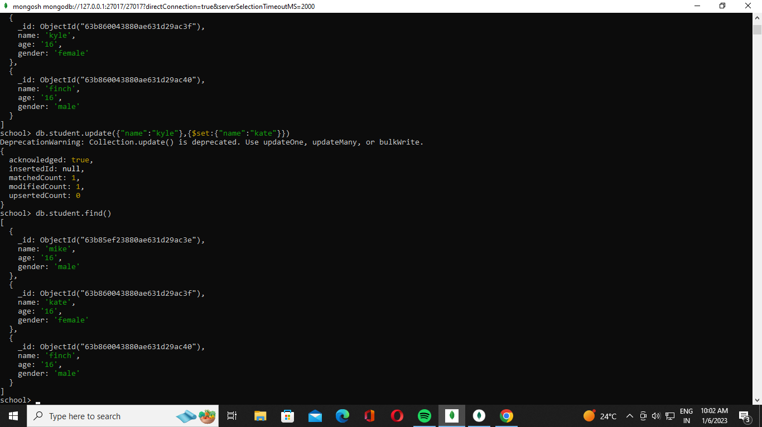

**GUI view**

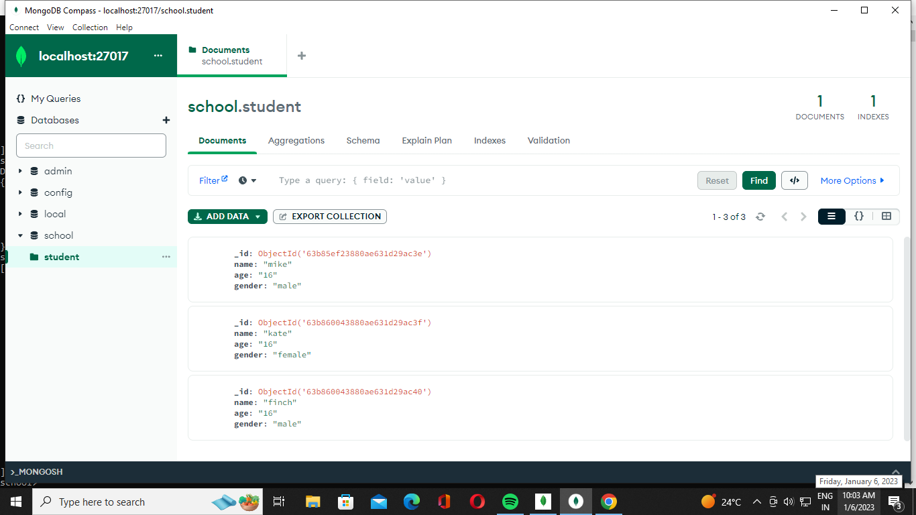

* **Here, we are updating the DOB field for Kate.**

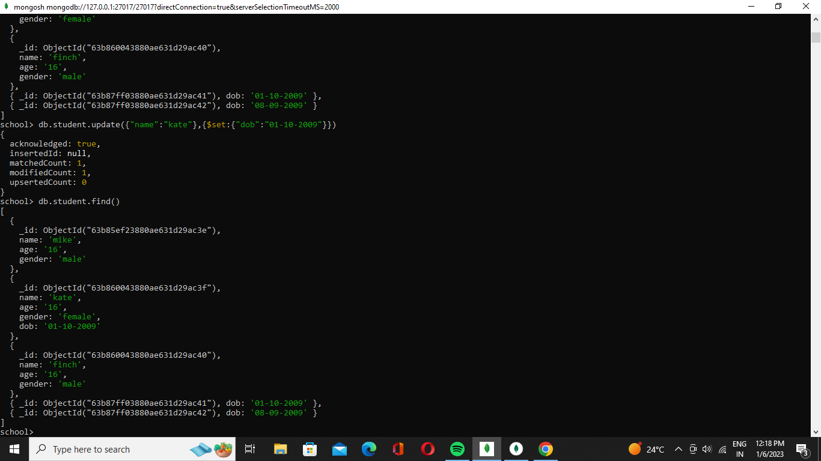

* **Here, we are adding the “city” field to the student collection using the set function.**

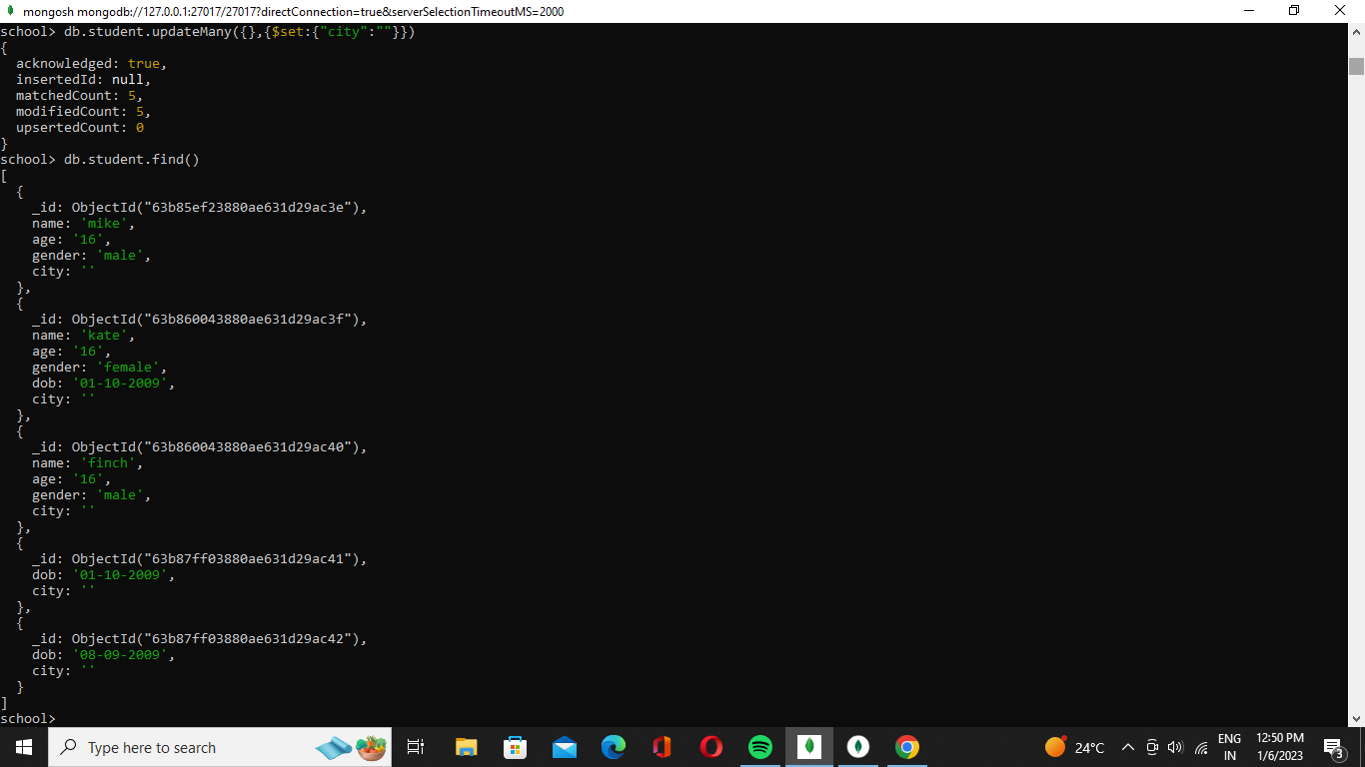

* **Dropping the field DOB.**

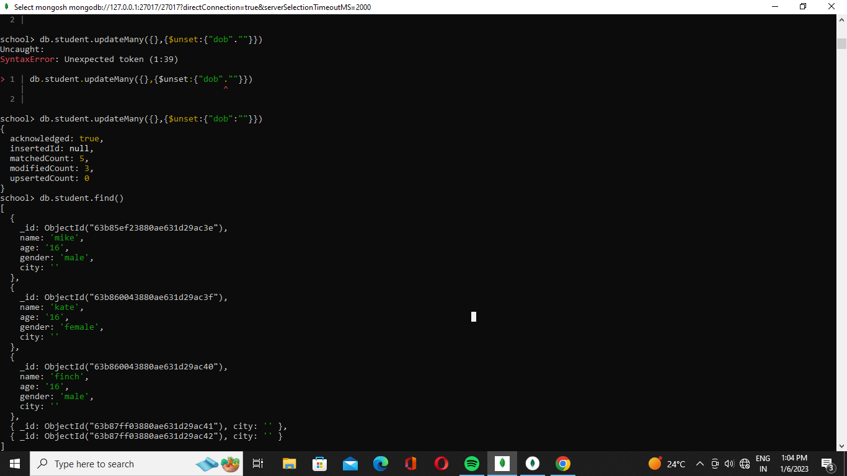

* **Truncate i.e, Removing fields**

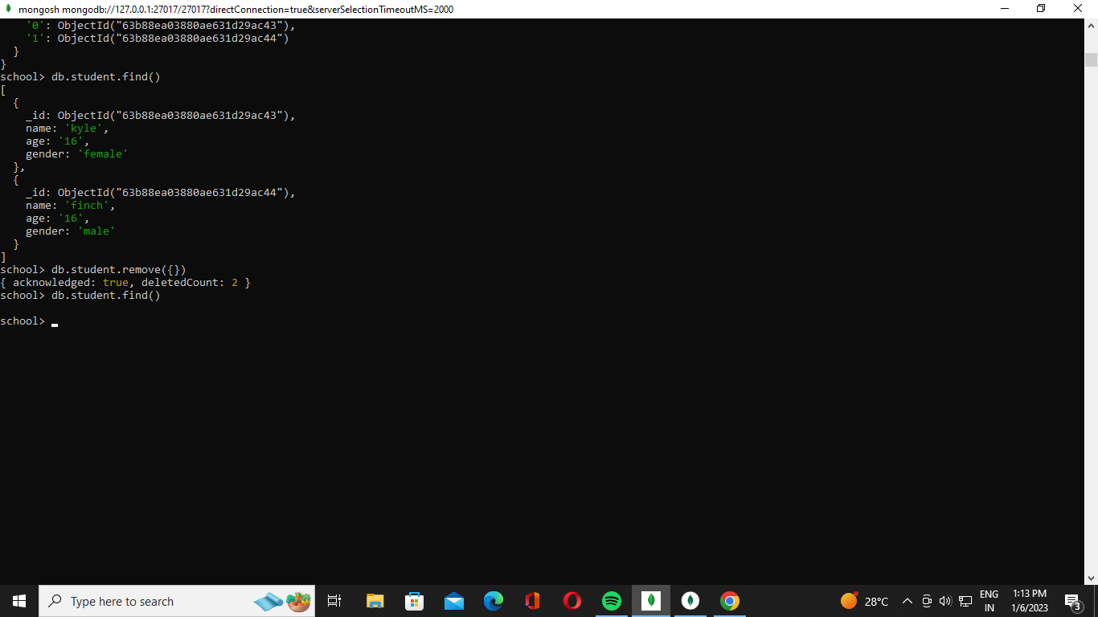

**Activity:-18**

**Demonstrate the following operation in Docker concepts.**

**a) Download the Docker image.**

**b) Create Docker container from Docker image.**

Step1: Register with hub.docker.com (In Google).

NOTE: If you have an account, you can sign in with that by username & password

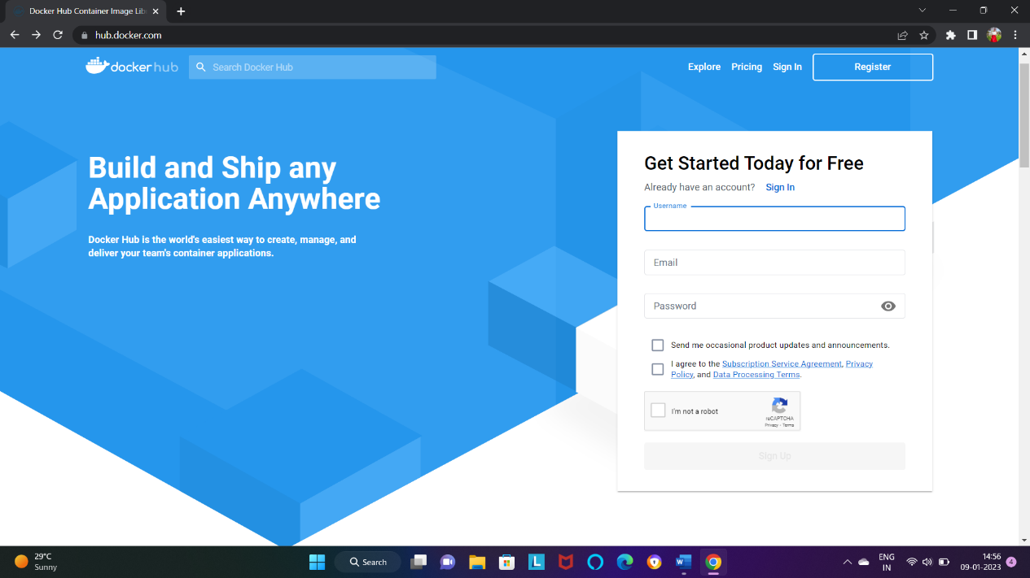

Step2: choose

Continue with free

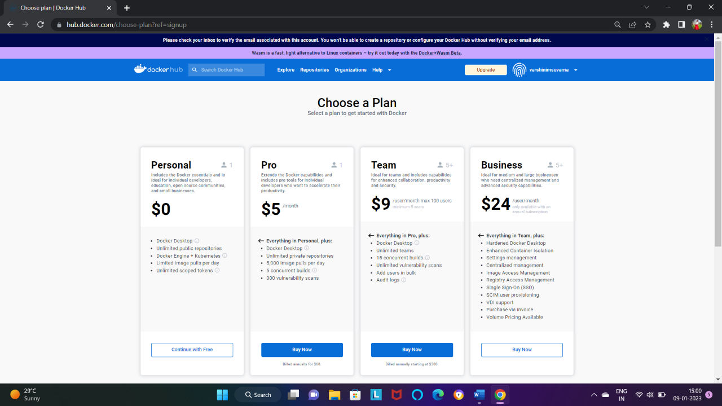

Step3: verify your email

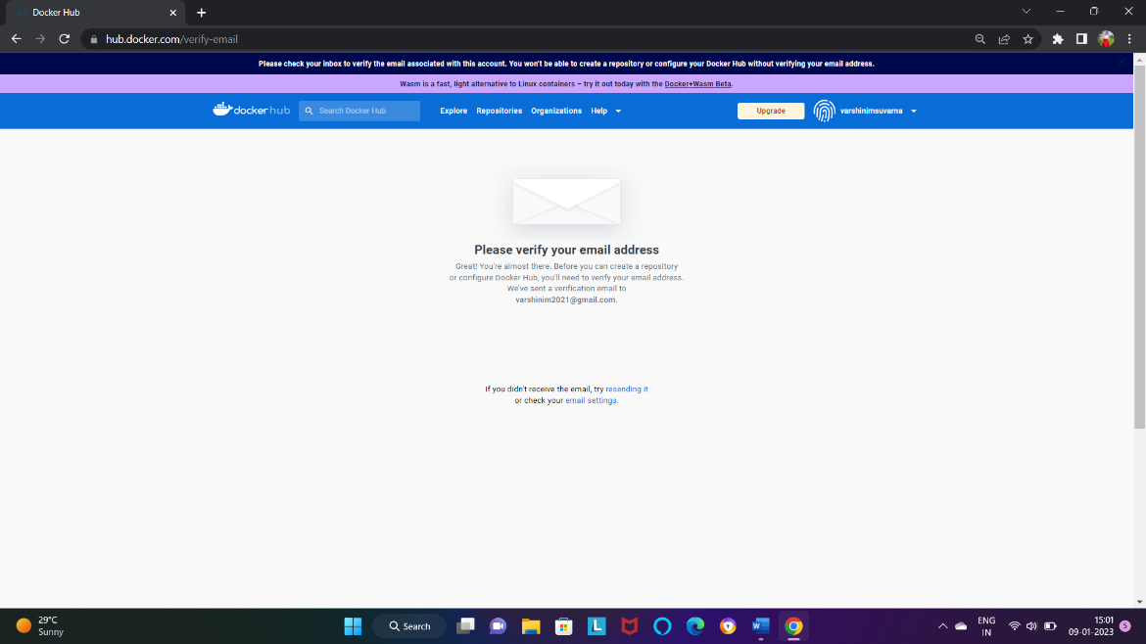

Step4: GO the search bar in the website and search Apache or any image you want and

Copy it.

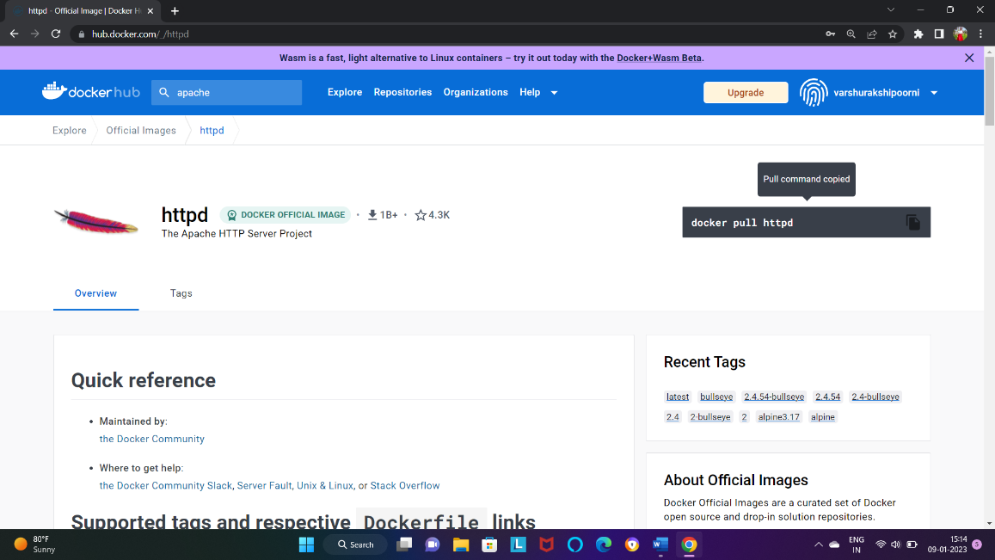

Step5: open PLAY WITH DOCKER in google to create a docker images.

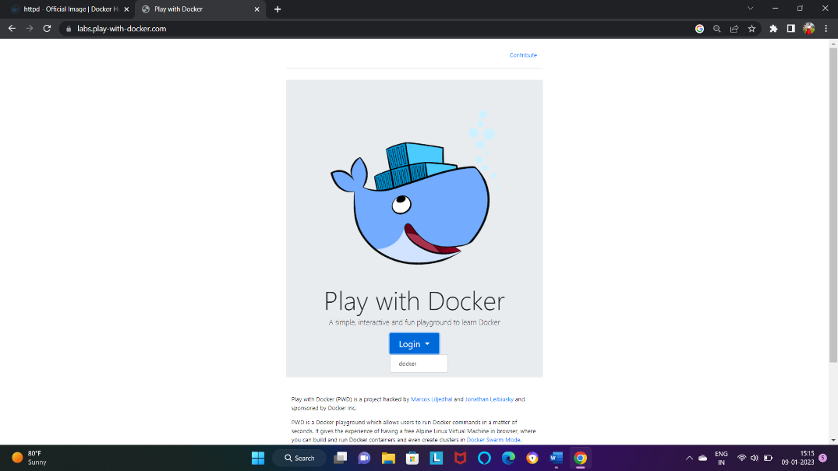

Step6: ADD NEW INSTANCE .

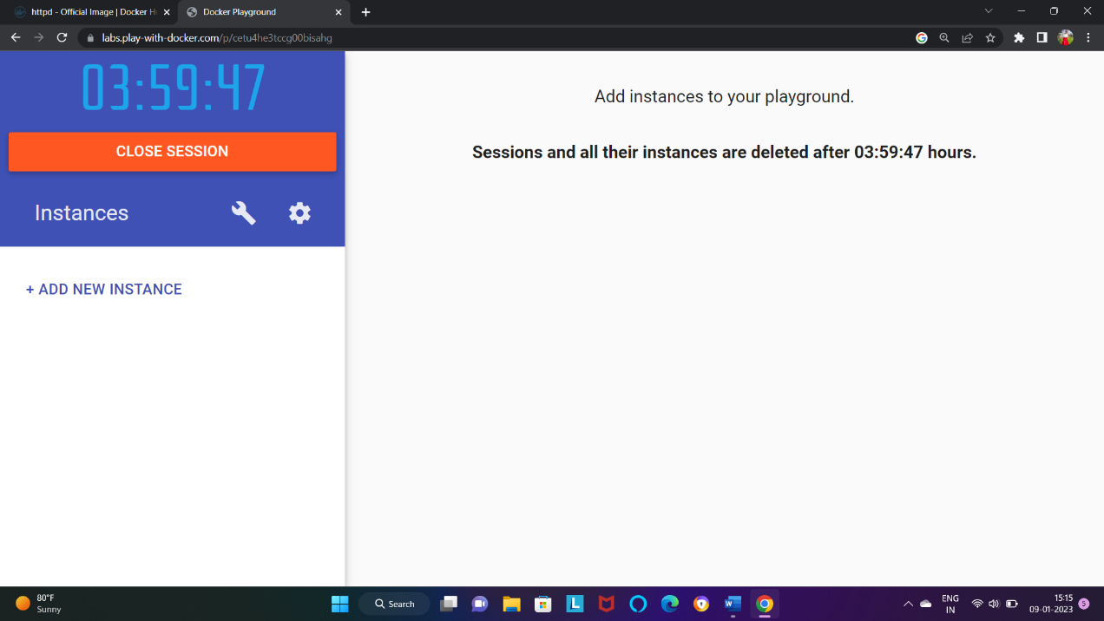

Step7: IN command

* sudo su [to be a root user].
* Docker pull httpd[paste the command which copied in the step:7]

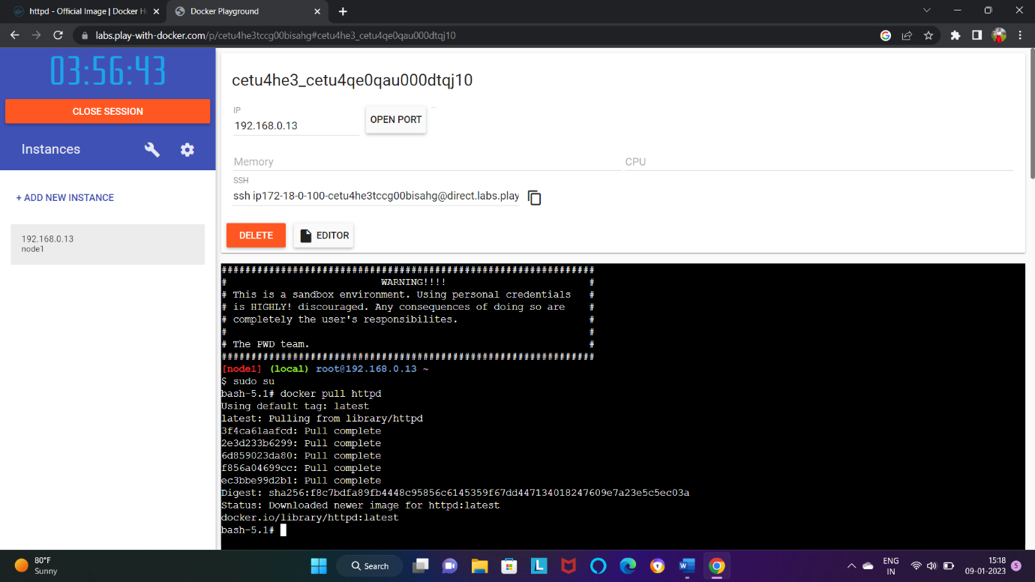

Step8: docker images [show the detail of image]

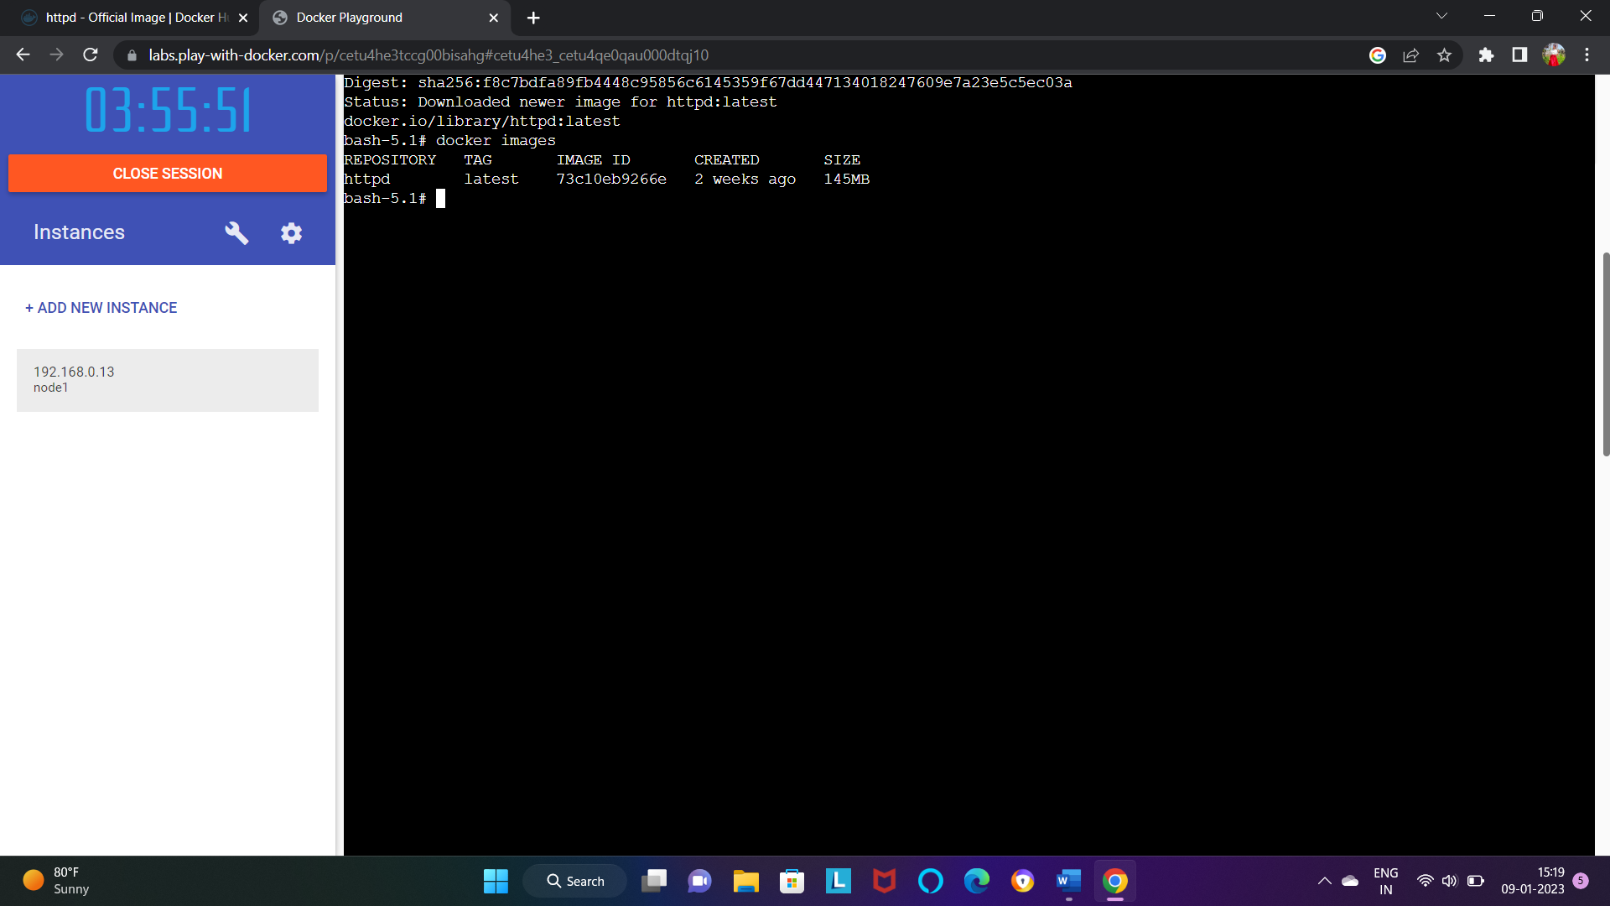

Step9: docker run image ID [to run image in FOREGROUND].

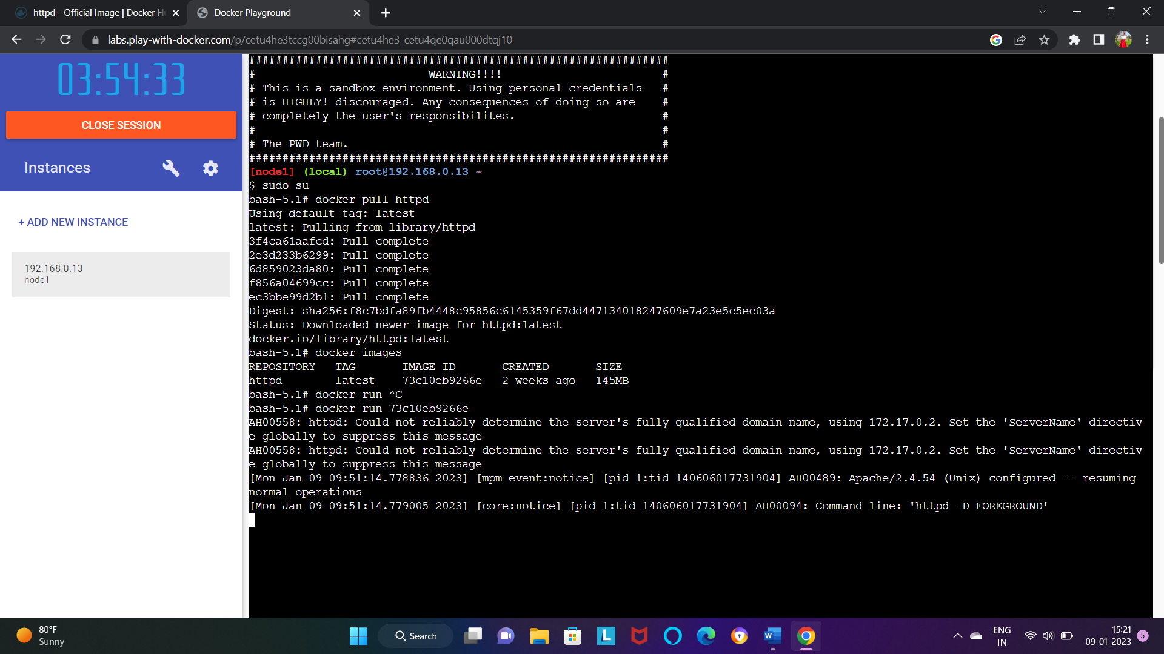

Step10: docker run -d image ID [to run image in BACKGROUND].

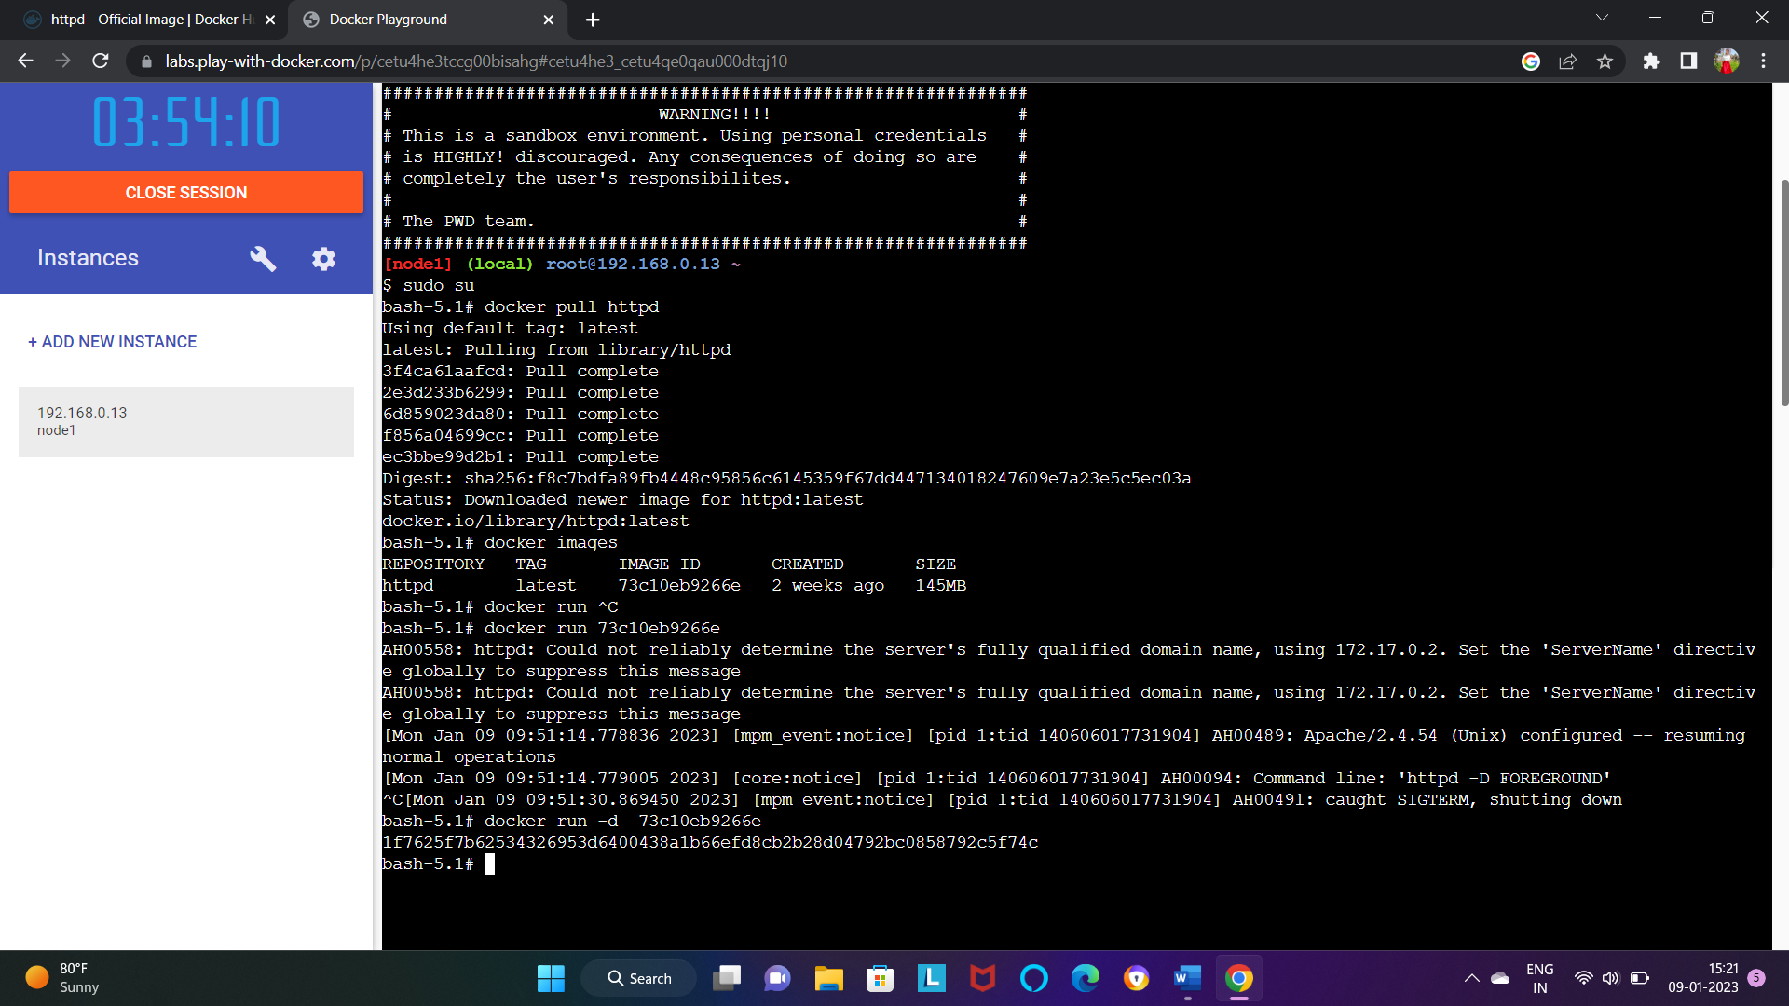

Step11:

* Docker ps [showing running container only].
* Docker ps -a [showing all the container].

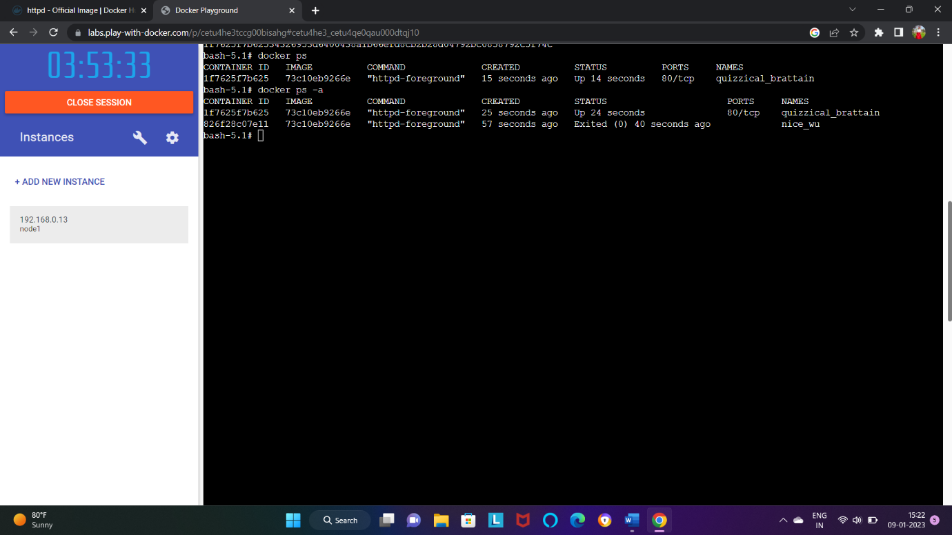

Step12: docker kill container ID [kill the ID by applying container ID].

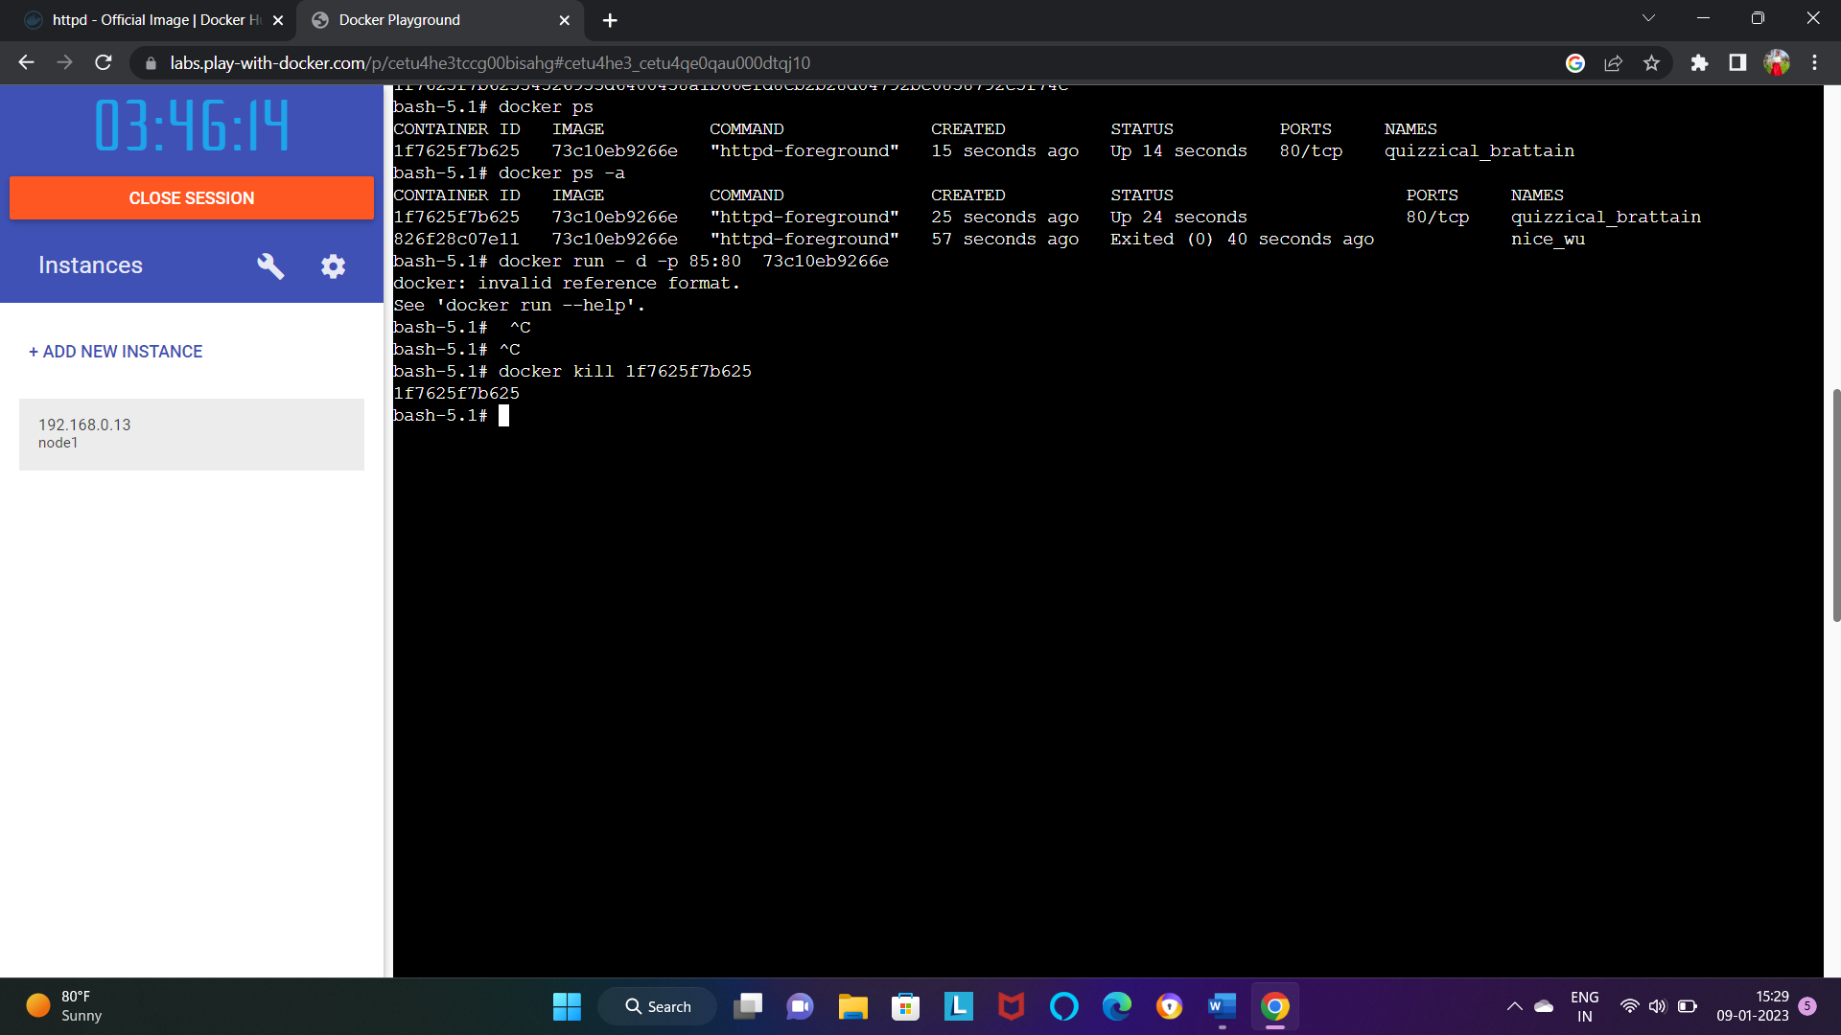

**Activity:-19**

**Create a class with function for Payment Simultation Gpay with the function method called "pay", which returns 1 or 0**

**1:Success payment**

**0:Failure**

**Step1:**

1. File →New → Java project →project name(junit→Finish)

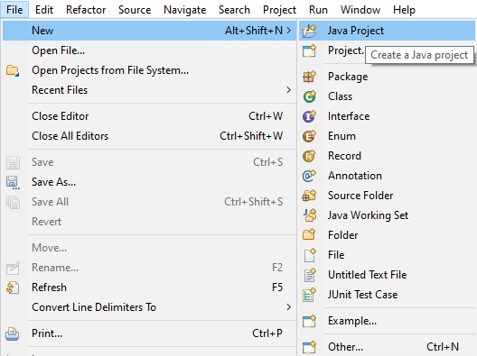

2) Right click on created java project → New → class → Name(Gpay) → Finish

3) Content Inside that class (Gpay-java)

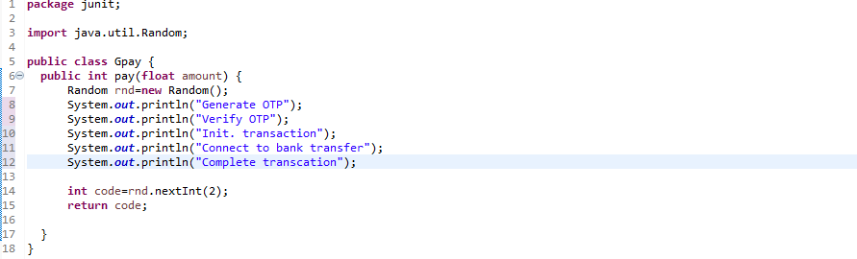

5) Right click on created java project→ New →other → Junit Test Class → Name: (PaymentText) ,New Junit Jupiter text (select this) →select this( Add Junit 5 Library to the build path) → ok

6) Remove this: fail ("Not yet implemented “)

7)Content Inside that Junit Test class (payment Text)

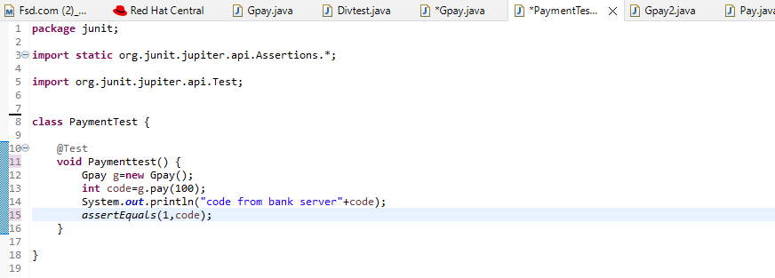

7) Right click on Junit Test class (PaymentTest.java) → Run As→ 2.JUnit Test → Ok

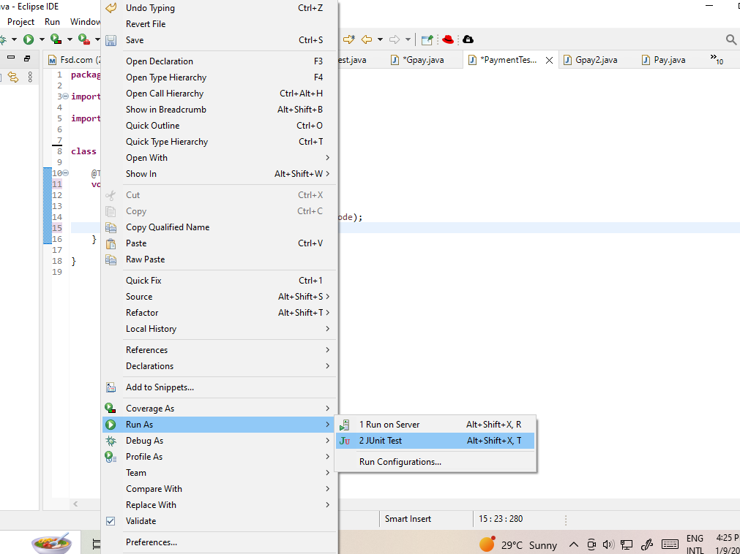

**Passed:**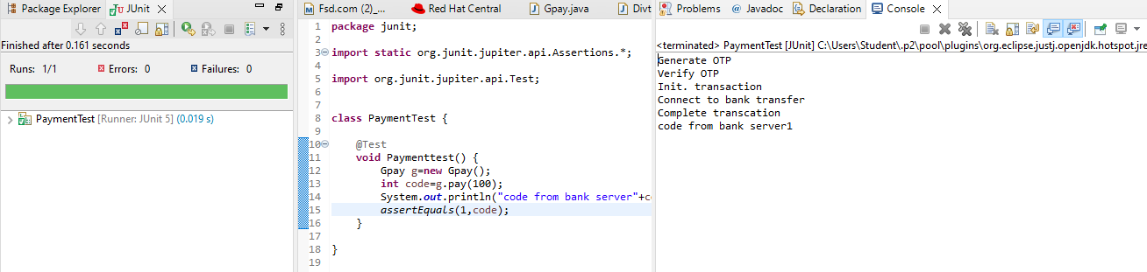

**Failed:**